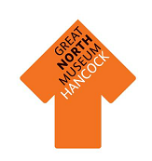

Greek Vases

Look around the Ancient Greeks gallery for the answers to these questions.

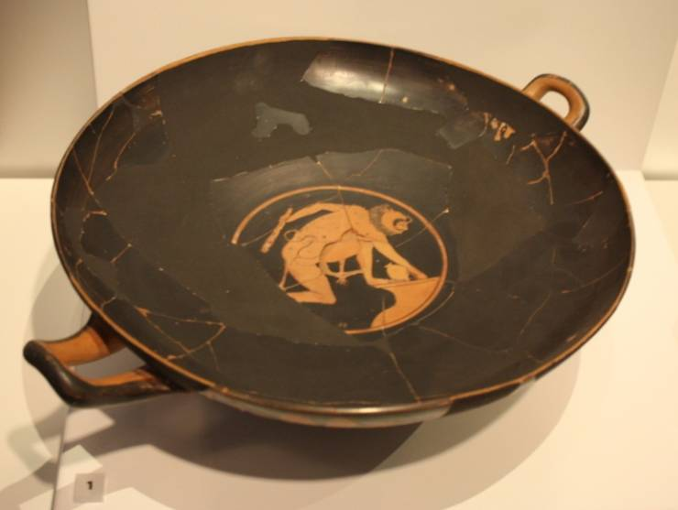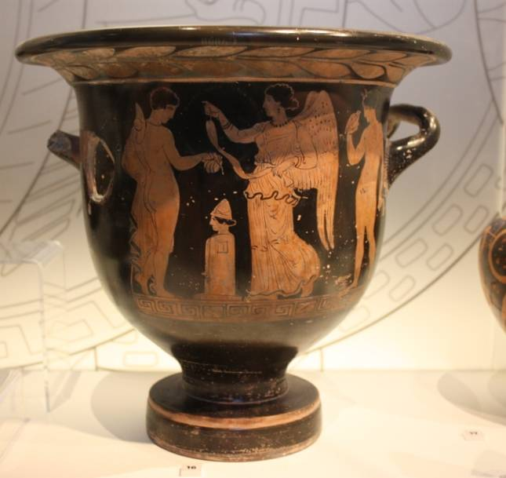

Who is depicted on this vase?...............

………………………………………………………………………………………………………………………..

What is happening?...............................

………………………………………………………………………………………………………………………...

**Key Word:** Depiction/Depicted—to represent something in a picture

Look closely at the image in the centre.

Describe the person in the picture ………….………………………..

………………………………………………..

What is the person in the picture doing?............................

………………………………………………..

Who is the creature depicted on the container?.................................................................................................................

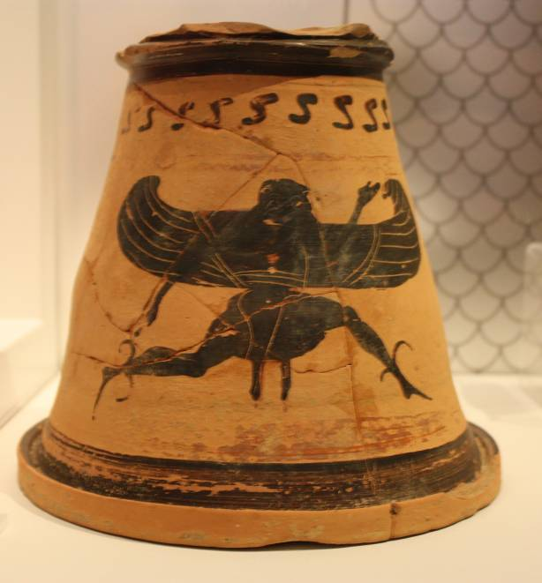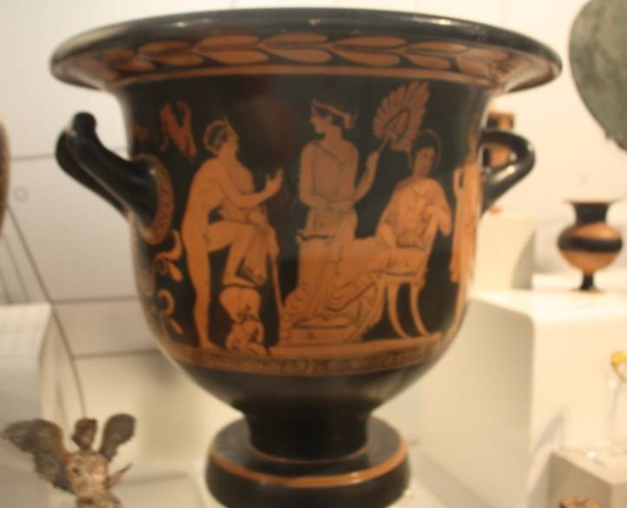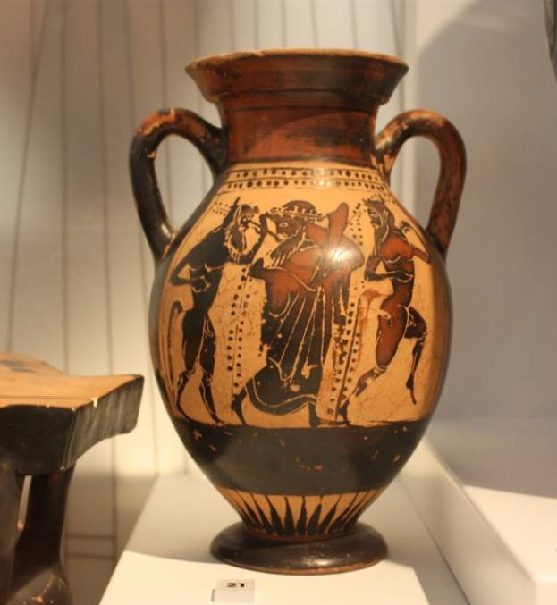

Greek Vases

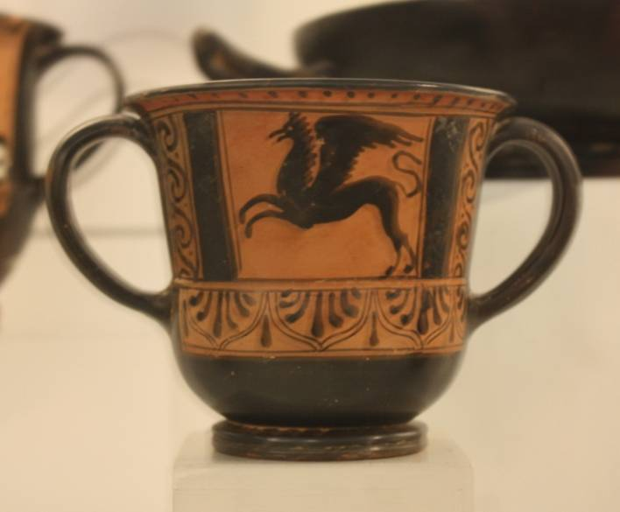

How many people can you see on this vase?......................................

Can you find out who they are?

………………………………………………………………………………………………………..

What creature is on this vase?

………………………………………………………………………………………………………...

What do you think is happening on this vase?....................................................……………………………………………………………………………………………………………………….

How many people are on the vase? ……………………………………………………………...

Who do you think the lady on the chair could be? …………………………………………

……………………………………………………………………………………………………………………….

**Key Word:** Depiction/Depicted—to represent something in a picture

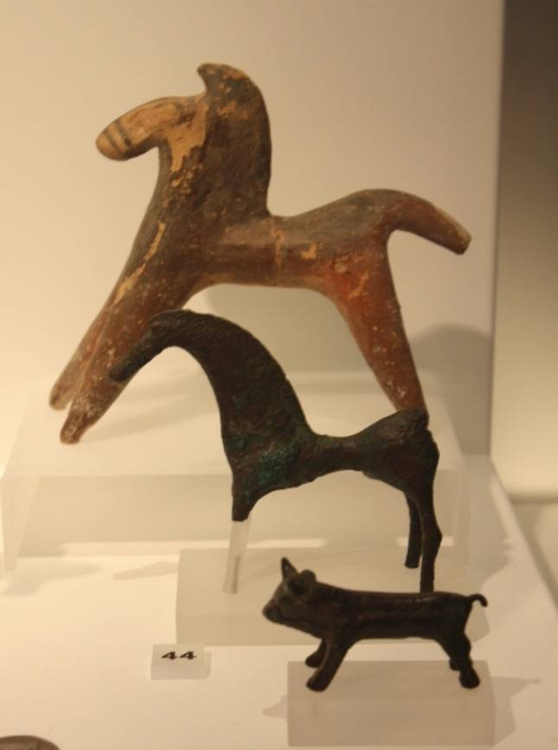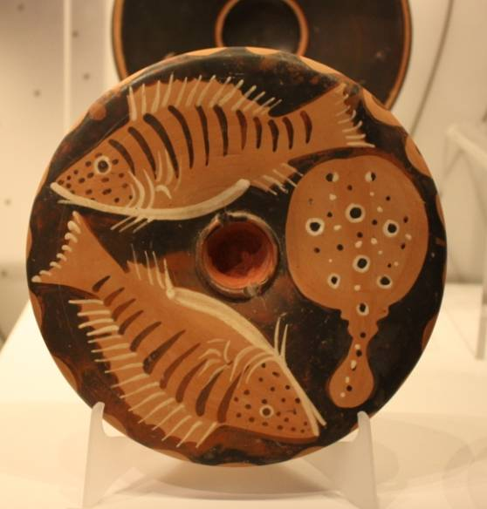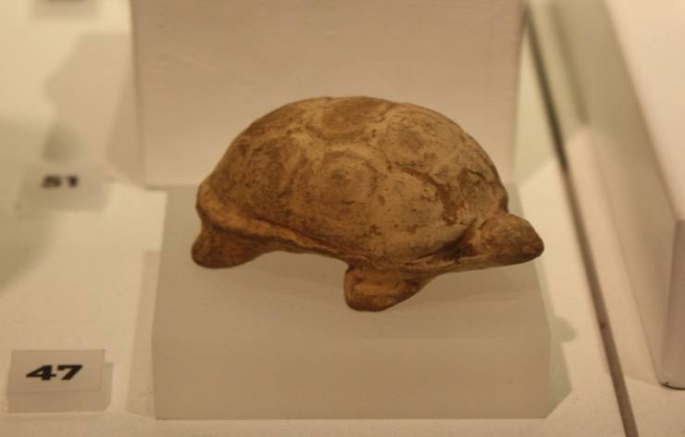

Can you find these animals. Identify what each animal is:

1……………………………………………………………

2……………………………………………………………

3……………………………………………………………

What information can you discover about the object above? Name two facts about this item.

1…………………………………………………………..

2…………………………………………………………..

Greek Animals

Look closely around the Ancient Greeks gallery for different animals. Identify the ones shown on this page by reading the information in each case.

Look for the plate with fish on. How many fish can see on this plate? …………………………………………………………...

The Ancient Greeks made small offerings to their Gods, sometimes they made animal shapes as a replacement for offering real animals.

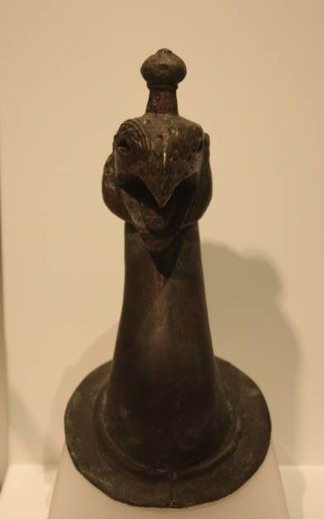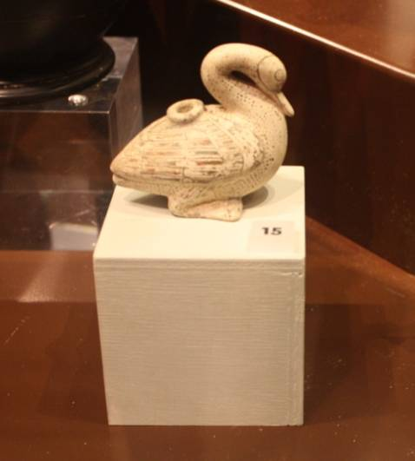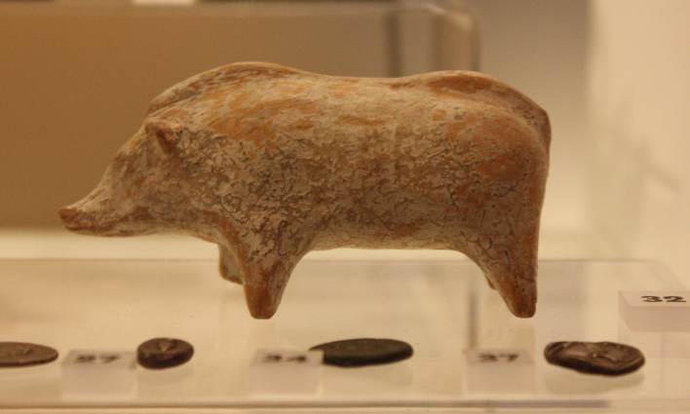

Can you find any other animals on pots or other objects around the gallery? ……………………………………………………………………………………………………………………………………………………………………………………………………………………………………………………………………………………………………………………………………………………………………...

What is the creature in the photograph to the right?

………………………………………………………

What is the animal made from?

……………………………………………………….

Greek Animals

What is the creature in the photograph to the right?

……………………………………………………………………………………………………………………………………………………………………..

What animal is on the photograph to the left?.............................................

Can you find out how this object might have been used?........................

………………………………………………………….

Can you name three other mythical Ancient Greek creatures?

1…………………………………………………..

2…………………………………………………..

3…………………………………………………..



Ancient Olympics

We know a lot about the Ancient Greek Olympics because of the evidence we have found.



The Ancient Greeks played a few sports during the Olympic games. Look around our gallery for evidence of these sports, and circle its name once you have found it.

Pankration Long jump Chariot race Mule cart racing

One of the sports played was wrestling, which they called pankration. What were the only 2 rules?

1………………………………………………………………………………………………………

2……………………………………………………………………………………………………..

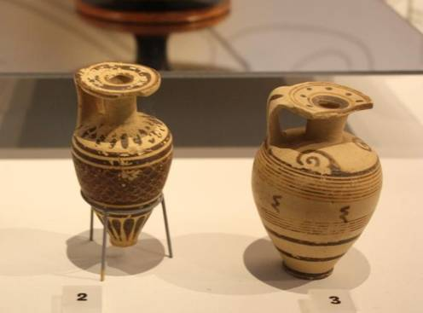

Can you find these two small pots? What was contained within them?........…………………………………………………………...

Why did athletes use these? ............................................................................... ................................................................

Draw a Strigil

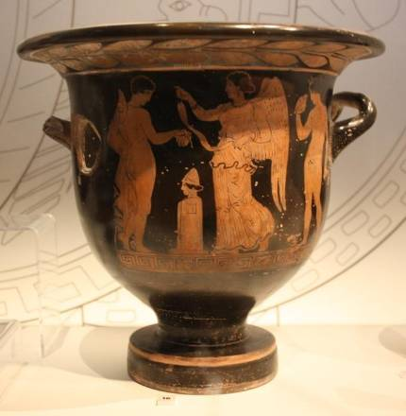

Read some information about this pot.   
Do you think the young man on this image was a successful athlete?.................................................  
  
Who is the lady on the image with wings?  
……………………………………………………………………………..



Ancient Olympic sports

Find these objects in the gallery. Each show us some of the different sports that were played during the Ancient Greek Olympics.

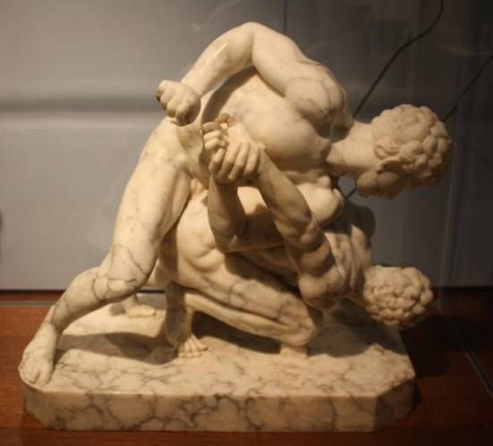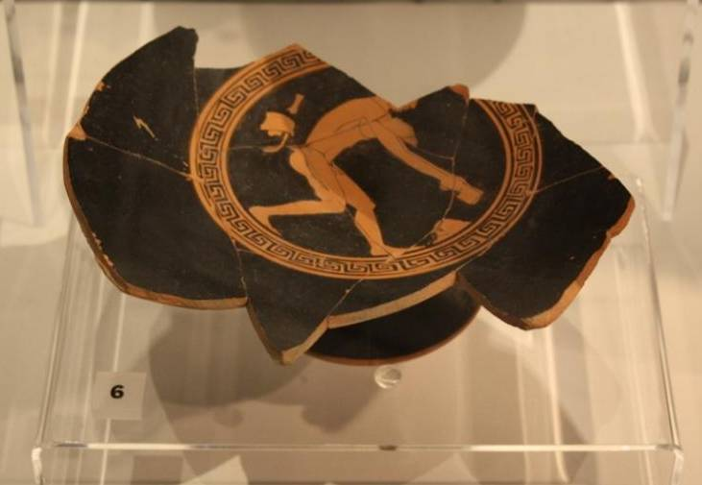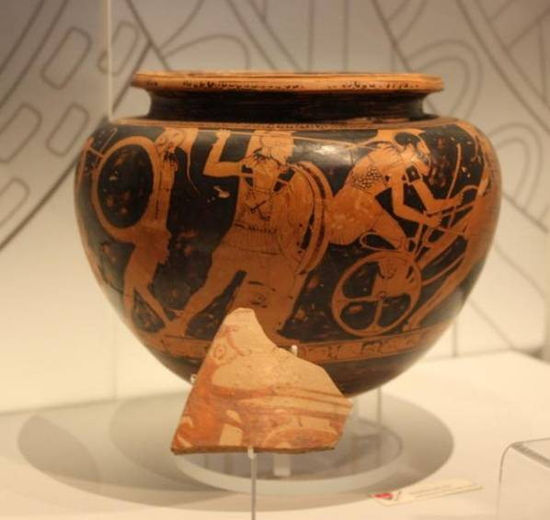

List each of the different sports that the pictures show us? (hint! You might have to read the information about each)

1………………………………………………..

2………………………………………………..

3………………………………………………..

4………………………………………………..

5………………………………………………..

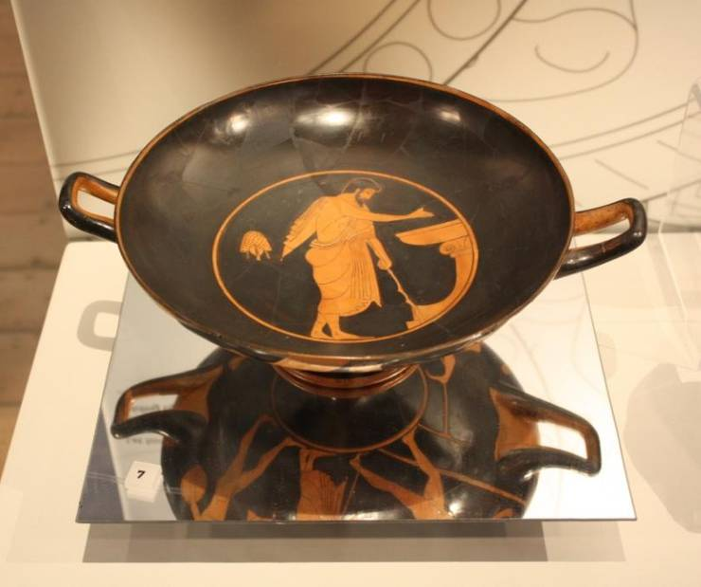

5

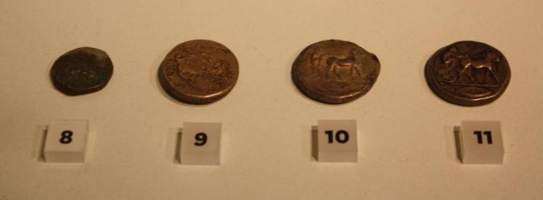

4

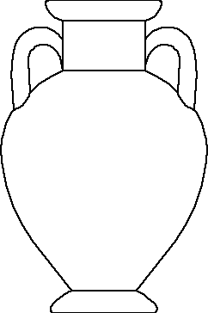

Greek Vases

In the space below draw three different Ancient Greek shapes, patterns and symbols you can find on the vases in this gallery.

List two different colours found on some Greek vases.

1………………………………………..

2………………………………………..

Create your own Greek vase in the outline using the facts gathered through exploring the Ancient Greek gallery.

Talk to your neighbour about:

Who you are putting on the vase?

How do they know each other?

What are they doing?

What story are you showing through your design?

We can use many Greek vases to give us information and clues about what life was like during the Ancient Greek time



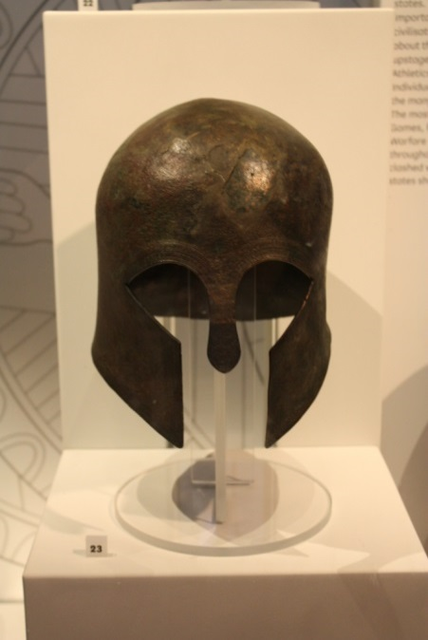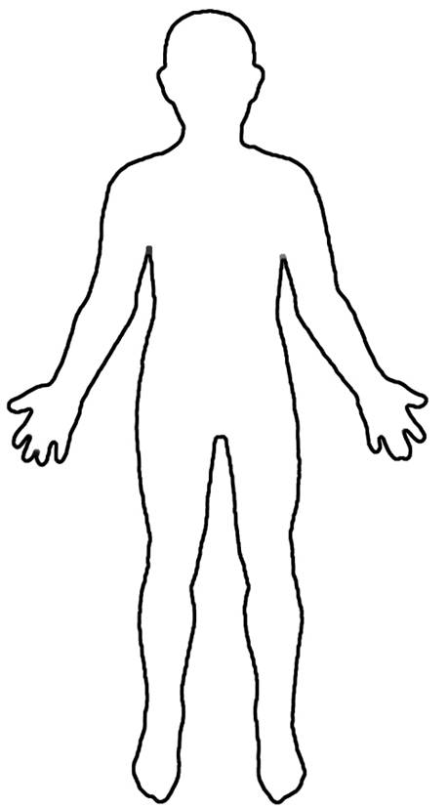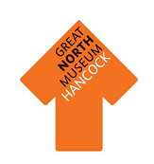

**Hoplite**

Look for the Hoplite equipment and the images of Hoplites on the walls.  
  
Draw your own Hoplite armour on the image on this sheet.

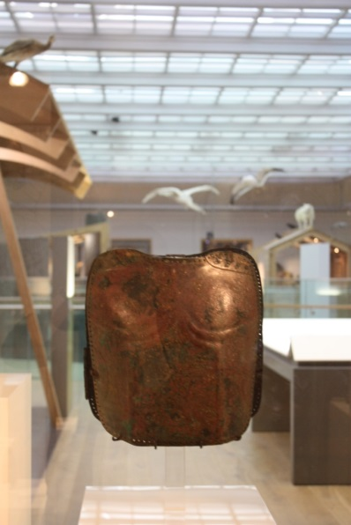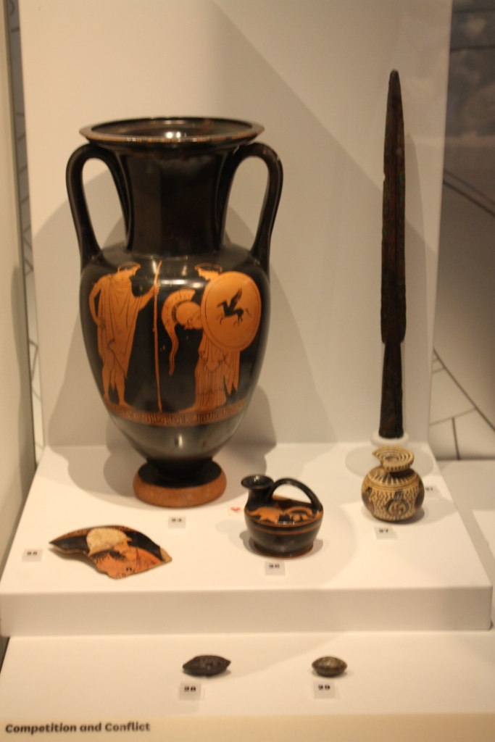

What would have been on top of this helmet?.....................................................................

What kind of decoration can you see on this breastplate? ………………….

………………………………………

……………………………………..

What is pictured on the shield on this vase?...............................................................

Design your own shield in the circle below.



**Archaeological evidence**

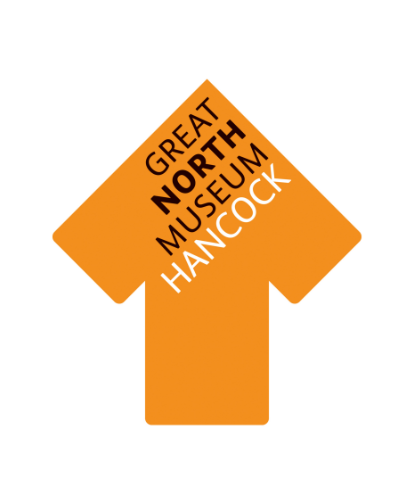

Circle the type of material that has survived the **best.**

**Earth Animal Plant**

Circle the type of material that has survived the **worst.**

**Earth Animal Plant**

What reasons do you think there are for this? Discuss your answers with your group.

|  |  |  |
| --- | --- | --- |
| Type of material | Tally of objects made from this material | Total |
| **Earth Materials:** stone, pottery, terracotta, clay, bronze, iron, gold, silver. |  |  |
| **Animal materials:** wool, cloth, ivory, leather, skin, bone. |  |  |
| **Plant materials:** linen cloth, wood, flowers, reeds. |  |  |

Objects are very important in helping us to understand Ancient Greece. Which objects survive over time depends on what material they are made from.

Walk around the Greek gallery and fill in the sheet below with the number of objects made from each material.

Work in a small group and collect evidence and ideas to complete this task. Follow each step and it will help you create your own Greek Myth.

Names:

My Greek Myth

Draw a picture of your mythical beast in this box.

Go to the Living Planet gallery. Find two animals that your mythical creature will be made up of.

Name of creature ……………………………………………….

Type of animals ………………………………………………….

…………………………………………………………………………..

What are its special powers? …………………………..

…………………………………………………………………………..

……………………………………………………………..................

Use this book to help you plan your own Greek myth.

2

**Mythical Creature**

**The Hero**

Will your hero meet a God on their travels? ..........................

Which God will your hero meet? ..................................................

……………………………………………………………….

Will the God give your hero any special objects or powers? .......................................................................................................

……………………………………………………………….…………………………………………………………………………………………………………………………………….

**Gods**

Each Greek myth had a hero or a villain. Create your own hero.

What is his/her name? …………………………..

What does your hero look like? ................

……………………………………………………………….

……………………………………………………………….

What is special about your hero? …………..

……………………………………………………………….……………………………………………………………….

3

What journey will your hero be on? .………………………………………………….

…………………………………………………………………………………………………………..

…………………………………………………………………………………………………………..

What has your hero been asked to do on the journey and how will they tackle this?…………………………………………………………………………………………………………………………………………………………………………………………………………………………………………………………………………………………………………………………

Will there be any difficulties on the journey? …………………………………………………………………………………………………………..

………………………………………………………………………………………………………….

…………………………………………………………………………………………………………..

How will your hero overcome them? ……………………………………………………………………………………………………………………………………………………………………………………………...

4

**Journey**

**Will your myth have….?**

What happens at the end of the myth? ....................................................................................................

………………………………………………………………………………………………….

………………………………………………………………………………………………….......................................................................................................

……………………………………………………………….

……………………………………………………………….

……………………………………………………………….

How will the battle be won or lost? ……......................................

……………………………………………………………….………………………………....……………………………….……………………………………………………………….……………………………………………………………….………………………………………………………………………………………………...………………………………

Will your story have a battle? If so write a little about it here ……………………………………………………………………………………………….

…………………………………………………………………………………………….……………………………………………………………………………………………….………………………………………………………………...................................

5

**Storyboard**

Use all the ideas you have collected in this booklet and put them together into a storyboard.

1

2

3

6

4

5

6

Your next mission is to tell your story to the rest of the group. Turn over the page.

7

As a team, plan how you will tell your story to the rest of the group.

If you need to make any notes about things you have found out today use this page.