**Museum Scavenger Hunt – Teachers’ 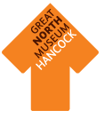Crib Sheet of Objects**

**Page 1**

1: Lioness (Sekhmet) Statue

2: Spider Crab

3: Hoplite helmet

4: Russian emerald and emerald turban brooch

5: Kiribati armour

6: *Tyrannosaurus rex*

7: Statue of Mithras

8: Owl

9: Bronze shield

**Page 2**

10: Rock art

11: Bakt en Hor mummy

12: Seal

13: Incorrectly posed wombat

14: Giraffe

15: Fossil trunks of tree-like club mosses (*Sigallaria*)

16: Great white shark model

17: Albatross (stuffed by John Hancock)

18: Porphyry foot

19: Bear cameo

20: Dolphin pottery fragment

21: Rothbury stone cross

**Museum Scavenger Hunt**

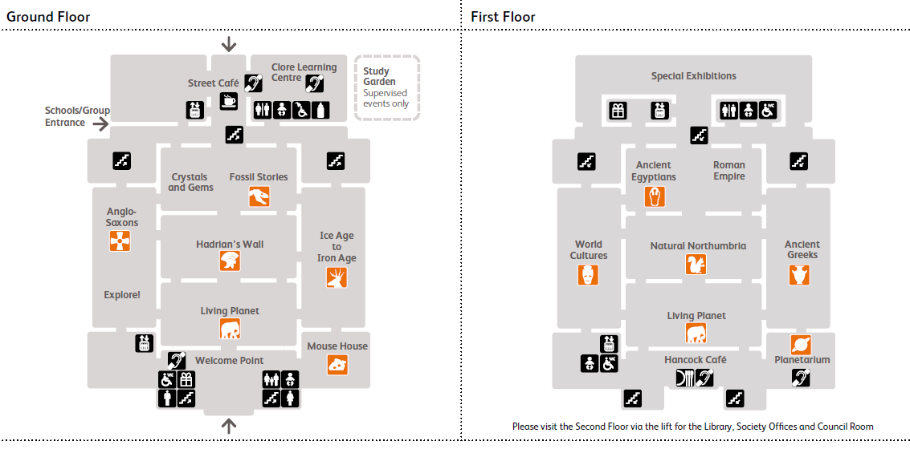

1

2

3

4

5

6

7

8

9

10

11

12

13

14

15

16

17

18

19

20

21

Can you find all of these objects around the museum? There is at least one in each galley and you don’t have to do them in order.

For an extra challenge, mark on the map where you have found them.

