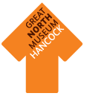
Rock Rainbows
Can you find a mineral in every colour of the rainbow? Write the name in the box next to the colour.
Red
Orange
Yellow
Green
Blue
Indigo
Violet

How about…..
Black
Silver
Gold
Clear
Crystals and Minerals
Draw your two favourite minerals from the crystals and mineral galleries. Remember to look carefully at the shape as well as the colour.

Rocks, Minerals and Shapes
Have a look in the North Pennine Orefield Case in the Crystals and Minerals gallery. Can you find these 3D shapes? When you have found them, name the shape, draw the object and write down what it is made of.
Look for number 4
This mineral is
_ _ _ _ _ _
This shape is a _ _ _ _

Look for number 12
This shape is a hexagonal
_ _ _ _ _
Look for number 20
This shape is a
_ _ _ _ _
Look for the big rock which is this shape:
This shape is a
_ _ _ _ _ _ _ _
These musket balls are made of
_ _ _ _
This mineral is
_ _ _ _ _ _
This rock is
_ _ _ _ _ _ _ _
_ _ _ _ _ _ _
Rocks, Minerals and Shapes
Now you have spotted the 3D shapes in the North Pennine Orefield Case, have a look at the rest of the minerals in the gallery and see what other 2D and 3D shapes you can spot. Draw your favourites and try to name the shapes you can see:
Shape: __________________
Shape: __________________
Shape: __________________
Shape: __________________

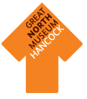
Minerals and Crystals
Treasure Hunt
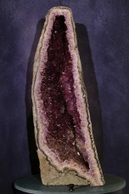  Amethyst | 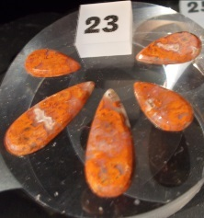  Carnelian | 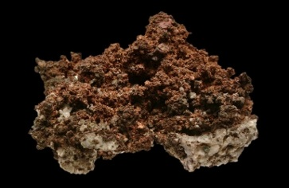  Copper
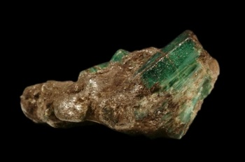  Emerald | 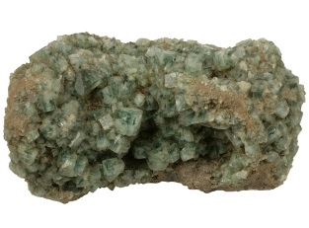  Fluorite | 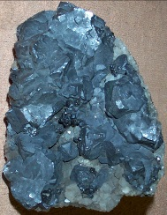  Galena (lead ore)
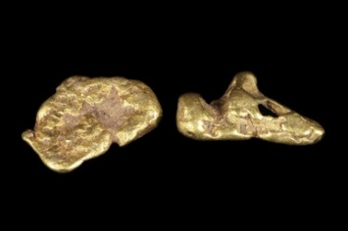  Gold | 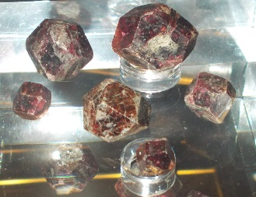  Garnet | 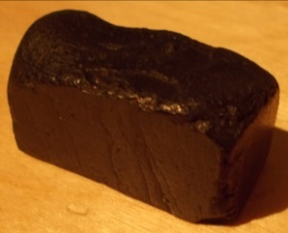  Jet
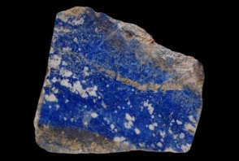  Lapis Lazuli | 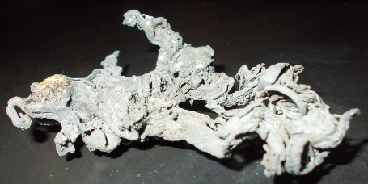  Silver | 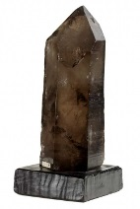  Quartz
Minerals and crystals are beautiful to look at and also useful. See if you can find these minerals which are displayed in the Crystals and Gems Gallery (hint: try looking for the names on the key lists by and in the cases). When you have spotted them all, have a look round the museum to find some ways in which people have used them.
Hadrian’s Wall

Jewellery — number 2, four rings

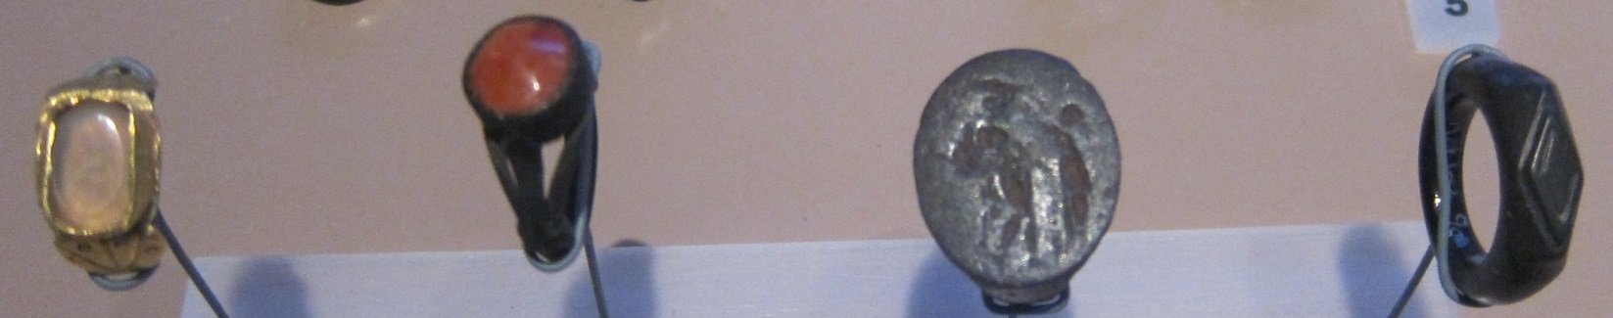

These are made with _ _ _ _, _ _ _ _ _ _, iron and _ _ _

Death and Burial on the Wall — number 2, coffin from Benwell
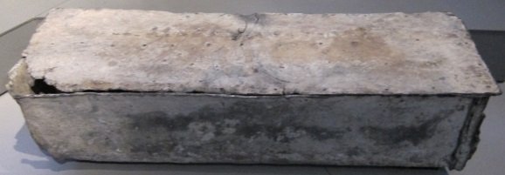
These is made out of _ _ _ _ which is made from its ore, _ _ _ _ _ _ (hint: look at the pictures on the first page to find the ore)

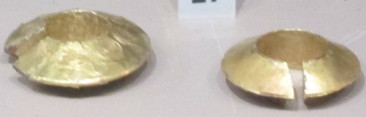
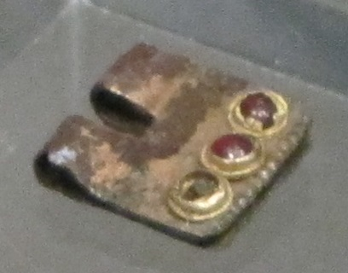
Death and Burial — number 27, two lock rings
These are made of _ _ _ _
Daily Life — number 18, buckle
The stones on this buckle are _ _ _ _ _ _ s
Anglo-Saxons
Ice Age to Iron Age
Ancient Egyptians
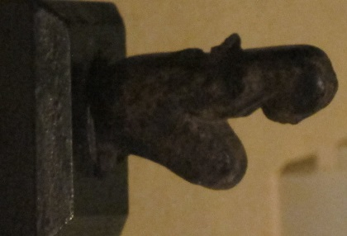
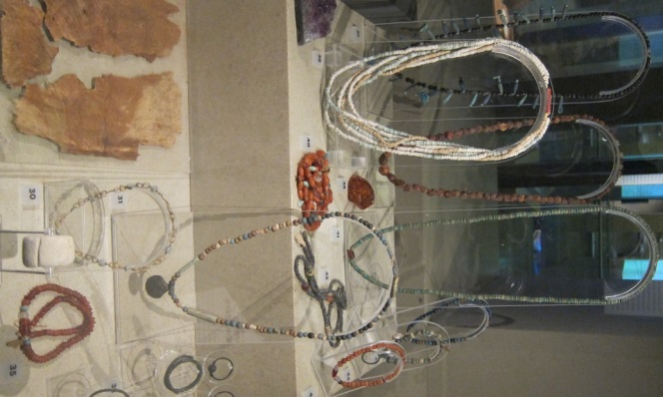
As you go around the museum, can you spot any more objects made from minerals which you have seen in the Crystals and Gems Gallery? Try looking out for pigments (colours) made from minerals – you can find some in the Ancient Egyptians gallery, along with the minerals they are made from and the palette used to grind them.
Foreign Encounters/ Arming the Nation — number 9, figurine
This is made of _ _ _ _ _ _ _ _ _ _ _
This is made of...…………………………………………..………….
Nile Style/ Looking Good — numbers 35 — 45
Some of these beads are made of shell, but some are
_ _ _ _ _ _ _ _ or _ _ _ _ _ _ _ _ _
Nile Style/ Looking Good — number 30, necklace
This is made of _ _ _ _
It also has unpolished green stones in it. Can you guess what mineral they are? _ _ _ _ _ _ _
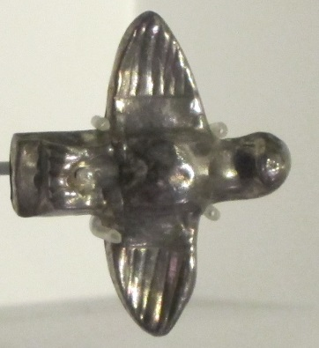
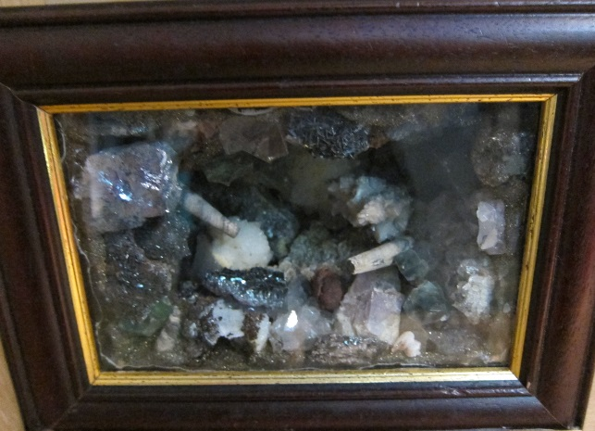
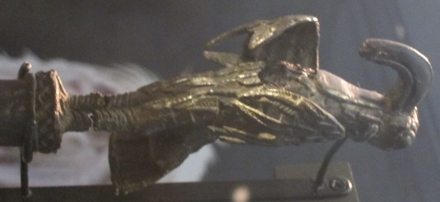
Natural Northumbria
Uplands Hide — spar box
The miners of the North Pennines were looking for lead ore, but found lots of beautiful minerals from which they made spar boxes like this. It is made using _ _ _ _ _ _,
_ _ _ _ _ _ _ _ and _ _ _ _ _ _
Ancient Greeks (Shefton Gallery)
Gifts for the Gods — number 49, hawk
This is made of _ _ _ _ _ _
World Cultures
State Authority — number 1, king’s staff from Nigeria
This is made of _ _ _ _ _ _

