**Dead, alive or never alive?**

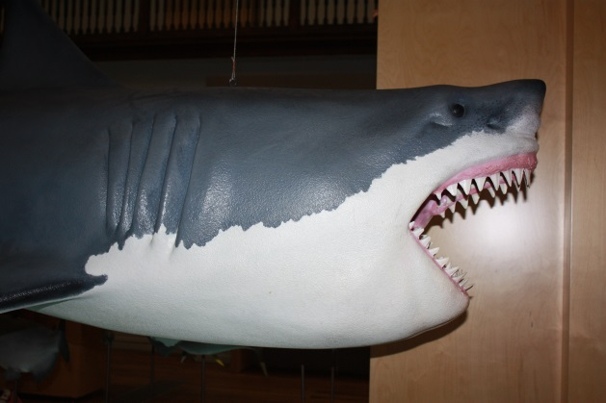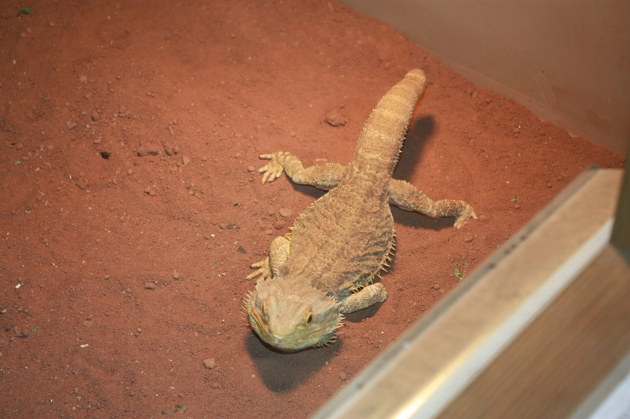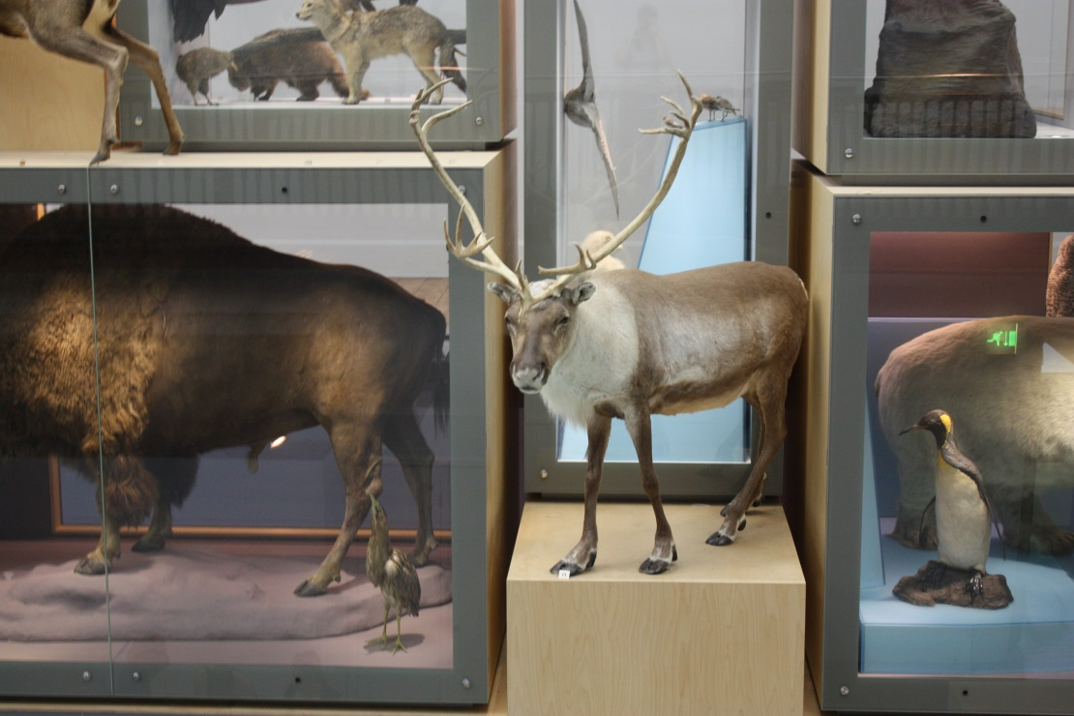Find these things in the Living Planet gallery. Have a good look at the real thing. Is it alive, is it dead or was it never alive at all? Join the picture to the correct box when you have made up your mind.

**Dead or Alive?**

Never Alive

Alive

Dead

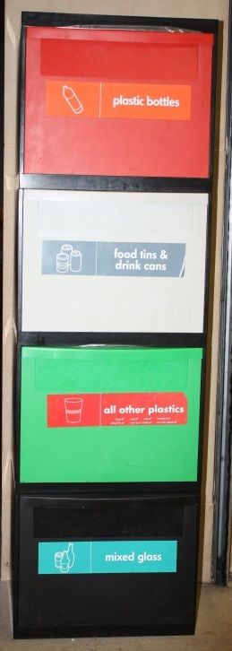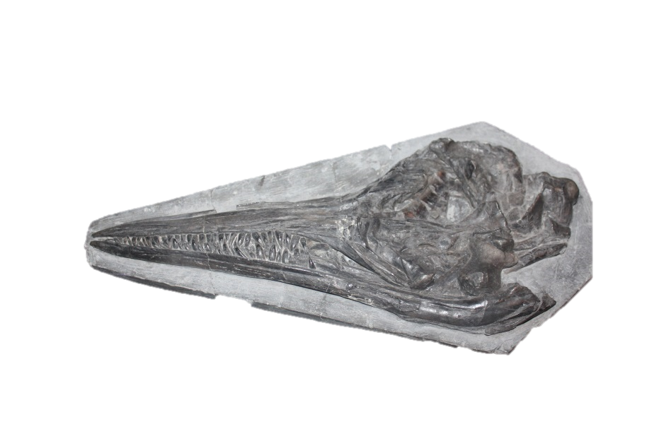Find these things in the Fossil Stories gallery. Decide if each one is alive, dead, was never alive or is a fossil. Join the picture to the right box.

Alive

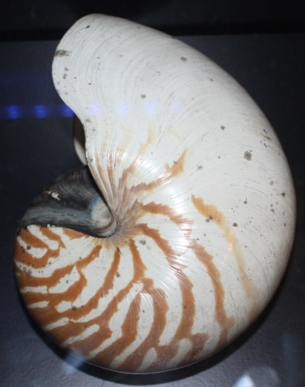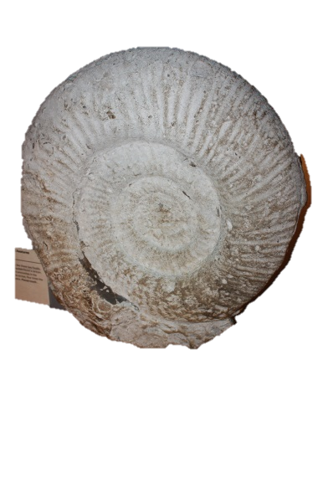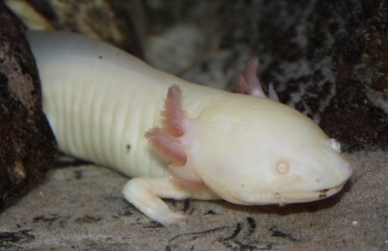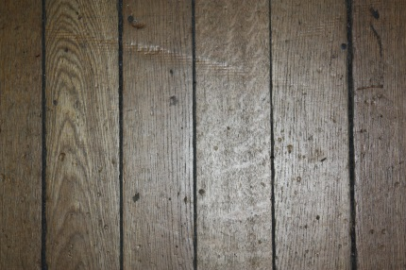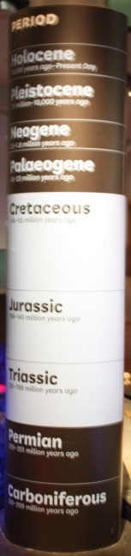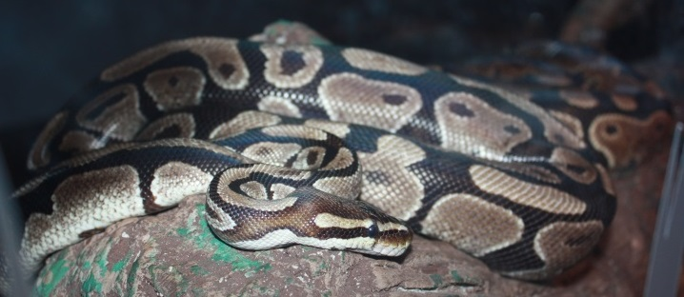

Dead

Never Alive

Fossil