Habitats and Adaptation

Welcome to the living planet.

This gallery displays a variety of animals from all over the world.

Animals live in lots of different environments and each has adapted to live in a particular habitat. All of the different adaptations that have evolved during the history of life on Earth are the reason we have such a rich diversity of species on this planet.

Adapting to an environment is not just about dealing with the landscape and weather conditions in a particular habitat, but an animal must also compete with other animals for food, shelter and mating opportunities. It must also be able to defend itself against predators. Natural selection will force a species to adapt to all of these factors if it is to survive.

Explore the Living Planet gallery (upstairs and downstairs and with the aid of the touchscreens) to help you complete the following worksheet.
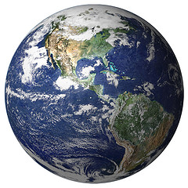

Match the following habitats to the statements below.

Desert Tropical Temperate Polar

This habitat supports the greatest diversity of plants
and animals anywhere in the world:

This habitat supports most of the world’s human population:

This habitat has the greatest daily temperature range anywhere in the world and can experience fiercely hot days and bitterly cold nights:

This habitat experiences 24 hour sunshine in the summer and 24 hour darkness in the winter:

Habitats and Adaptation

Certain physical features can help an animal to survive in its environment.

Q - How is the giraffe’s long neck an advantage in its habitat?

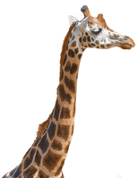

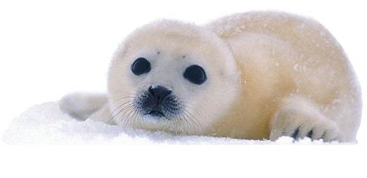
List two physical features which can protect animals
living in the polar regions from hunger and cold

To survive in the desert, the relatively few animals and plants that live there must be very good at conserving water.

List two strategies which animals use for conserving water in drylands

In the struggle for survival many animals must avoid being predated (eaten by predators) Prey animals have a range of defensive techniques to avoid being eaten.

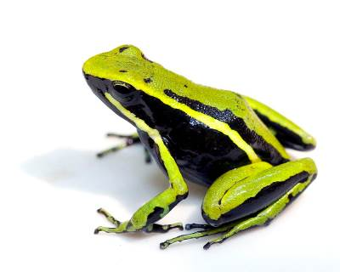
List three ways in which tropical animals defend themselves from predators

Habitats and Adaptation

As well as having physical adaptations, animals must also adapt their behaviour to survive in their particular habitat.

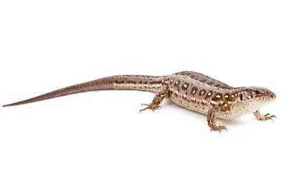
List 2 ways in which animals in the desert avoid the fierce heat

Animals in the temperate zones can face different challenges all year round as the weather changes with the seasons.

List 3 strategies that animals in the temperate zones use to survive as the cold weather and short days of winter approach

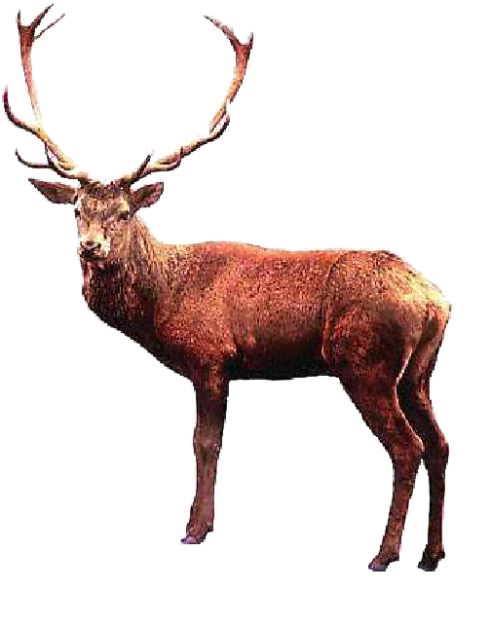
Can you find the 2 red deer in the gallery? Over time, evolution has endowed the males of this species with large antlers which they use to fight each other to compete for mates in a competition called the ‘rut’.

Find an example from each zone of the Living Planet gallery of an animal and how it competes for mates:

Desert:

Tropical:

Temperate:

Polar:
Habitats and Adaptation

Choose an animal from within the gallery. Describe how it is well adapted to its environment. Thinking about both the animal’s body and its behaviour, write down as many adaptations as you can. Use the touch screens and the information on the cases to help your research, along with any other information you may already have about the animal.

Using the space below, sketch the animal that you have just described.
Add labels with arrows pointing to any physical adaptations that you have discussed above.

