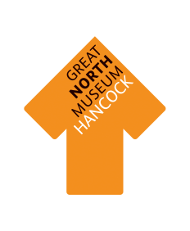
Food Chains in NE England—
Natural Northumbria Gallery

Work in groups to make food chains for wildlife in different places around the region. There is an unnamed diagram so you can look at other sites around the gallery too.

- Use the information in the cases around the Natural Northumbria gallery to help you find out which animals eat what. and make your food chains.

- You could make lots of different food chains for each place—there isn’t just one answer!

- You may find you don’t need all the links on the chains—or that you need to draw on more of your own!

When you have made all your food chains, get back together to talk about the following questions:

- Can you identify producers and consumers on your food chain?

- Which animals on your food chain are predators and which are prey?

- What is the top predator in your environment—the deadliest animal?

- If more than one group has made a food chain for the same site, do they look the same?

- What is similar and different about food chains from different habitats?

- What would happen if you took out one link of the chain—for example if the species in the second box developed a disease and died out?

Food Chain—
Cockle Park Farm

Food Chain—
Gosforth Park Nature Reserve

Food Chain—
Farne Islands

Food Chain—
Upper Teesdale

Food Chain –
Kielder Forest

Food Chain—
Alston Moor

Food Chain

