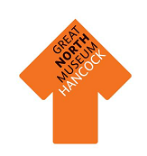Classification
To help us to understand the different kinds of animal, scientists divide them into groups.
Join the type of animal to the right description

Reptiles | Have feathers  Have wings and 2 legs  Lay eggs  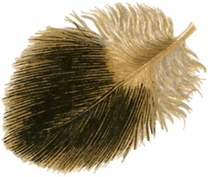  Warm blooded
Amphibians | Live in water  Breathe with gills  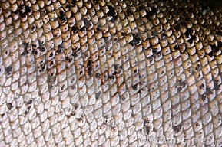  Have no arms, legs, fingers or toes
Birds | 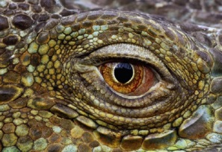  Have scales not fur or feathers  Cold blooded  Most lay eggs
Fish | 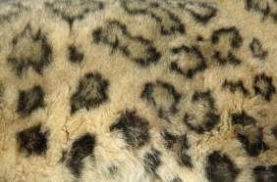  Warm blooded  Have hair or fur  Feed their young with milk
Mammals | Cold blooded  Have four legs  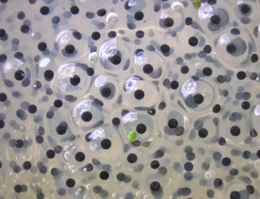  Lay eggs in water
Now you have thought about what different animals are like, can you find each type of creature in the Living Planet gallery? Write its name and draw a picture of it.

This is a ______________________________ . It is a type of reptile

This is a ______________________________ . It is a type of amphibian

This is a ______________________________ . It is a type of bird

This is a ______________________________ . It is a type of fish

This is a ______________________________ . It is a type of mammal
What do different animals eat?
One of these animals eats meat, the other eats plants. Which do you think is which?
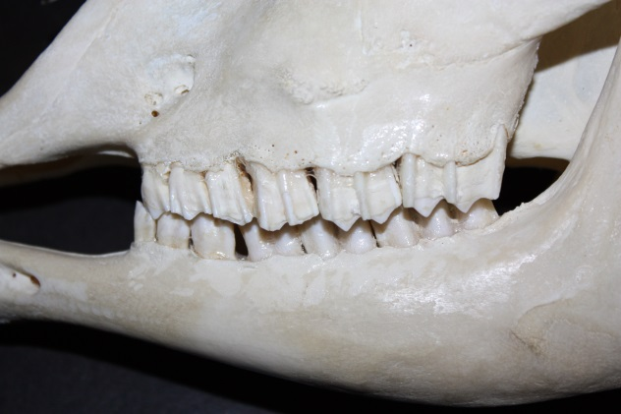
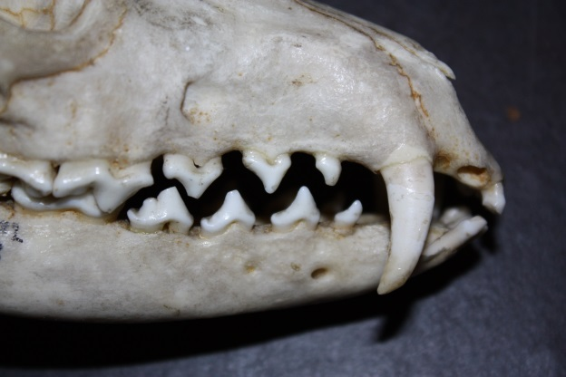

This animal eats
__________________
This animal eats
__________________

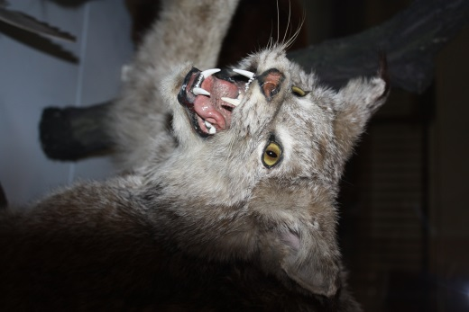
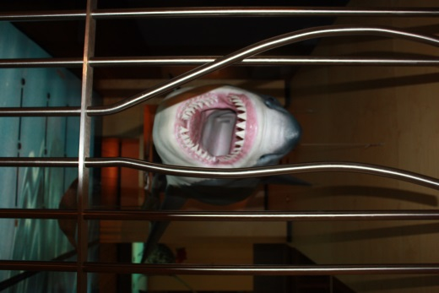
Can you find these meat eaters around the museum? They are in the Fossil Stories gallery and the Living Planet gallery. Tick the box when you find each one. Keep a look out for other animals showing their teeth as you go round and see if you can work out what they eat.
