

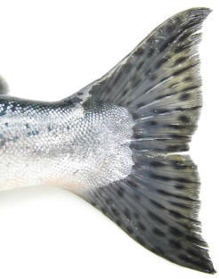

Something with a tail

Something bigger than you

Something pink

Something that scares you!



Something spotty

Something

beginning

with

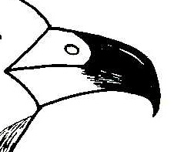

Something with a beak

Something that lives somewhere cold

**Can you find?**

Can you find these things in the

Living Planet gallery?

A baby animal

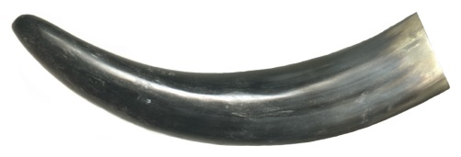

Something with horns



**Best Beast!**

Find your favourite animal in the Living Planet gallery and draw its picture. Where does it live?_______________________________



An animal with tail

How does this

animal move?

______________________________________



A bat

Where do you think bats live?

_______________________



Explore the Natural Northumbria Gallery on the first floor and see how many of these animals you can find.

When you find an animal that fits the description, tick the box.

If you want more of a challenge, answer the questions too.

**Can you find?**

An animal with webbed feet

How does this animal move?

_____________________



An animal that lives in water

What is it called?

_______________

MCj03978100000[1]

An animal with big ears

This animal must have a good sense of

_ _ _ _ _ _ _

An animal beginning with

What colour is the

animal?

______________

An animal with 6 legs

What is special about this animal?

____________________________________

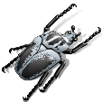

An animal with spikes

Why do you think it has spikes?

________________________________________

A bird with a large, sharp beak

What do you think this animal eats?

_____________________________

MCj01503510000[1]



**Great North East Beast**

Draw a picture of your favourite animal that can be found locally - in your garden, the park or on a walk in the countryside.

**Classification**

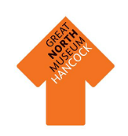

To help us to understand the different kinds of animal, scientists divide them into groups.

Join the type of animal to the right description

|  |  |
| --- | --- |
| Reptiles | Have feathers  Have wings and 2 legs  Lay eggs  http://thegraphicsfairy.com/wp-content/uploads/2013/08/Free-Feather-Illustration-GraphicsFairy.jpgWarm blooded |
|  |  |
| Amphibians | Live in water  Breathe with gills  http://thumbs.dreamstime.com/x/macro-fish-skin-11391033.jpgHave no arms, legs, fingers or toes |
|  |  |
| Birds | http://static.desktopnexus.com/thumbnails/452257-bigthumbnail.jpgHave scales not fur or feathers  Cold blooded  Most lay eggs |
|  |  |
| Fish | http://designyoutrust.com/wp-content/uploads/2012/10/7.free-fur-textures.jpgWarm blooded  Have hair or fur  Feed their young with milk |
|  |  |
| Mammals | Cold blooded  Have four legs  http://upload.wikimedia.org/wikipedia/commons/7/7d/Frogspawn_closeup.jpgLay eggs in water |



Now you have thought about what different animals are like, can you find each type of creature in the Living Planet gallery? Write its name and draw a picture of it.

This is a ______________________________ . It is a type of reptile



This is a ______________________________ . It is a type of amphibian



This is a ______________________________ . It is a type of bird



This is a ______________________________ . It is a type of fish



This is a ______________________________ . It is a type of mammal

What do different animals eat?



One of these animals eats **meat**, the other eats **plants**. Which do you think is which?

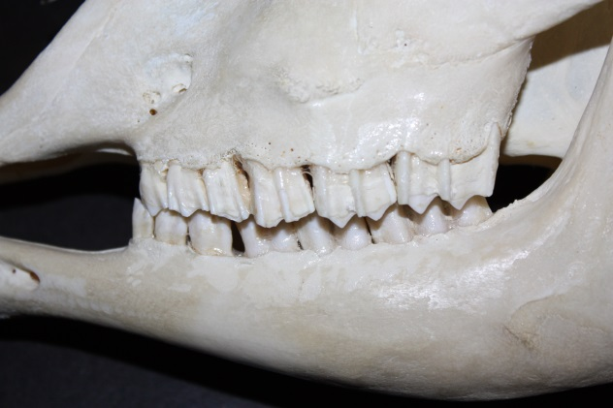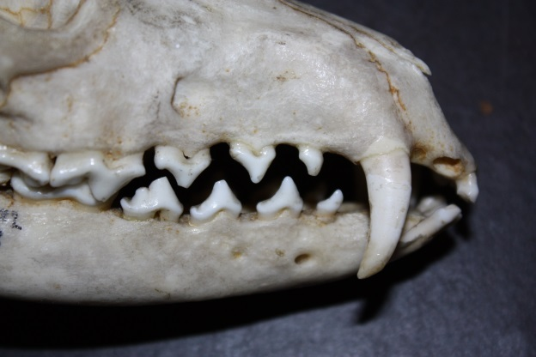

This animal eats

__________________

This animal eats

__________________

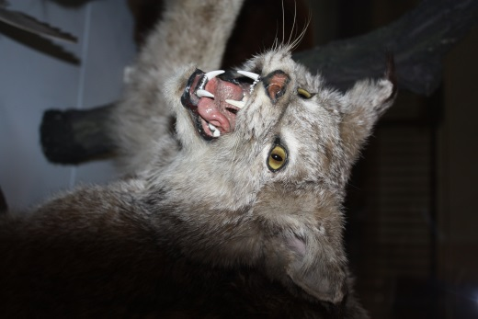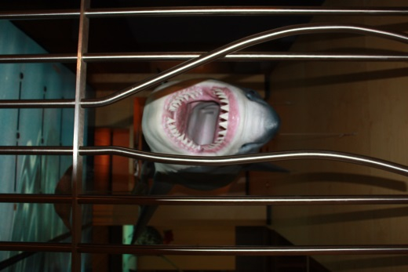Can you find these meat eaters around the museum? They are in the Fossil Stories gallery and the Living Planet gallery. Tick the box when you find each one. Keep a look out for other animals showing their teeth as you go round and see if you can work out what they eat.

