Anglo Saxons

Gallery resources and activities

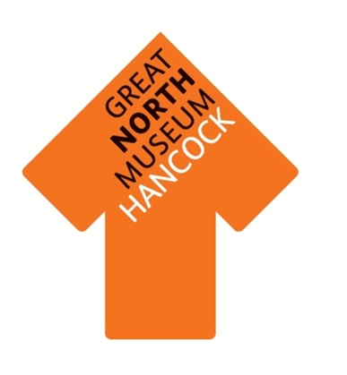
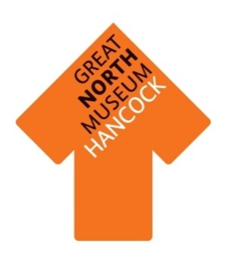
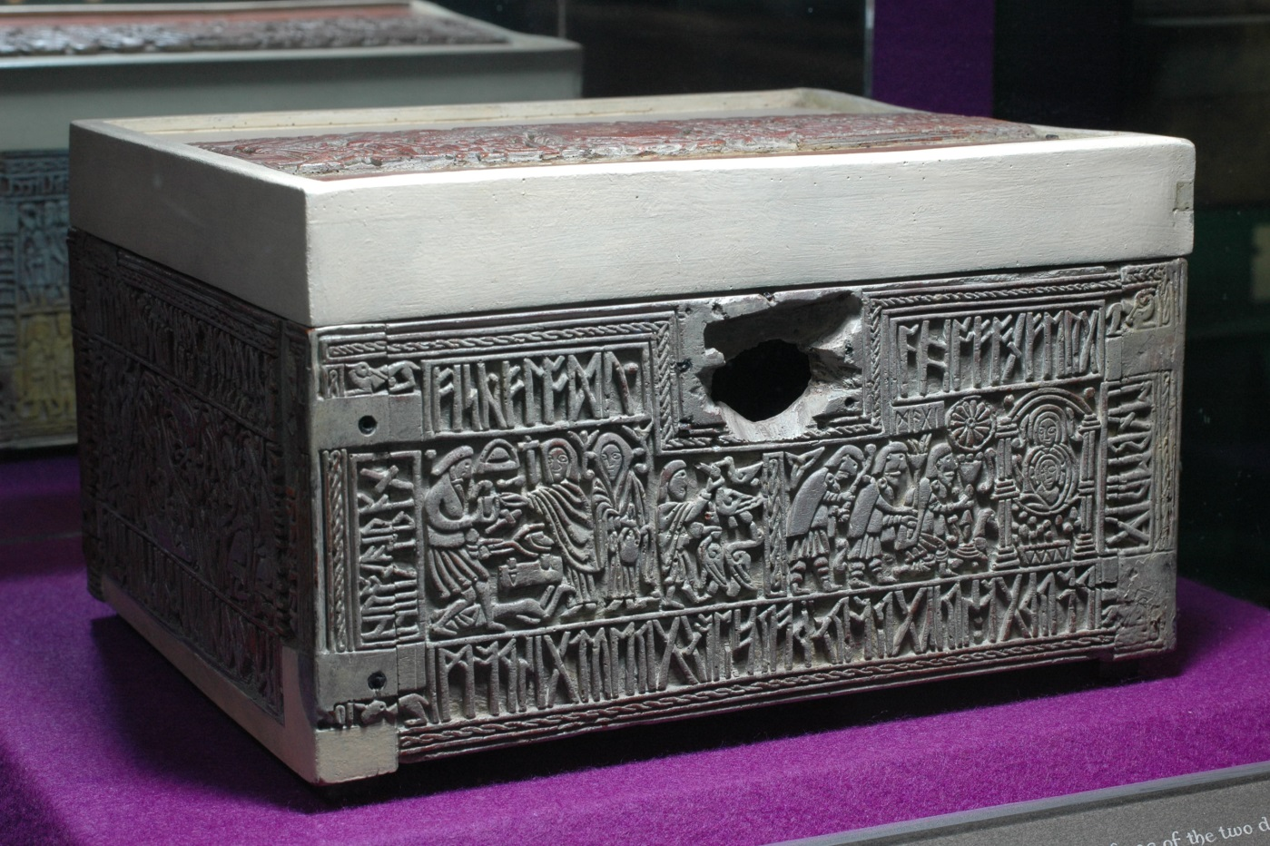
This whalebone box was probably carved in Northumbria at the same time as the Lindisfarne Gospels were being produced. It is carved with a variety of scenes including the three kings visiting the infant Jesus, as well as Romulus and Remus being suckled by a she wolf.

What other images can you see on the casket?
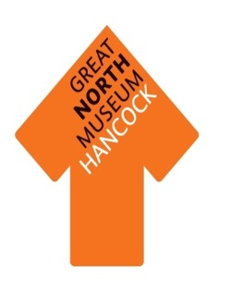
Can you find these Anglo Saxon belt buckles?

What material has been used to make them?

What other materials can you find in the display case?

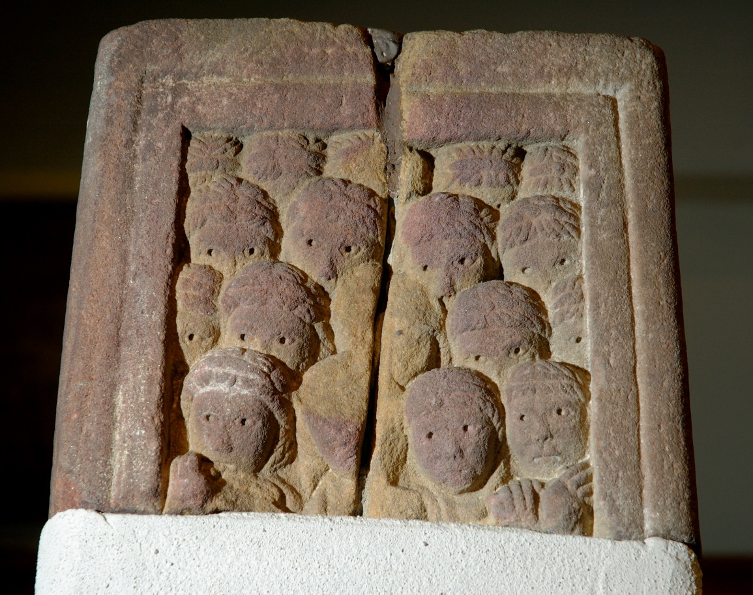
Can you find this object which was part of the Rothbury Cross? Originally it would have been over four metres high.
Look at the faces carved into the stone, what expressions can you see?

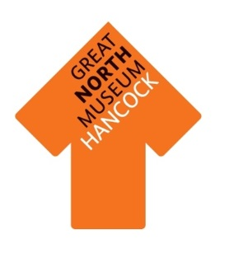
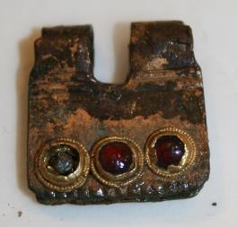

Can you find this very small object on display?

It is made from bronze and is decorated with garnet stones set in gold foil. Can you find out what it would have been used for?

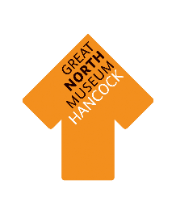
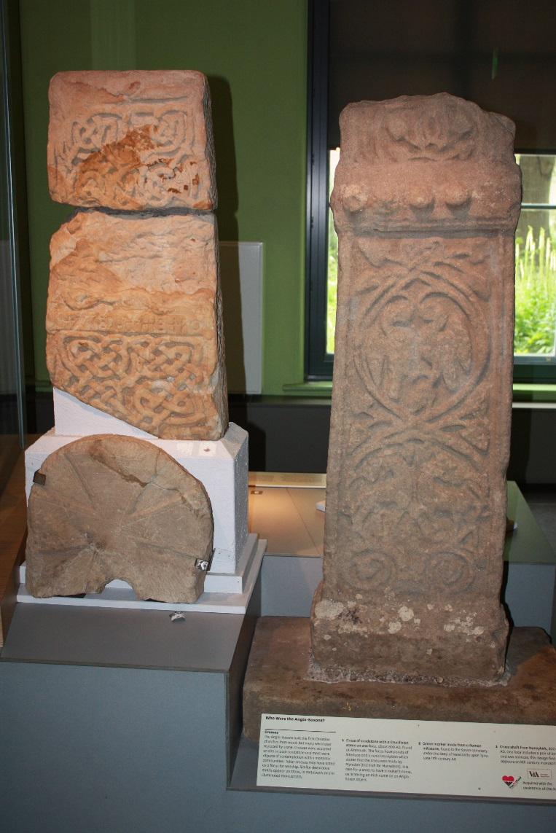
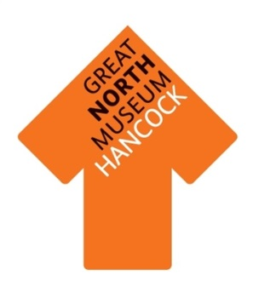
The Anglo Saxons used sandstone to build many of their monuments. Can you find this object and see what patterns and animals have been carved on it?

Archaeological Evidence
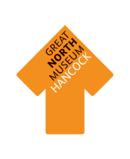
Objects are very important in helping us to understand Anglo Saxon Britain. Which objects survive over time depends on what material they are made from.
Walk around the Anglo Saxon gallery and fill in the sheet below with the number of objects made from each material.
Type of material | Tally of objects made from this material | Total
Earth Materials: stone, pottery, terracotta, clay, bronze, iron, gold, silver.
Animal materials: wool, cloth, ivory, leather, skin, bone.
Plant materials: linen cloth, wood, flowers, reeds.

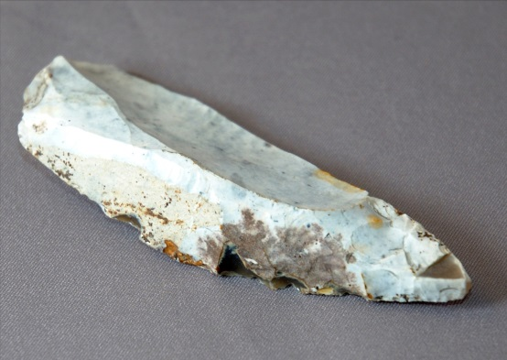
Circle the type of material that has survived the best.
Earth Animal Plant

Circle the type of material that has survived the worst.
Earth Animal Plant

What reasons do you think there are for this? Discuss your answers with your group.

Animals and Art of the Lindisfarne Gospels
The Lindisfarne Gospels, one of the most magnificent manuscripts of the early Middle Ages, was written and decorated at the end of the 7th century by the monk Eadfrith, who became Bishop of Lindisfarne in 698 and died in 721. Lindisfarne Priory was situated on Holy Island, a major religious community on the Northumberland coast that housed the shrine of St Cuthbert, who died in 687. The Lindisfarne Gospels is now on display in the British Library in London.

It is the year 700 AD.
You live in the monastery on the island of Lindisfarne. You are learning to be an artist and scribe. You are an assistant to Eadfrith, Bishop of Lindisfarne, during the writing of the Lindisfarne Gospels. Different kinds of animals adorn the pages of the Gospels.

Eadfrith says:
‘Go and find these birds, animals and fish which live near Lindisfarne. Once you have done that choose one and draw it to give me an idea for my designs, but don’t come back until you have found them all.’

Can you find a cormorant in the Natural Northumbria gallery?
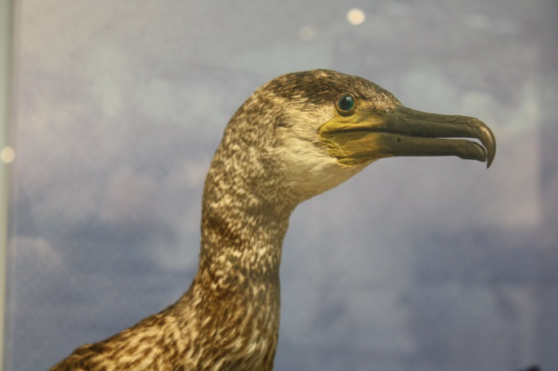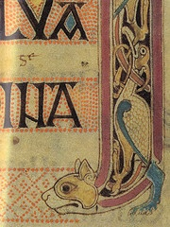

Cormorants are coastal birds. They are supreme hunters that enjoy dining on fish and small eels. What features to they have that will help them catch their prey?

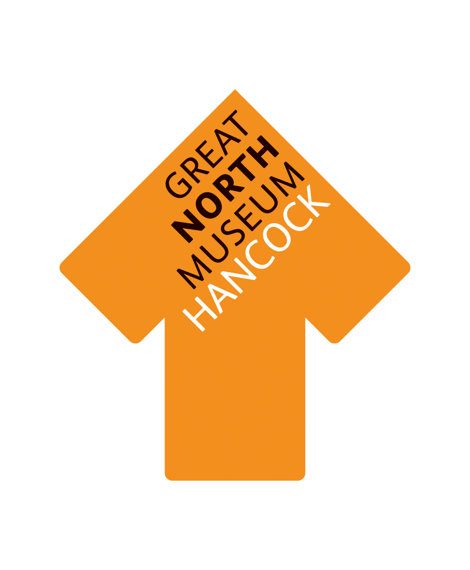

Can you find an eider duck in the Natural Northumbria gallery?

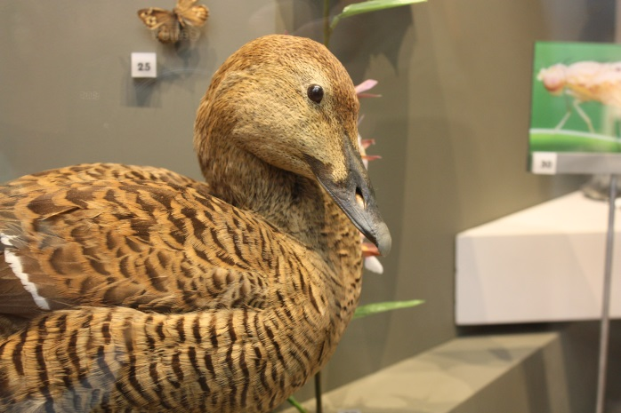

The eider duck is the heaviest and fastest flying duck in the UK. They generally live along coastlines, including the grassy shores of Lindisfarne. Can you see the male and female eiders? How do they look different?

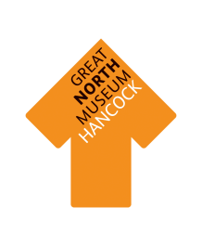
Can you find a peregrine falcon in the Natural Northumbria gallery?

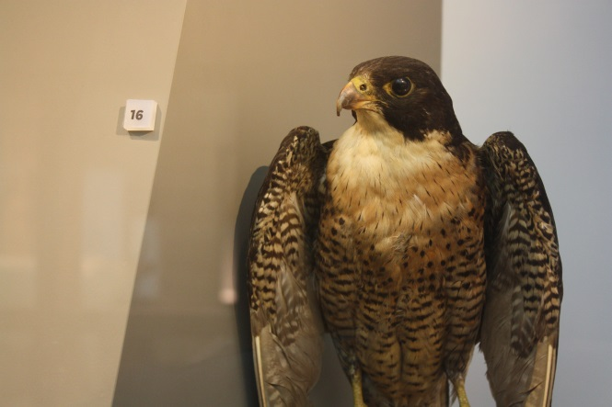

The peregrine is a large and powerful falcon. They survive on a diet of smaller birds including pigeons, small ducks and wading birds. What features do they have that will help them catch their prey?

Can you find an adder in the Natural Northumbria gallery?

The adder is the only venomous snake native to Britain. They prey mainly on rodents, lizards and frogs in woodlands and open countryside. Do you think they would be easy to spot in these places?

Can you find this wild cat in the Living Planet gallery?

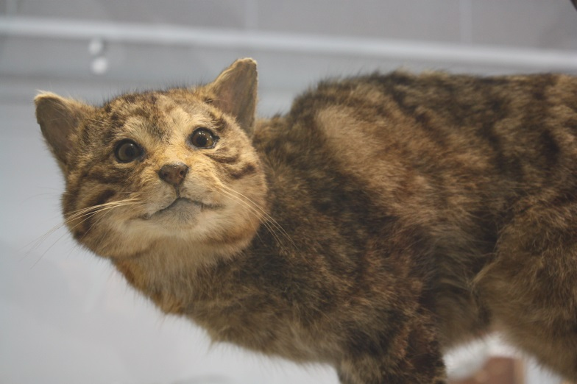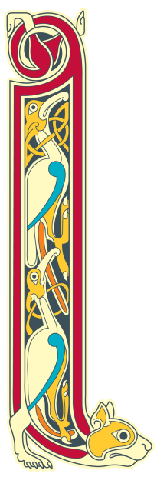

Wild cats are extremely rare in Britain and are at serious risk of extinction. They survive on a diet of rabbits, small mammals and game birds, hunting mainly at night. Can you find any other big cats in the Living Planet gallery that are at risk?

Can you find the Chillingham cow in the Natural Northumbria gallery?

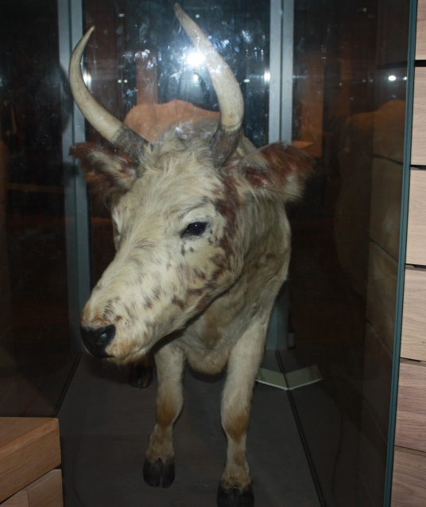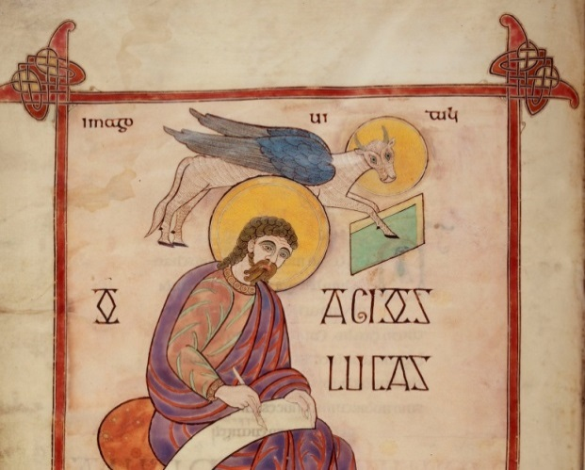

Chillingham cows still live in Northumberland though there are less than 100 living in the wild. Anglo Saxons would rear cattle on farms, which parts of the animal would they find useful?

