Cracking the Code activity instructions

Task 1
We would recommend that younger children work in small groups with an adult while older children may want to work in pairs.
Using the hieroglyph alphabet sheets translate the five codes and write the messages down on the sheet provided (some letters have the same or very similar symbols so be careful!) There is one alphabet sheet per coded message so place it where all the children can see it.
You don’t need to do the messages in order but we would recommend writing the message for ‘code 4’ in the space where it says ‘code 4 message’.
When you are finished ask an adult to check the answers for you from the ‘answers’ folder.

Task 2
You may have discovered that each message is a question. You may already know some of the answers but if not then explore the Egyptian gallery to find out the answers. We would recommend writing the answers in English rather than hieroglyphs.
When you are finished ask an adult to check the answers for you from the ‘answers’ folder.

Task 3
If you have any spare paper or a sketchbook then why not write a question or message in hieroglyphs and get a friend to decode it?

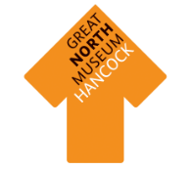
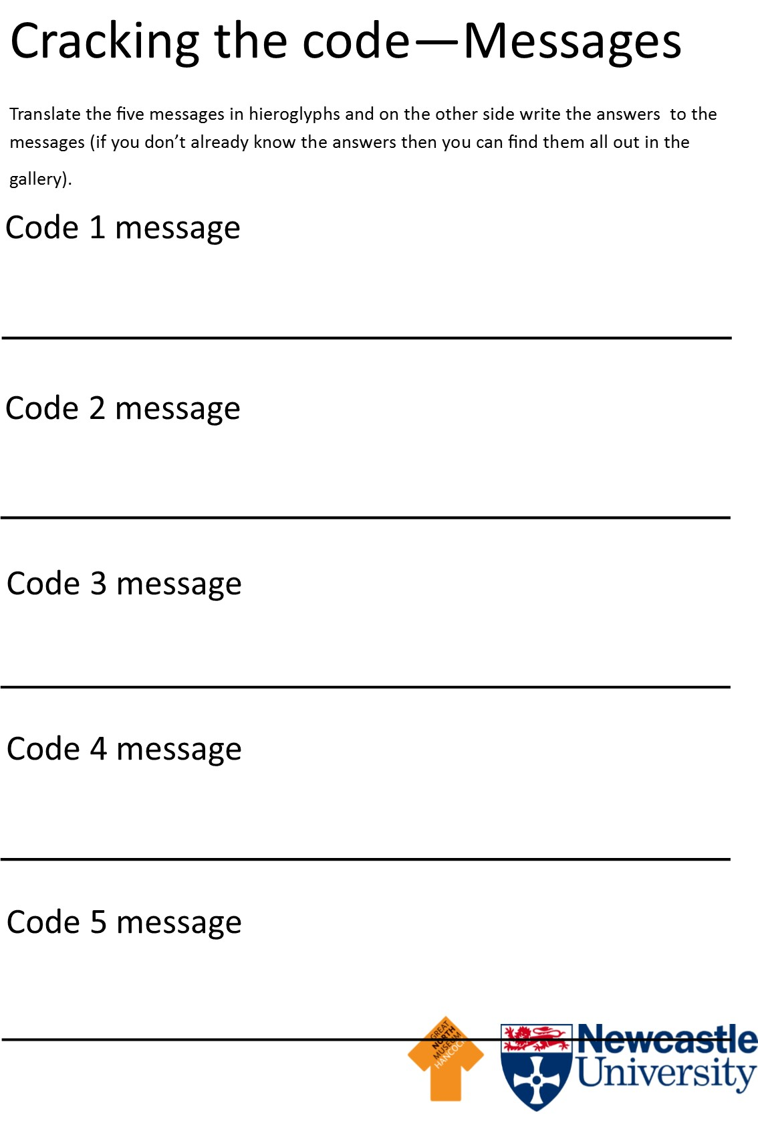
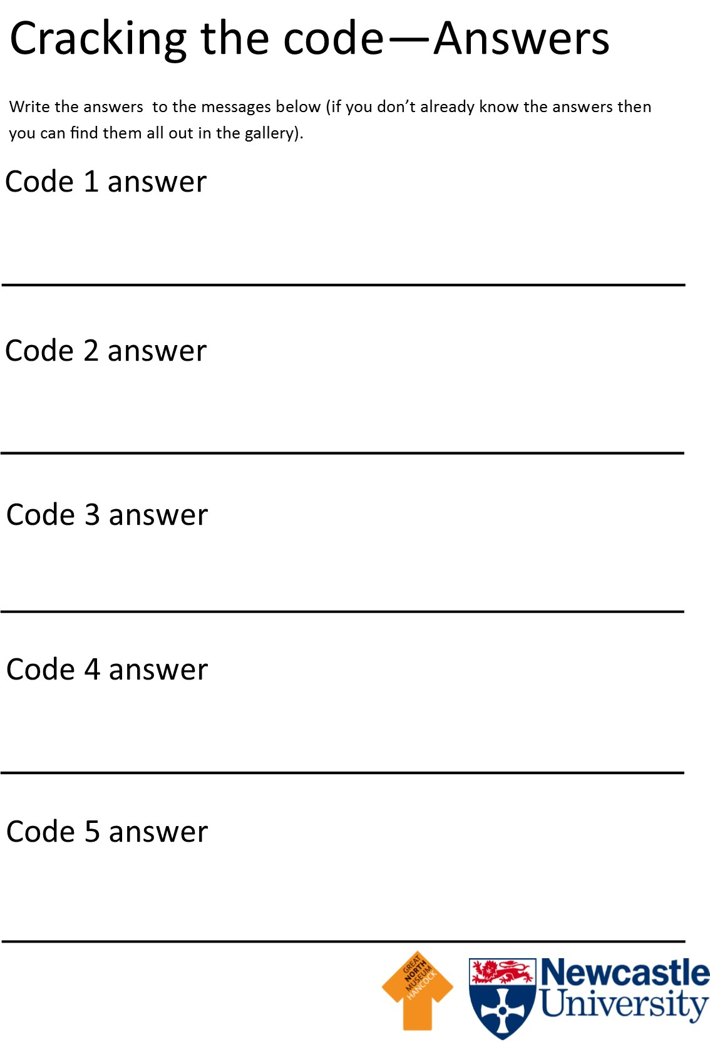

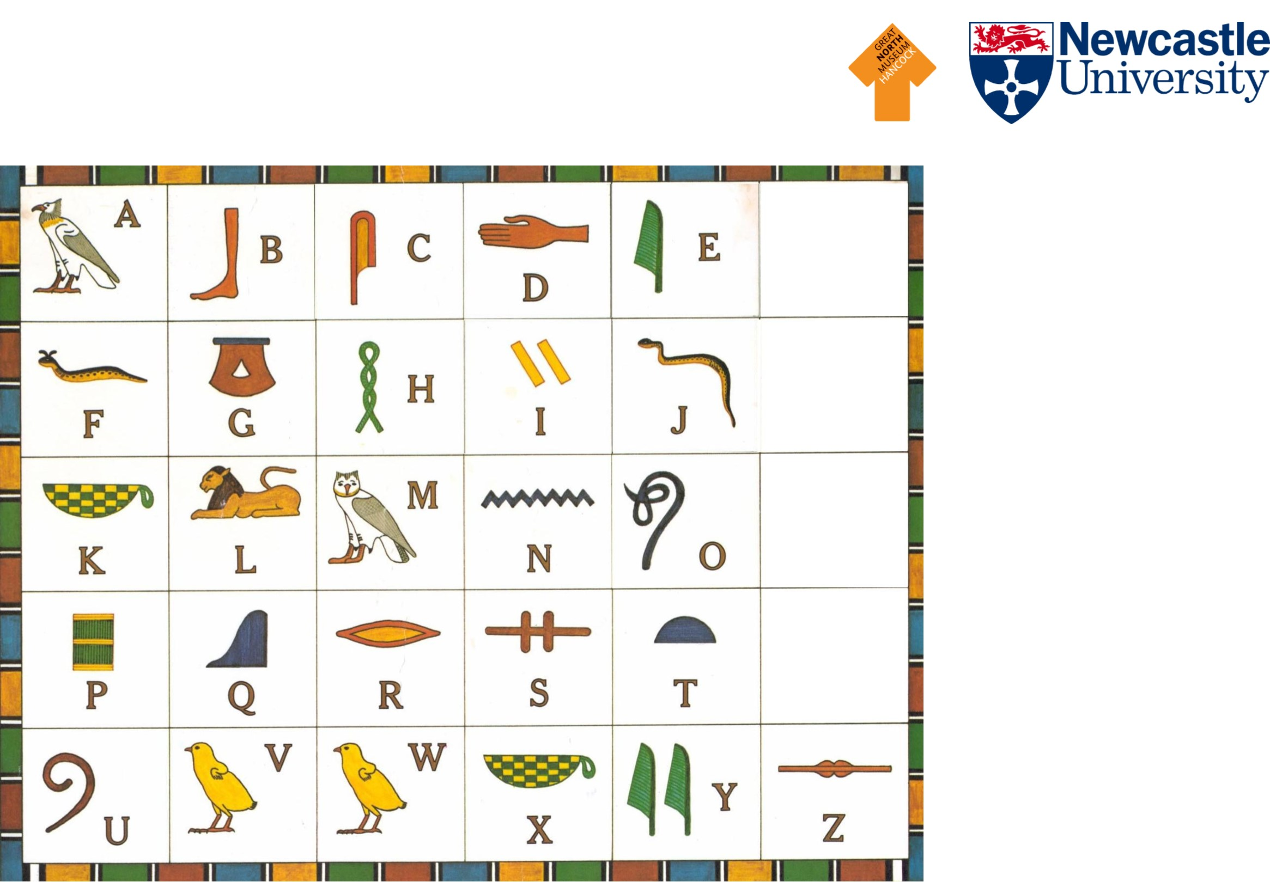
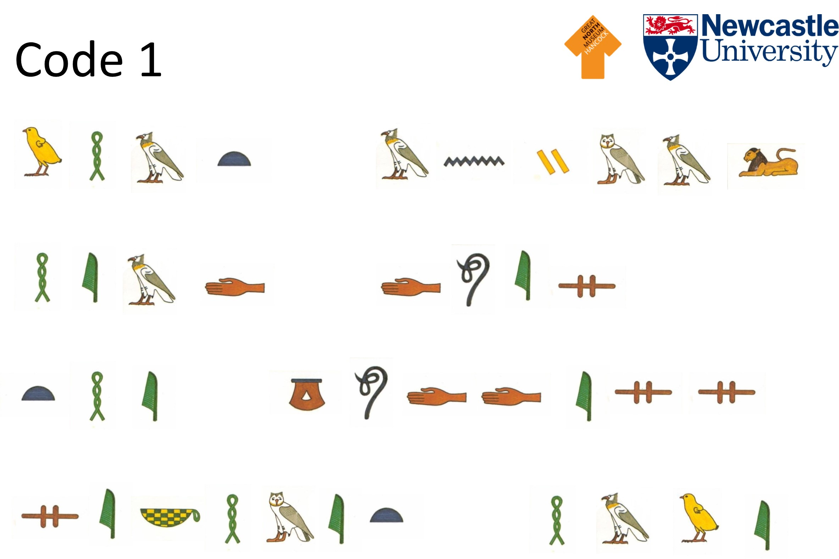
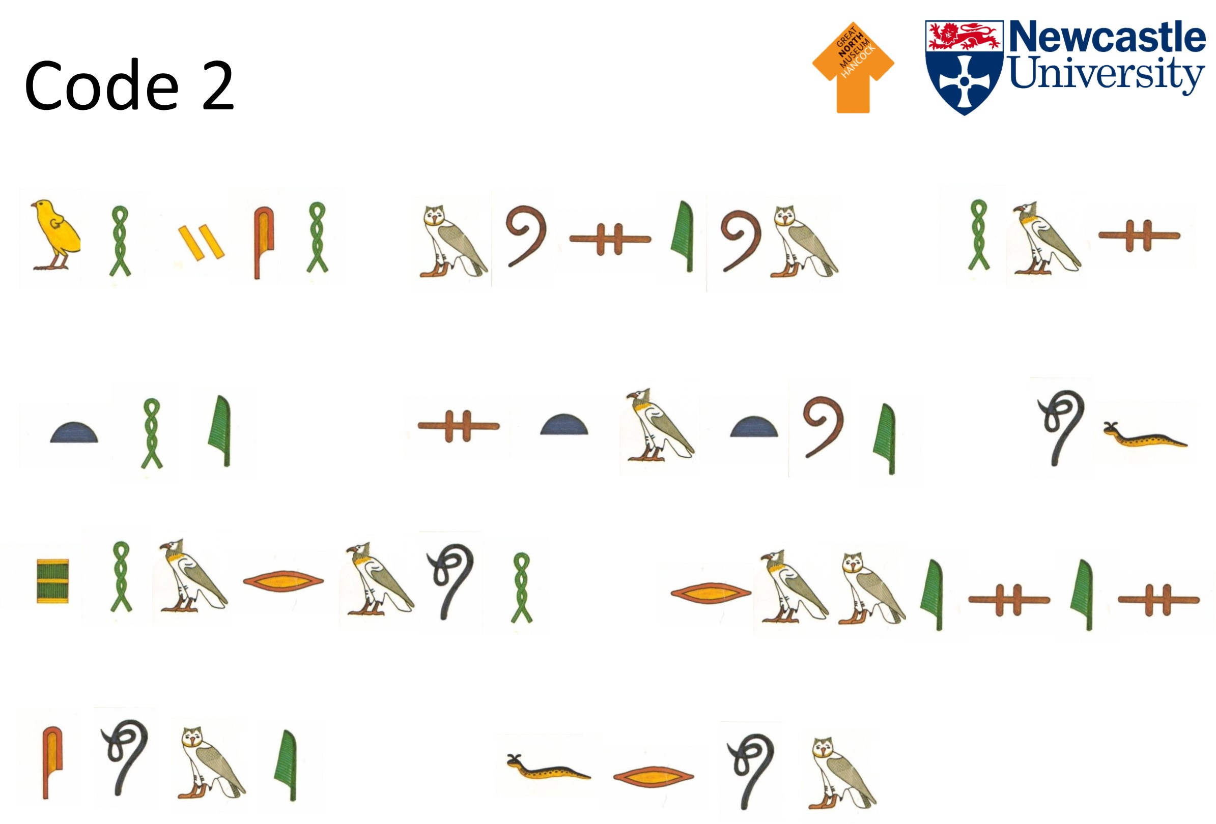
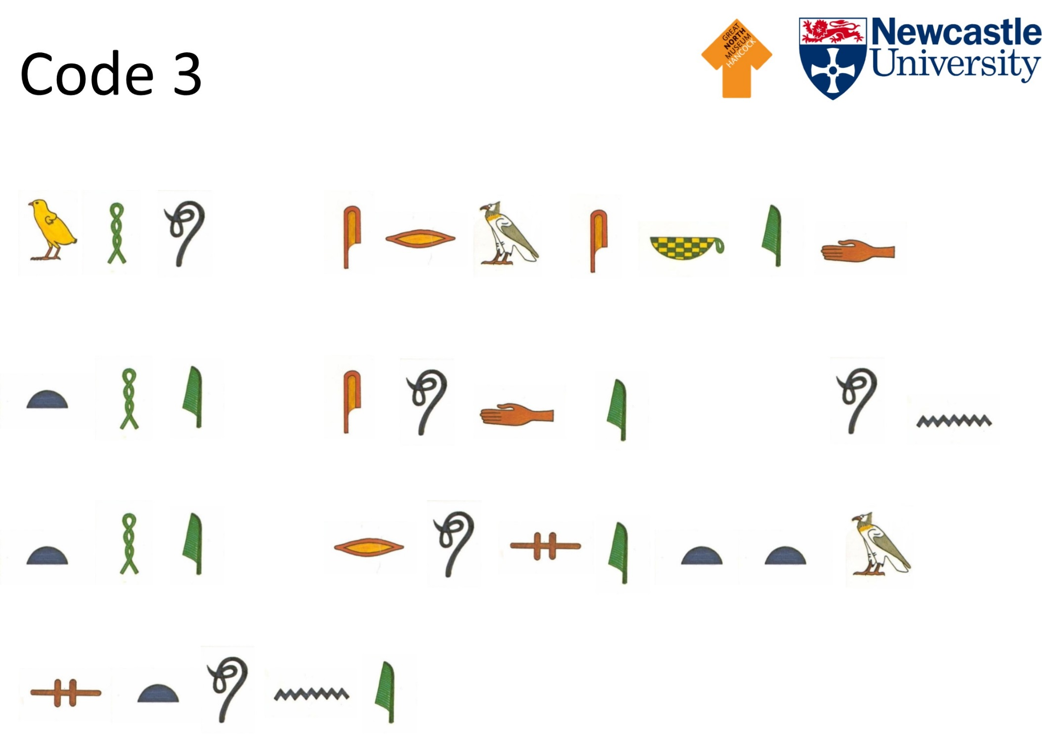
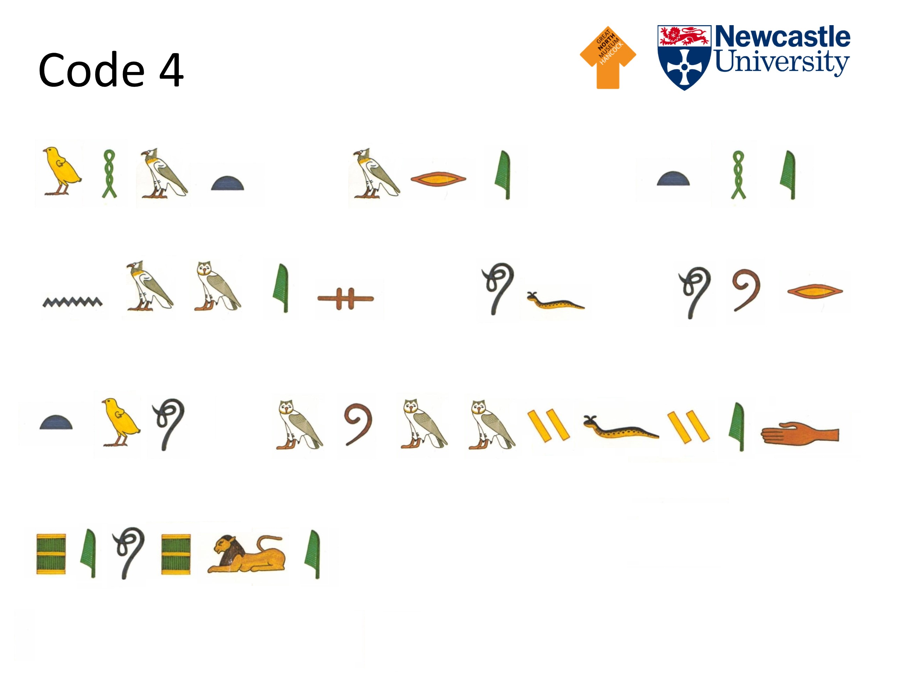
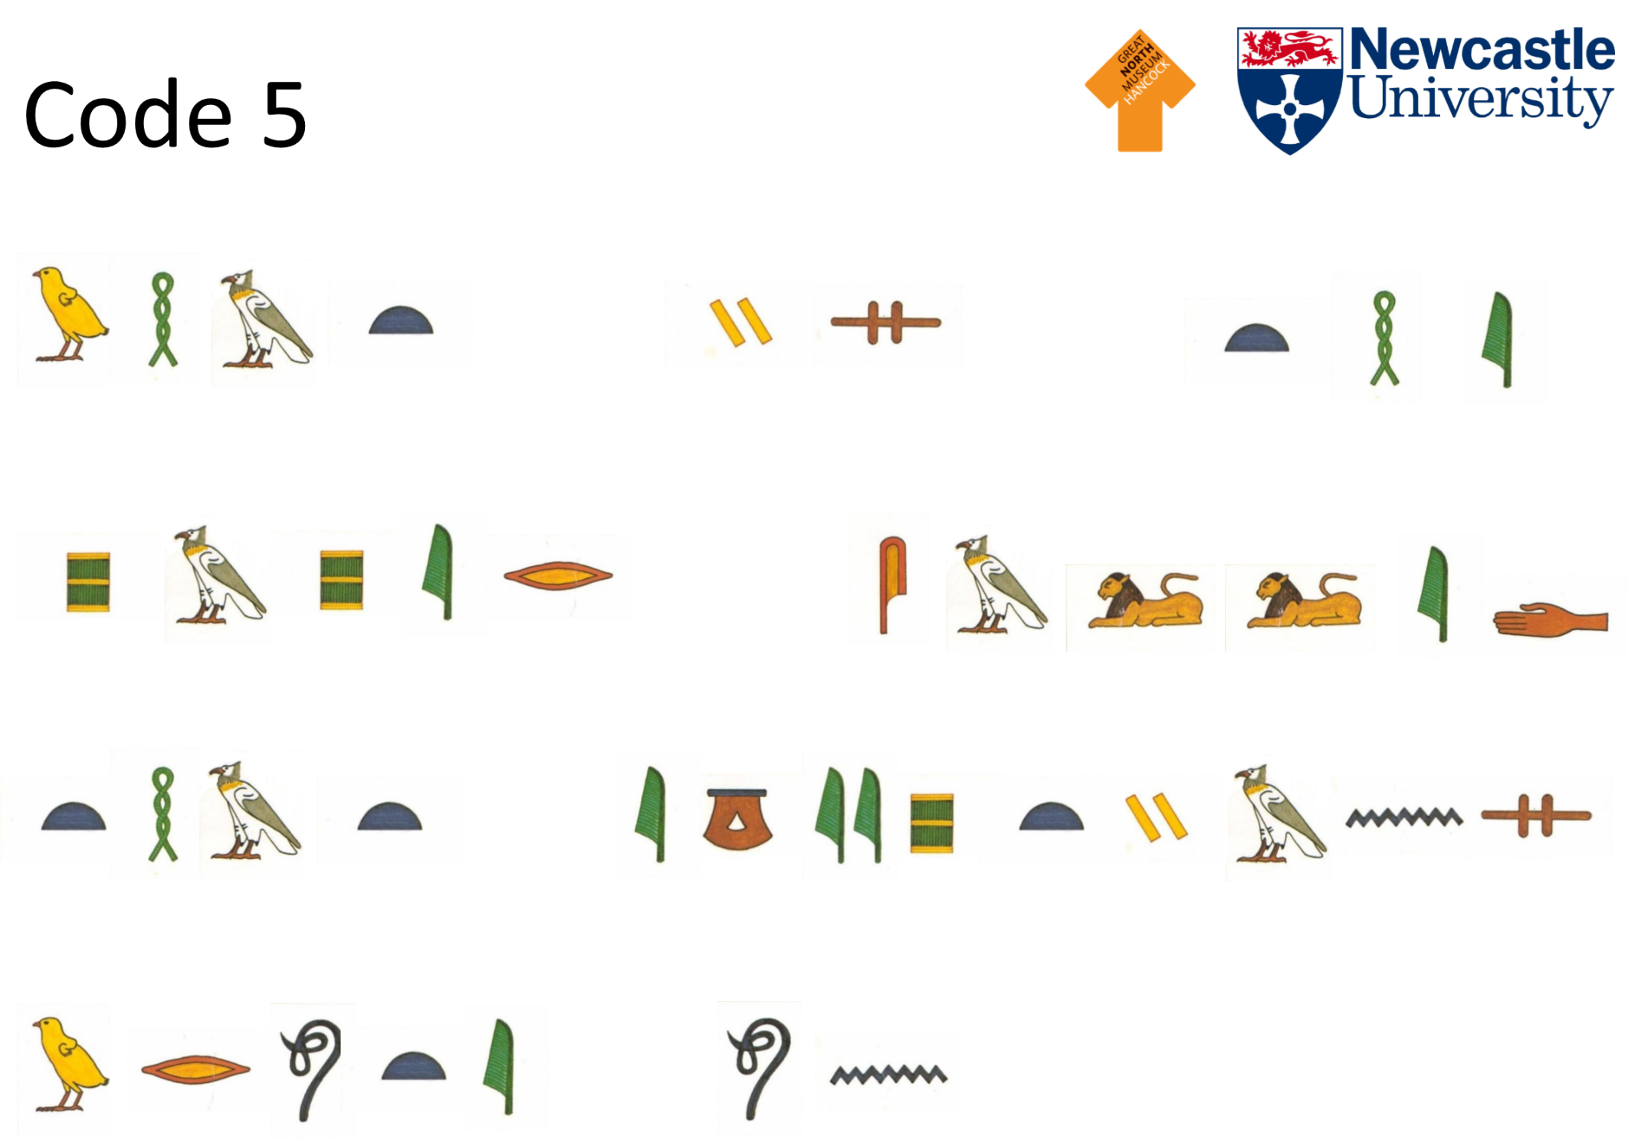
Answers
Cracking the Code activity

Code 1
Message: What animal head does the goddess Sekhmet have?
Answer: Lioness

Code 2
Message: Which museum has the statue of Pharaoh Rameses come from?
Answer: British Museum

Code 3
Message: Who cracked the code on the Rosetta Stone?
Answer: Jean-Francois Champollion

Code 4
Message: What are the names of our two mummified people?
Answer: Irtyru and Bakt en Hor

Code 5
Message: What is the paper called that Egyptians wrote on?
Answer: Papyrus

