The Big Questions
This resource has been created to promote philosophical enquiry in the museum. Philosophical enquiry creates opportunity to teach thinking skills, improve speaking and listening and practice the ability to question and reason. This strategy fits in with both the Social and Emotional Aspects of Learning (SEAL) agenda and the Spiritual, Moral, Social and Cultural development (SMSC) agenda.
Suggested ‘Big Questions’ have been included in this pack to be used as discussion points which relate to aspects of the museum collection. The activity works best in small groups so that all the children (and adults) can share their opinions. It is important to reinforce that there is no right or wrong answers to these questions and once you have heard one person’s opinion it is ok to change your point of view.
Additional information on philosophical enquiry can be found through the following links:
- A guide to philosophical enquiry in the primary classroom
- What is Philosophical enquiry?
- Helping schools promote SMSC
- Creative Philosophical Enquiry
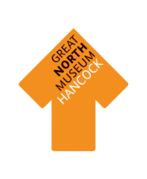

If you were a Greek Hoplite soldier would you rather have a sword or a shield?

Do animals think?

Was the Egyptian Afterlife real?

If birds are evolved from dinosaurs then are there still dinosaurs?

Were the Romans right to invade Britain and build Hadrian’s Wall?

How long did it take to make the earth?

Do we understand ourselves better through our myths or through our museums?

Can you believe in God and the theory of Evolution?

Do we need museums?

