Ancient Egyptian explorers

These resources have been created to help your group explore the ancient Egyptian gallery at the Great North Museum: Hancock.

The activities include:
- Object Eye Spy
- Mummified People Investigation
- Measuring the past
- Map the Egyptian gallery
- A BIG Question

If you have any suggestions on other resources we can create that would support your groups learning or if you would like to share any of your work with the museum then please email learning@greatnorthmuseum.org.uk
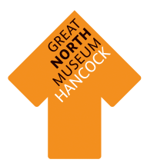
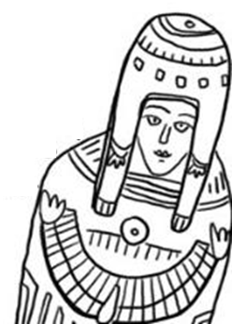

Object Eye Spy

Find all these objects in the Egyptian gallery and write what they are called beneath them.

Mummified People Investigation
What information can you find out about our two mummified people?
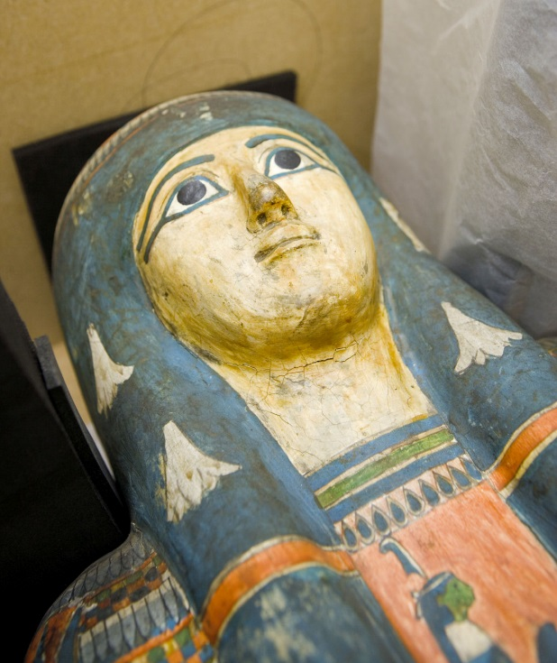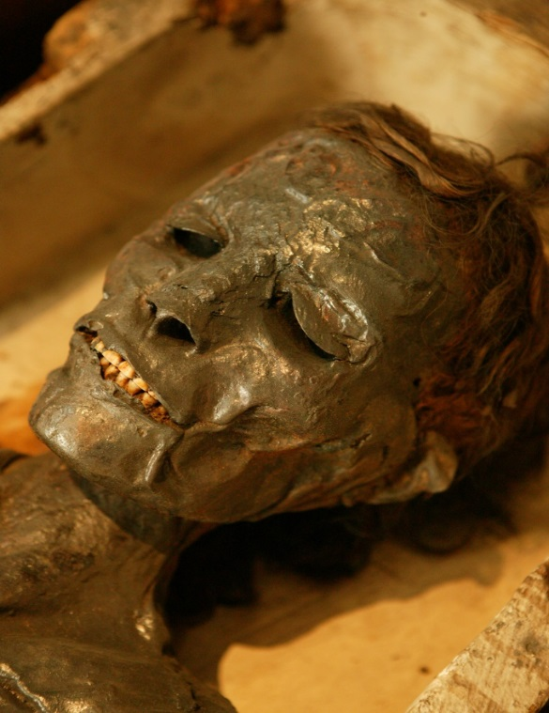
Name of mummified person:
Male or female:
Approximate age:
Extra fact:

What would you like to know about the mummified person but haven’t been able to find out in the gallery?
Name of mummified person:
Male or female:
Approximate age:
Extra fact:

What would you like to know about the mummified person but haven’t been able to find out in the gallery?

Measuring the Past

Objects are very important in helping us to understand Ancient Egypt. Which objects survive over time depends on what material they are made from.
Count the number of objects made from each type of material in five cases.
Type of material | Tally of objects made from this material | Total
Earth Materials: stone, pottery, terracotta, clay, bronze, iron, gold, silver.
Animal materials: wool, cloth, ivory, leather, skin, bone.
Plant materials: linen cloth, wood, flowers, reeds.

Circle the type of material that has survived the best.
Earth Animal Plant
Why do you think this is?

Circle the type of material that has survived the worst.
Earth Animal Plant

Why do you think this is?

Choose a starting point and an end point in the Egyptian gallery. Draw your favourite objects on the route, remember to label what they are.

Make it your own!
Map the Egyptian gallery

A BIG Question

What was the Egyptian afterlife like?

Note – there is no right or wrong answer to this question. If you and friends disagree then try and persuade each other with good reasoning why your answer is the strongest with evidence.

