Cracking the Code activity instructions

Task 1
We would recommend that younger children work in small groups with an adult while older children may want to work in pairs.
Using the hieroglyph alphabet sheet translate the five codes and write the messages down on the sheet provided (some letters have the same or very similar symbols so be careful!)
You don’t need to do the messages in order but we would recommend writing the message for ‘code 4’ in the space where it says ‘code 4 message’.
When you are finished ask an adult to check the answers for you from the ‘answers’ folder.

Task 2
You may have discovered that each message is a question. You may already know some of the answers but if not read the attached ‘Egyptian collection at the Great North Museum’ fact sheet to find the answers!

Task 3
If you have any spare paper or a sketchbook then why not write a question or message in hieroglyphs and get a friend to decode it?

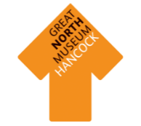
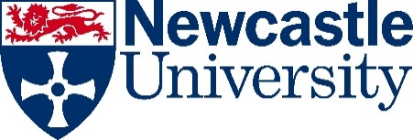

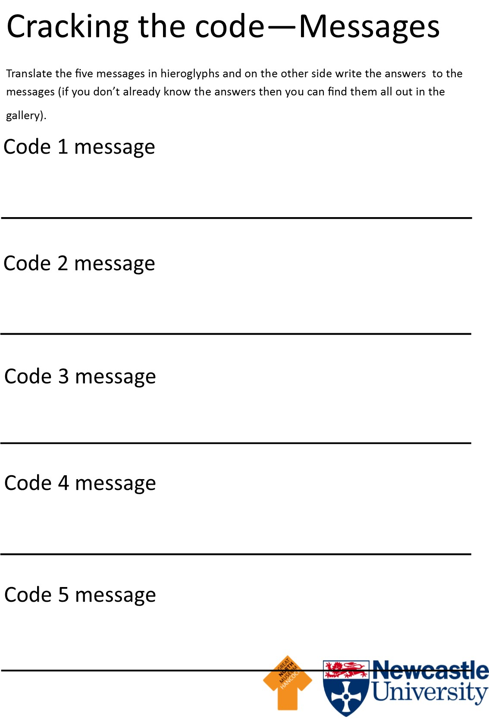
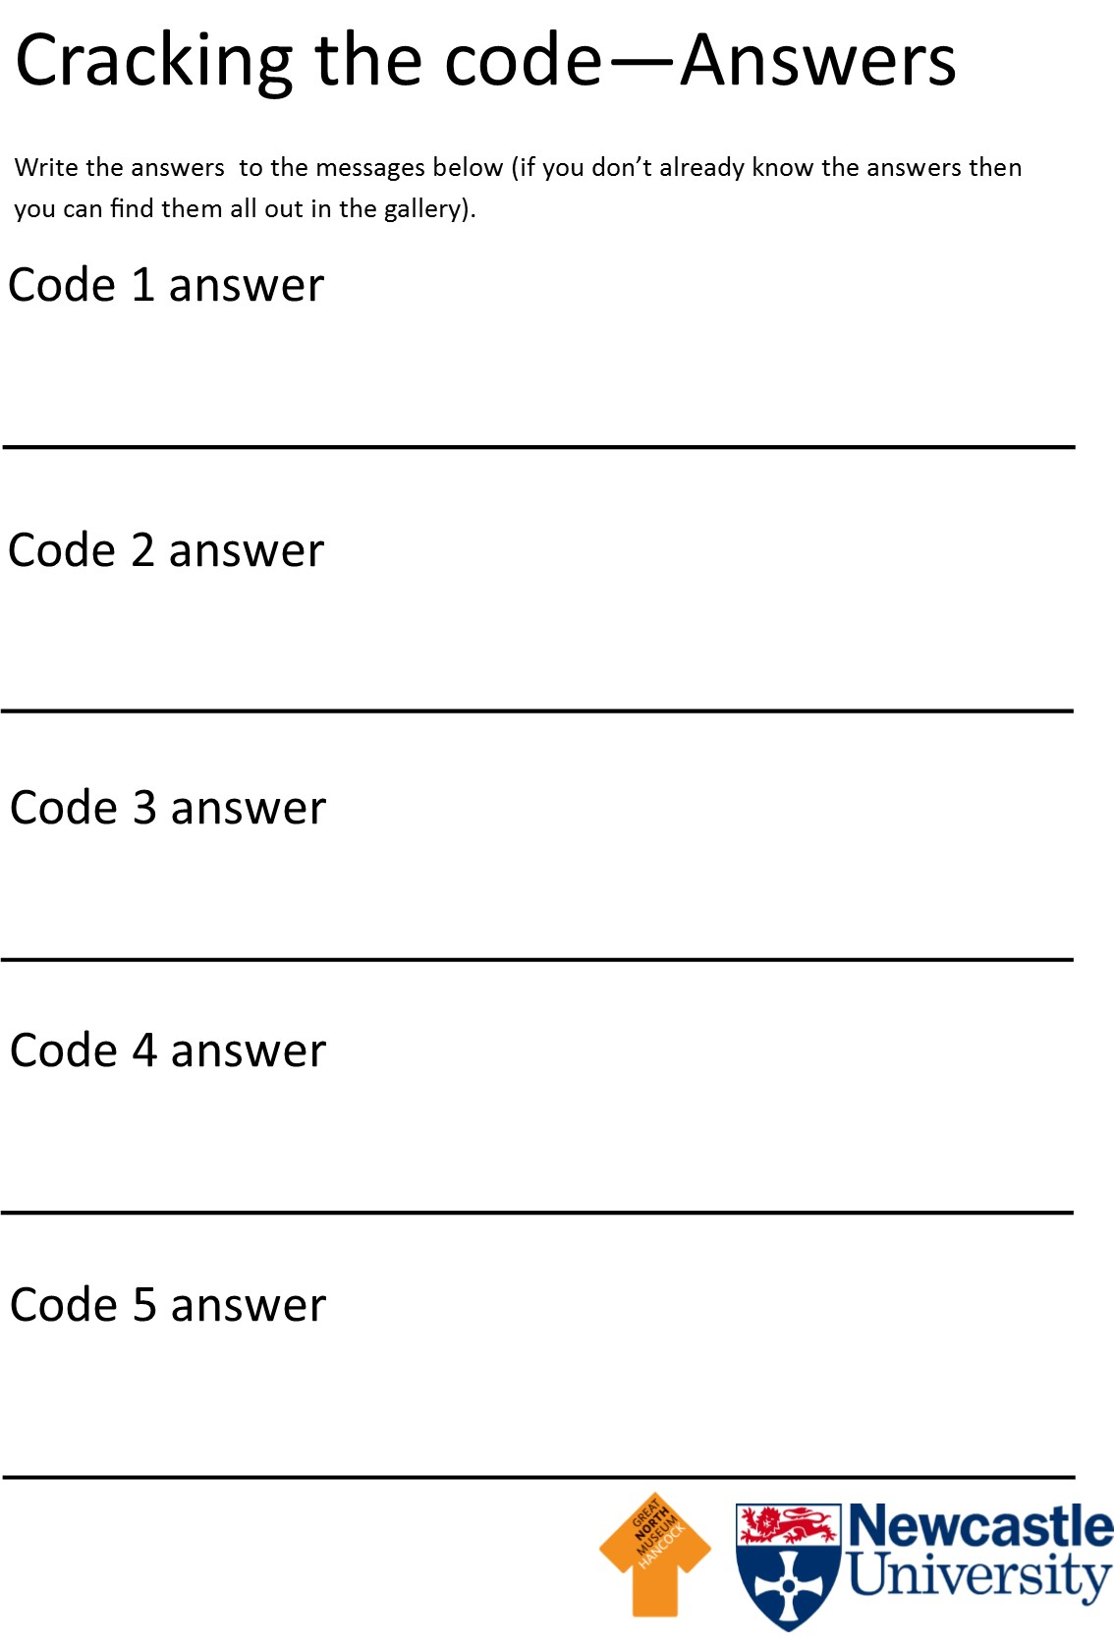

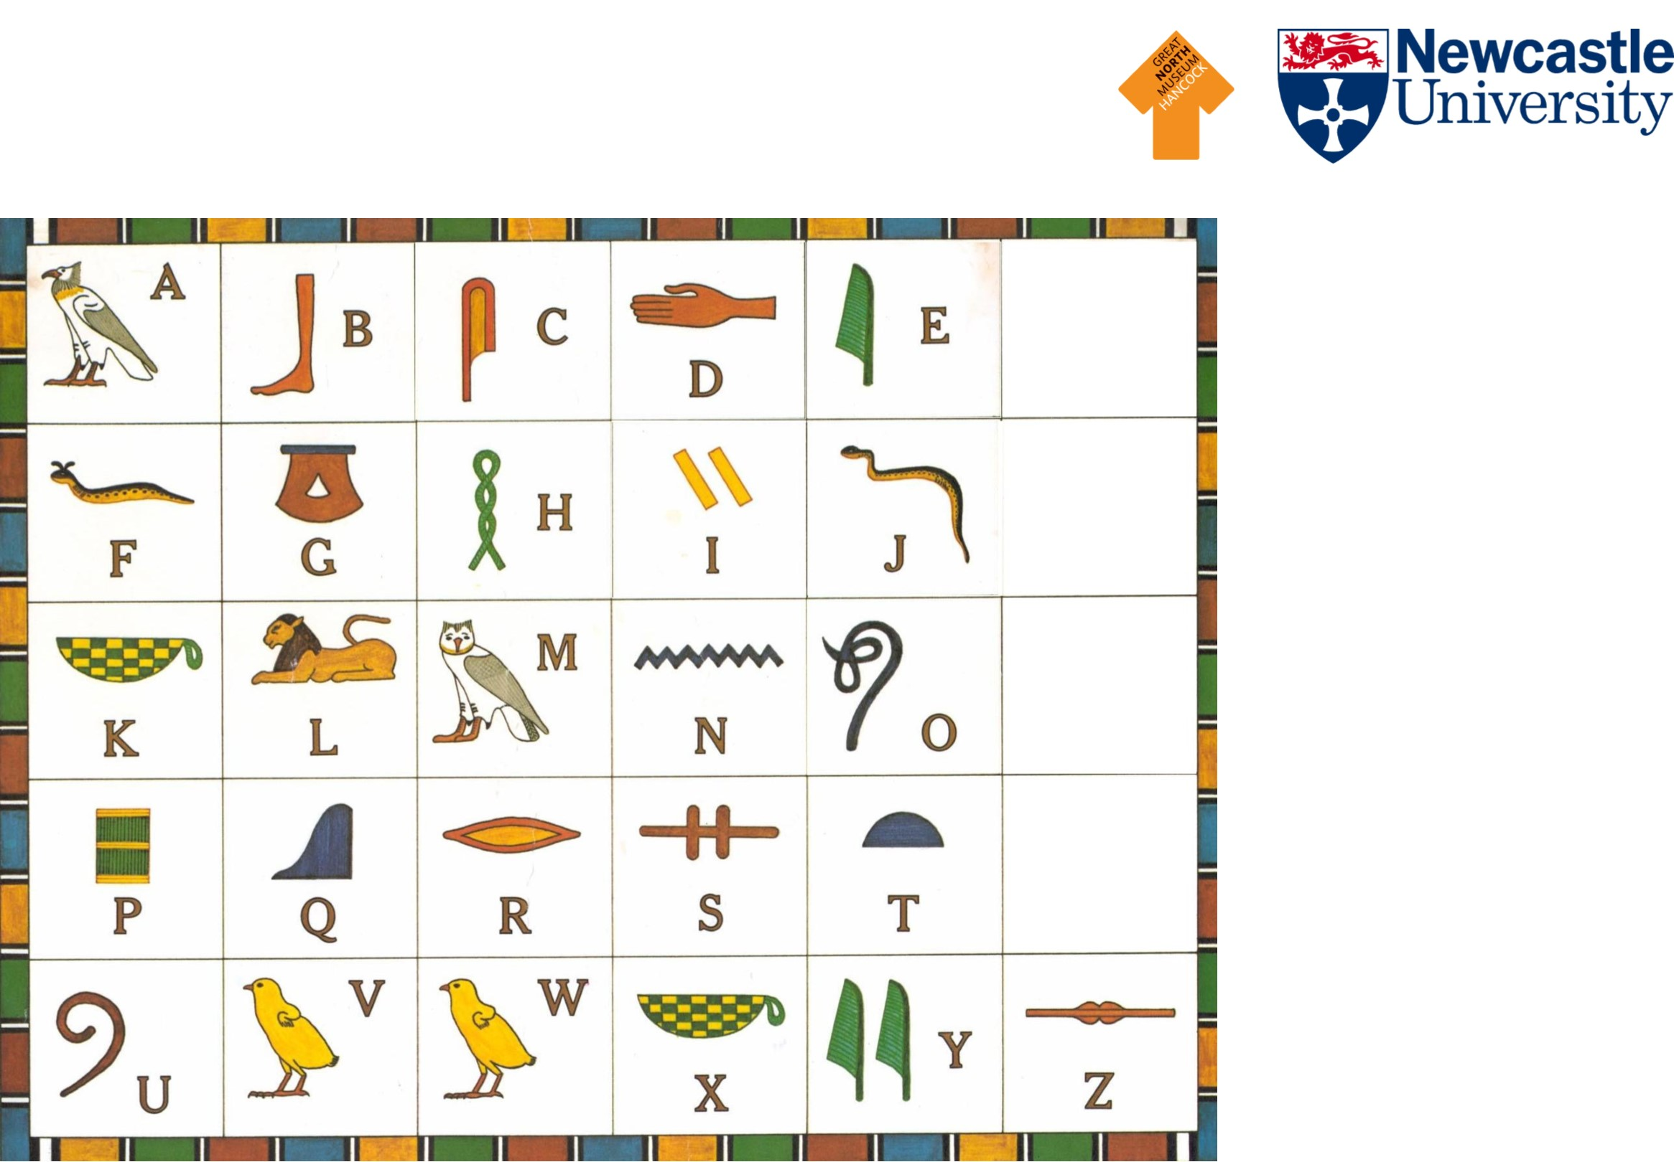

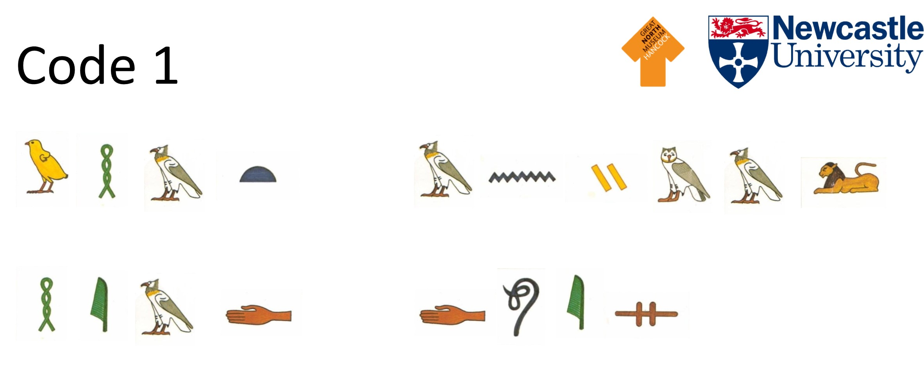
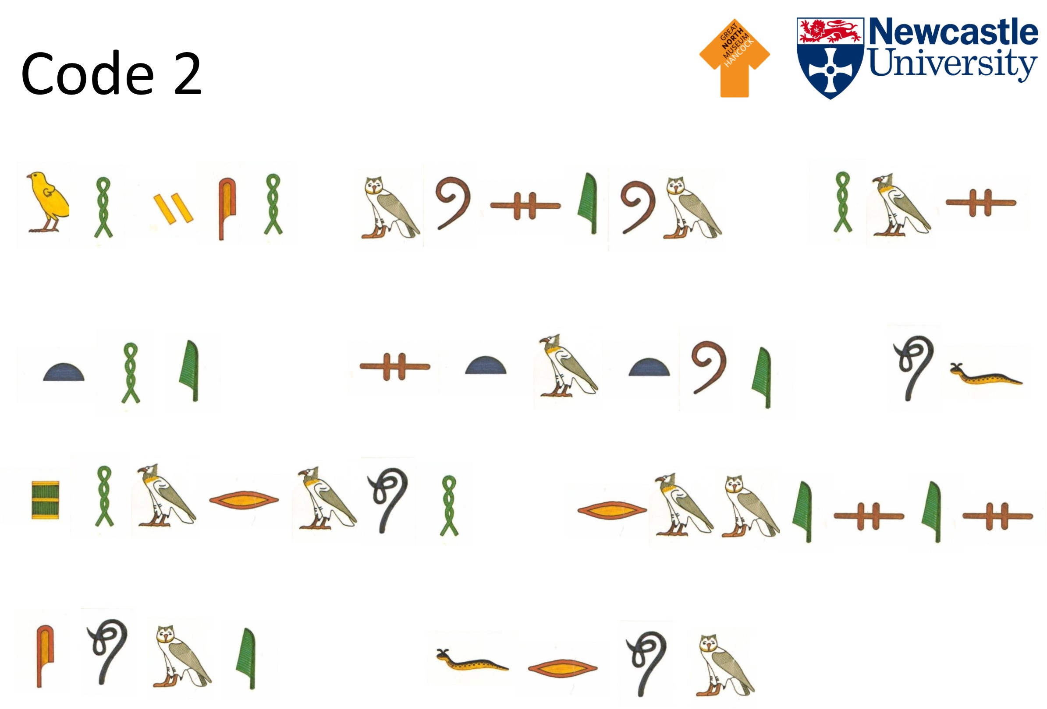
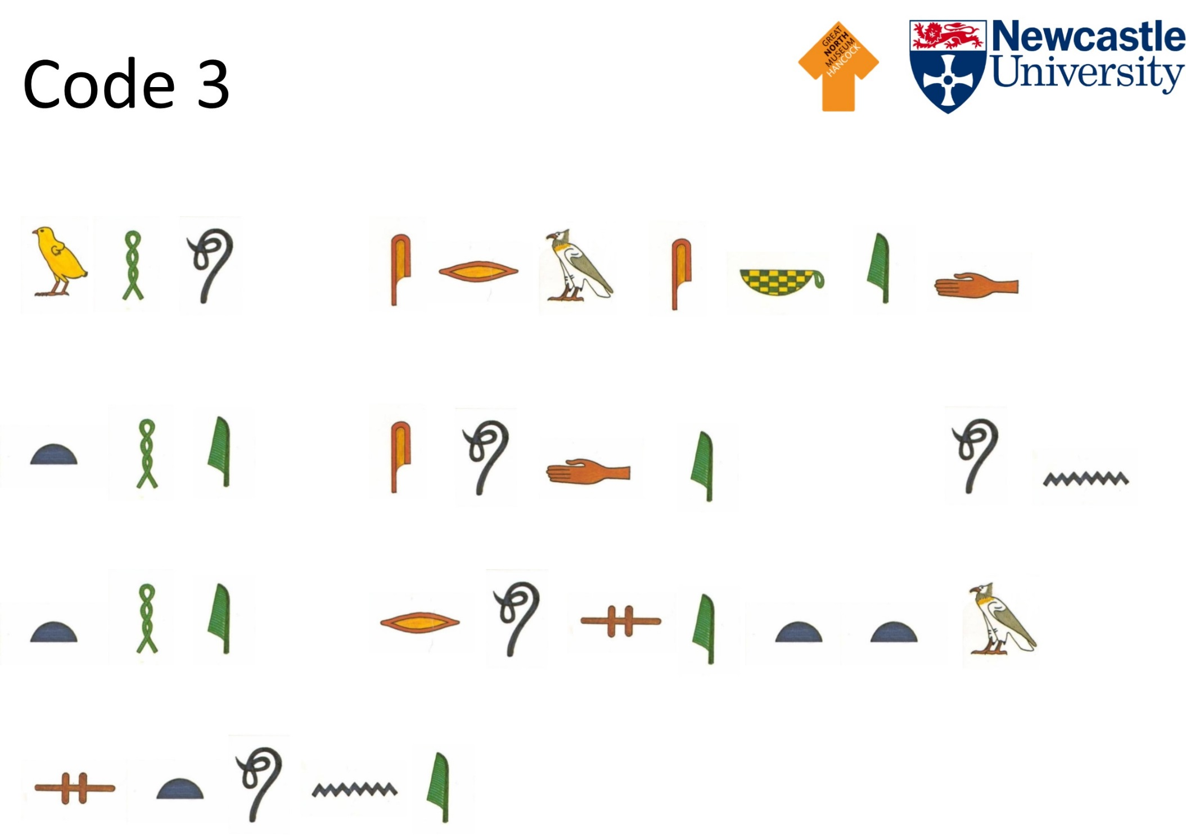
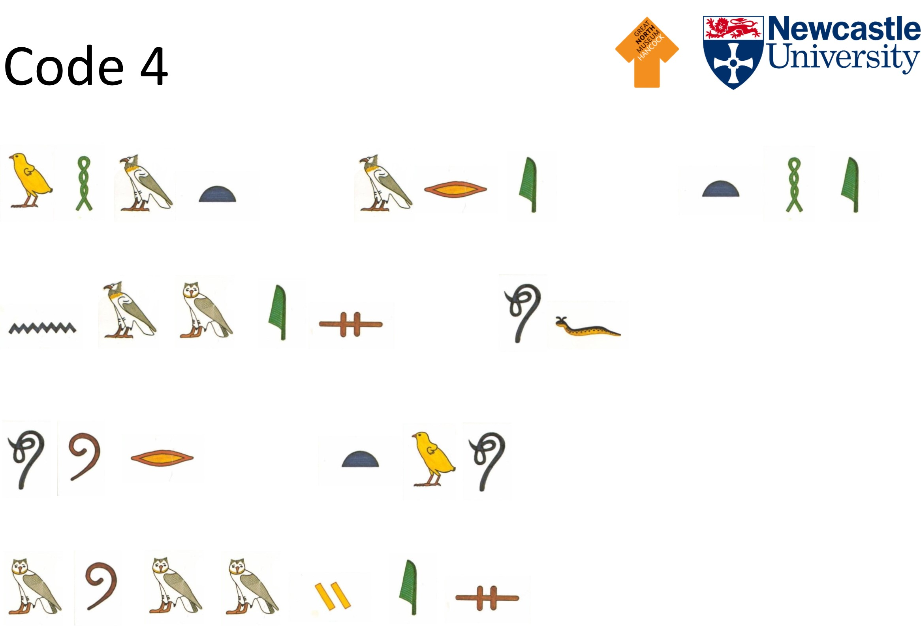
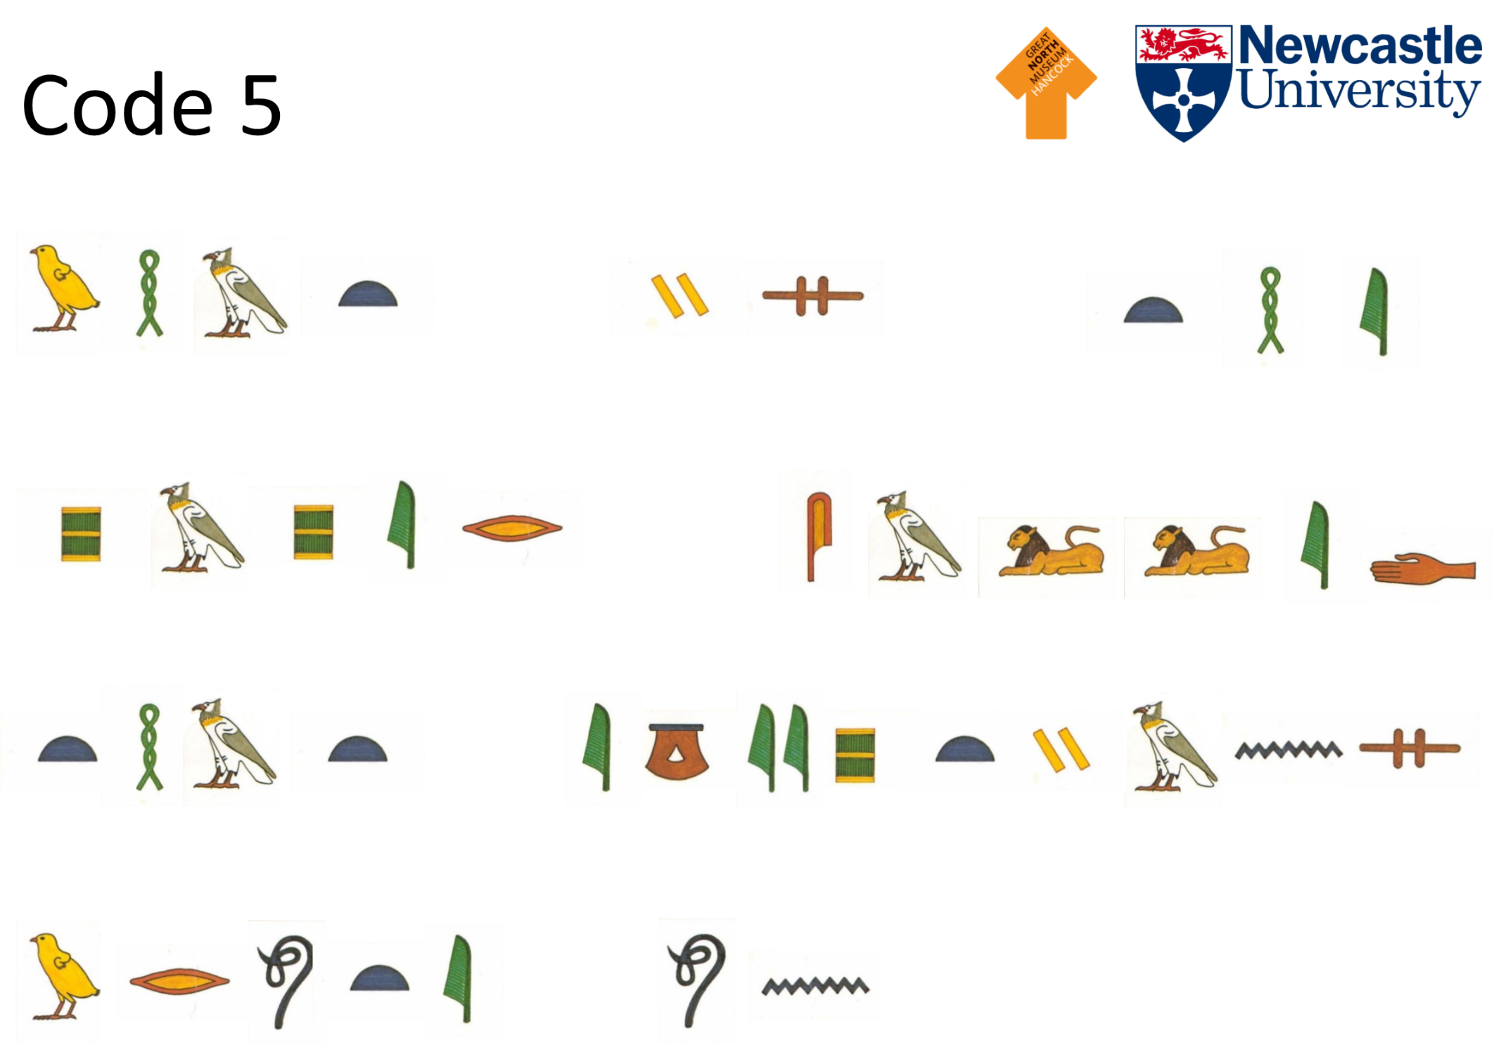
Answers
Cracking the Code activity

Code 1
Message: What animal head does the god Anubis have?
Answer: Jackal

Code 2
Message: Which museum has the statue of Pharaoh Rameses come from?
Answer: British Museum

Code 3
Message: Who cracked the code on the Rosetta Stone?
Answer: Jean-Francois Champollion

Code 4
Message: What are the names of our two mummies?
Answer: Bakt-en-hor and Irtyru

Code 5
Message: What is the paper called that Egyptians wrote on?
Answer: Papyrus

