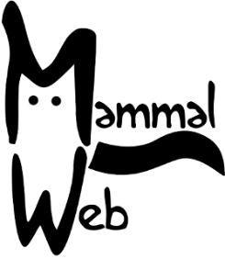
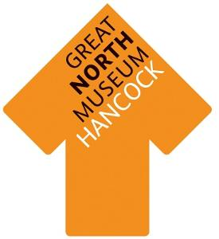
Mammal Bingo!
All of these local animals can be found hiding somewhere in the museum, can you find them all and get bingo?

Red fox | Brown hare | Hedgehog
Roe deer | European otter | European badger
Red deer | Stoat | Pine marten

How to play:
- Search the Great North Museum: Hancock’s Natural Northumbria gallery until you find each of the animals.
- When you find an animal either:
  - Draw a picture of it in the box
  - Write down one fact that you found out about that animal
- Once you have found them all, congratulations, you have bingo!

The MammalWeb screens in the Natural Northumbria gallery hides show animals from camera traps around North East England. What animals can you find on them?

