KEY STAGE 1
First of all, go and take your time to look at Dippy the Diplodocus and Big Mike the Tyrannosaurus Rex! Remember to look at all the little details too.
Now you’ve had a look at Dippy and his friend Mike, it’s time to see what you’ve learnt about them!
Task 1: Dinosaur Body Experts!
Dippy:
- Below is a diagram of Dippy’s body. Can you label the different parts pointed out? What body parts does Dippy share with you?
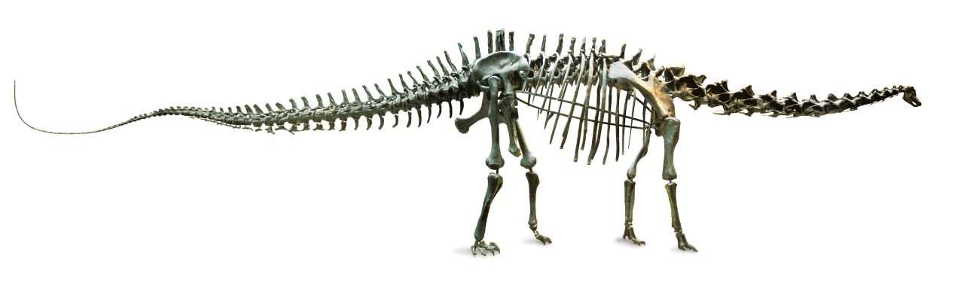

- Using your diagrams that you’ve labelled, how many legs do you think Dippy has? Did he have any arms?
- Did Dippy have a long or short neck?
- Can you see if Dippy had any teeth?
- Did Dippy have a long tail?
- Dippy used to love eating lots of veg, particularly leaves! Do you think he was a carnivore or a herbivore?
Big Mike:
- Below is a diagram of a Tyrannosaurus Rex (Big Mike). Can you label the different parts of his body that have lines pointing to them? What body parts does Mike share with you?
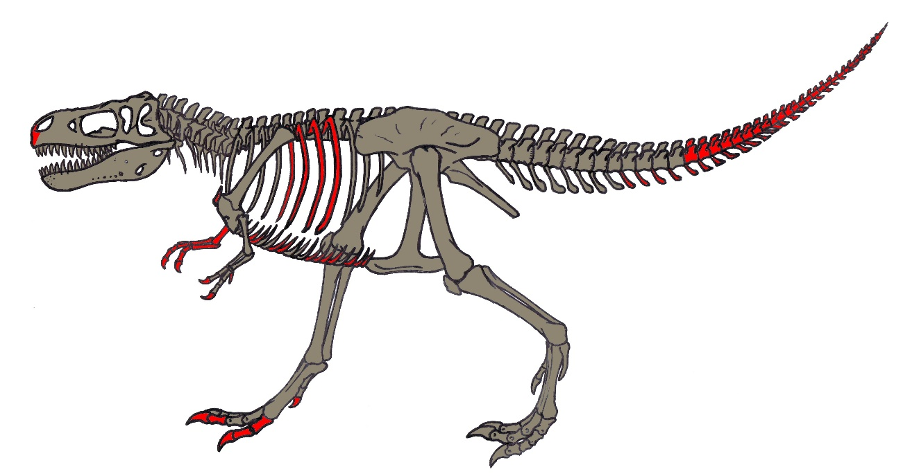

- Using your labelled diagram, how many legs did Mike have? Did he have any arms?
- How many teeth can you count?
- Mike used to love eating other dinosaurs or animals! Do you think he was a carnivore or a herbivore?
- Did Big Mike have a short or a long tail?
Task 2: Habitat Explorers!
Dippy and Big Mike are now EXTINCT and their fossils are always being discovered. Using all the different fossils found, scientists have been able to reconstruct replicas of the skeletons that you have seen today! However, these animals used to live here on earth, but in a world you probably wouldn’t recognise! Your teacher will now describe to you the type of world that Dippy used to live in, the types of food he used to eat, the different plants that were there and describe some other dinosaurs that were Dippy’s friends! Try to listen carefully, because you’re going to draw it next!

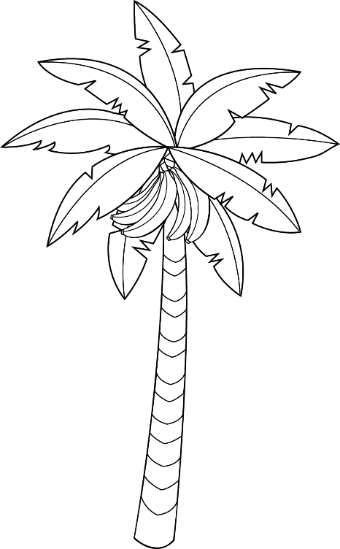
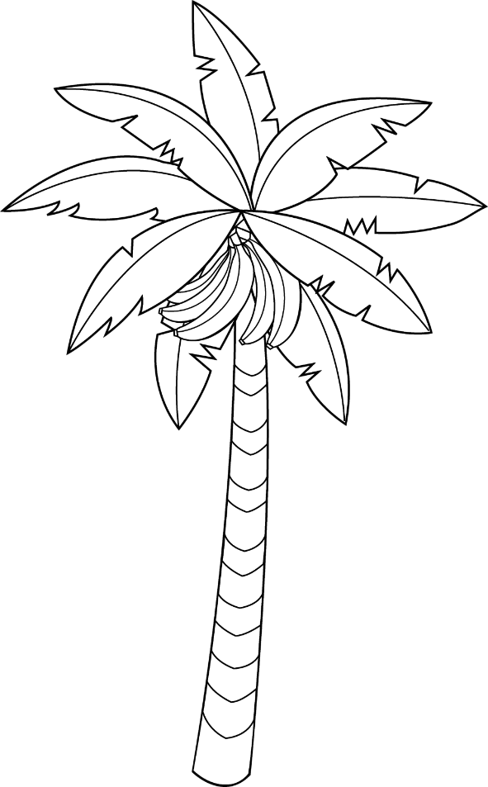
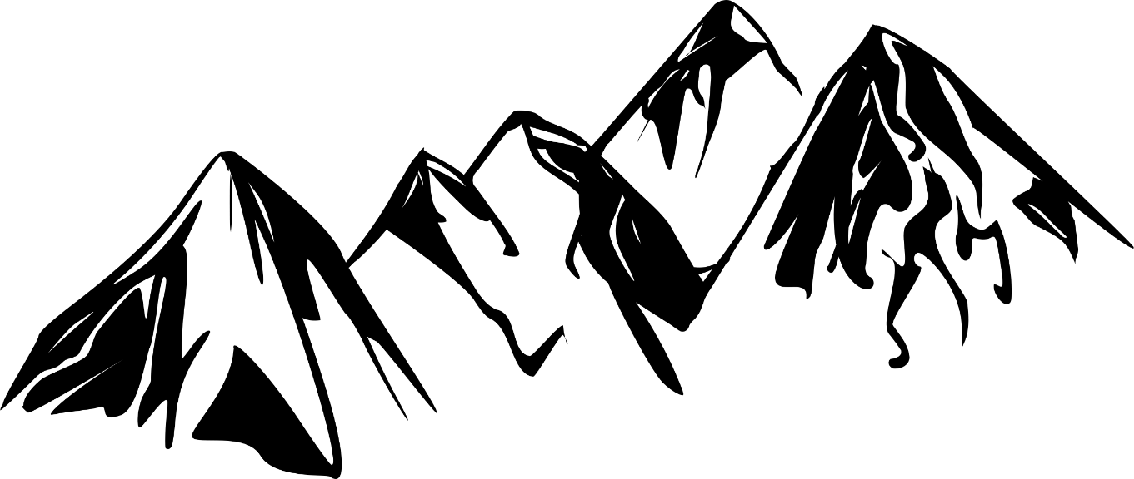
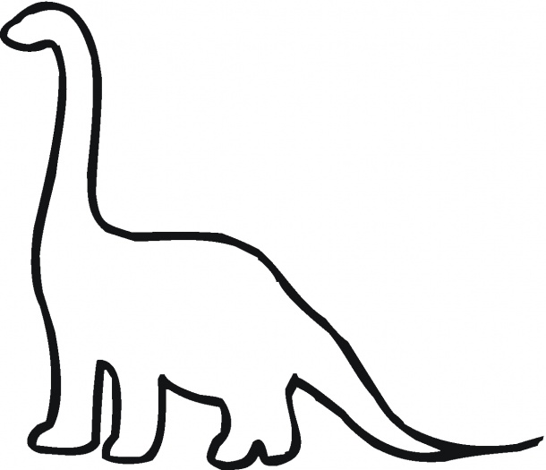
HOW DO I SOUND?
Now grab a piece of paper and draw your habitat…don’t forget to make the noises of all the things you draw to get a real feeling for what it would be like to live with Dippy!
What different noises do you think dinosaurs would’ve made?

Task 3: Timeline warriors!
Time to create a dinosaur timeline!
Below are the dates of when Dippy and Big Mike were alive, as well as some other dinosaur beasts! Using these, I want you to cut out and organise the pictures of them into order of when they lived! Do you think Dippy and Big Mike would have ever met each other?

Hypsilophodon: 129–125 million years ago

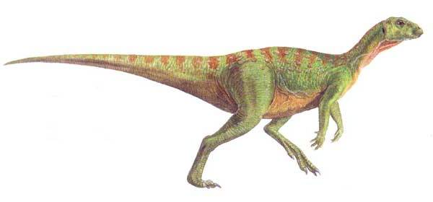
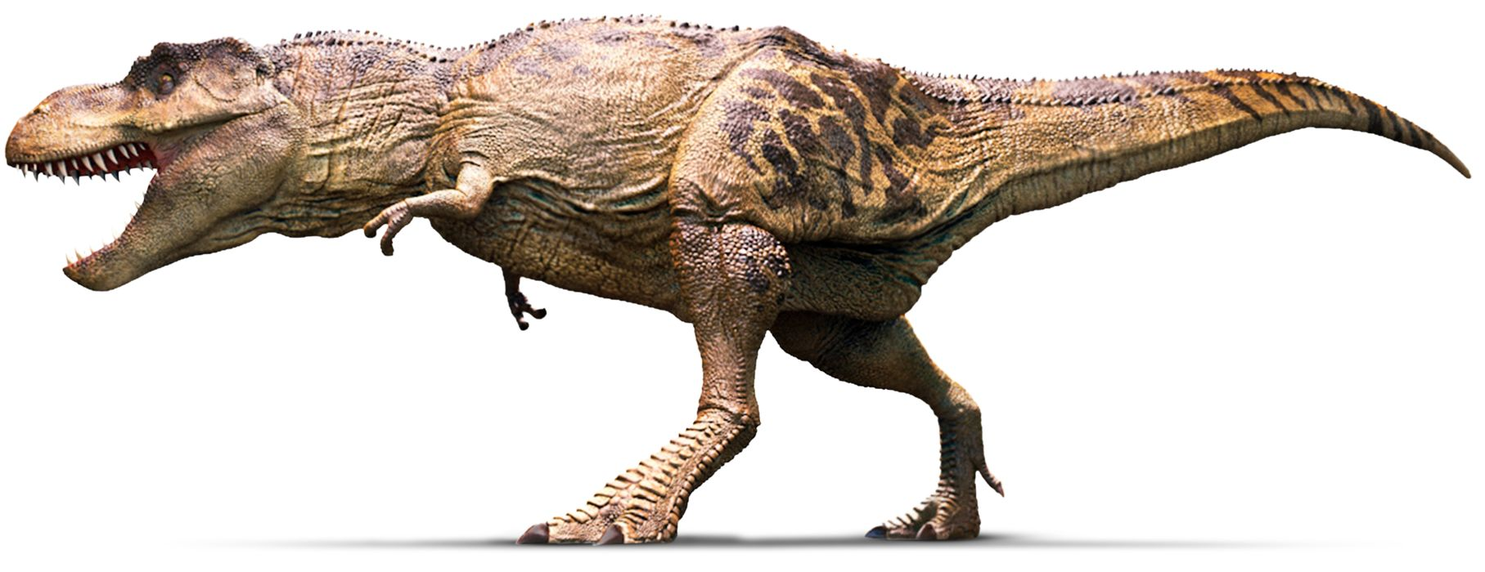
Tyrannosaurus rex: 68–66 million years ago
Diplodocus: 155–145 million years ago

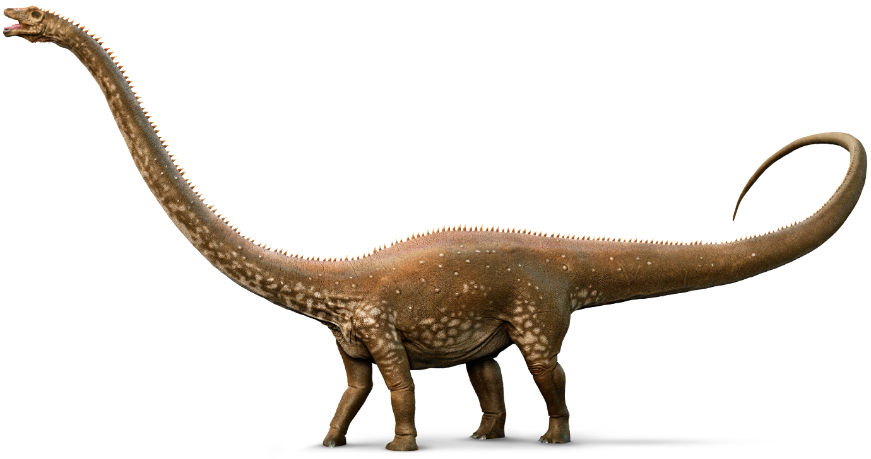

Velociraptor: 75–72 million years ago

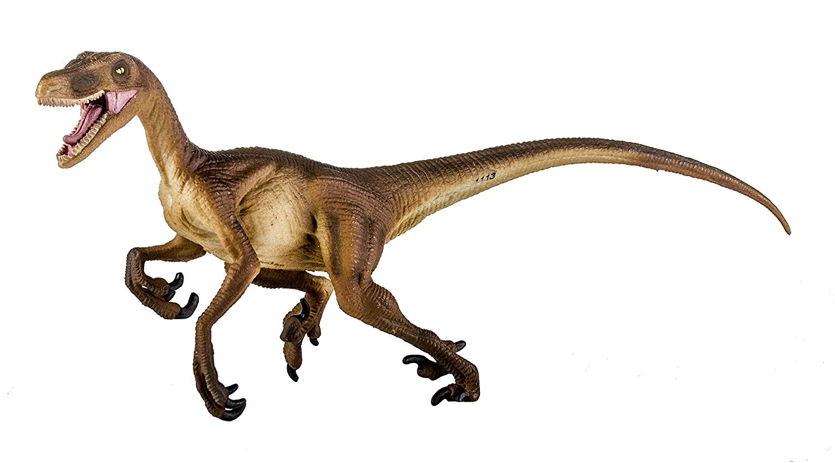

Iguanodon: 129–120 million years ago

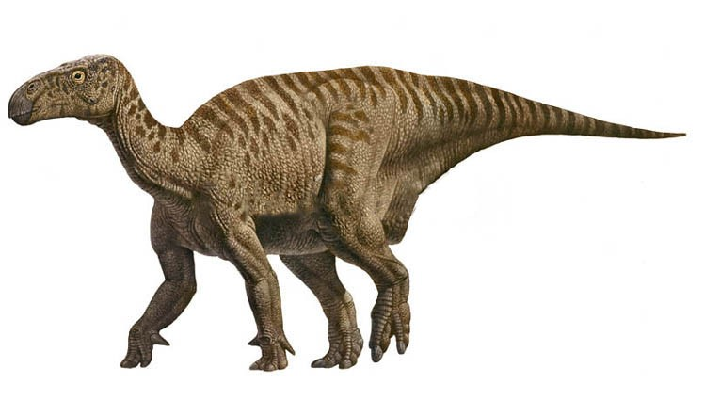

Albertosaurus: 70–66 million years ago

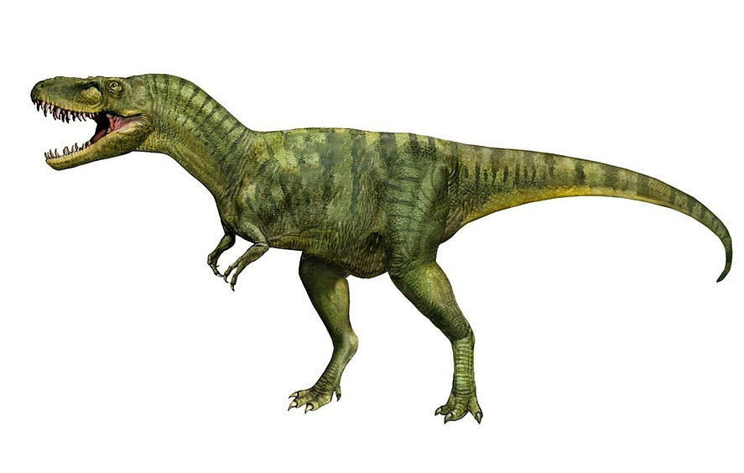

Links to images:
Task 1 images:
https://www.bing.com/images/search?view=detailV2&id=7C4E8C39ECDC51B32408385EB712BF42A137B8A1&thid=OIP.UVI47cfSjyOjM-sH-LlvWwHaD6&mediaurl=https%3A%2F%2Fupload.wikimedia.org%2Fwikipedia%2Fcommons%2Ff%2Ff5%2FMOR555_skeletal_material.JPG&exph=1920&expw=3630&q=MOR-555&selectedindex=42&ajaxhist=0&vt=0&eim=1,2,6
Task 2 images:
https://www.bing.com/images/search?view=detailV2&id=7A6C355C86FA2B082DD3B36C6381761747FC6153&thid=OIP.AOop7qDy-Bwnwr7WRzu-0wHaGX&exph=525&expw=610&q=dinosaur+outline&selectedindex=0&ajaxhist=0&vt=0&eim=1,2,6
https://www.bing.com/images/search?view=detailV2&id=A9F06CB372DD8E5FCA7598A51185C918C1CC5095&thid=OIP.VmwiK9cVziPeu3UTneOeFwHaDI&mediaurl=https%3A%2F%2Fi.pinimg.com%2Foriginals%2F0e%2F60%2F2a%2F0e602aeff27a52af5172f7fa0bf3e5bd.png&exph=1016&expw=2400&q=mountain+outline&selectedindex=9&ajaxhist=0&vt=0&eim=1,2,6
https://www.bing.com/images/search?view=detailV2&id=B9443548C731A5704F120B8E4462287596A44192&thid=OIP.1u0TuagisSeNRk9Xwg65TAHaL8&mediaurl=https%3A%2F%2Fmarisa-hamanako.com%2Fwp-content%2Fuploads%2F2017%2F02%2Fbanana-tree-leaf-outline-clipart-clipartfox-coloring-page-banana-tree-1024x1651.png&exph=1651&expw=1024&q=tree+outline&selectedindex=64&ajaxhist=0&vt=0&eim=1,2,6
Task 3 images:
https://www.bing.com/images/search?view=detailV2&id=DE84A252975601D7BCC0ED3DE481204A4FC1CA87&thid=OIP.d-qfN1j-zVF1Yk-iwTiOkQHaD6&mediaurl=https%3A%2F%2Fres.cloudinary.com%2Fdk-find-out%2Fimage%2Fupload%2Fq_80%2Ch_1000%2Cf_auto%2Fdiplodocus_whole_amzt6e.jpg&exph=1000&expw=1895&q=Diplodocus&selectedindex=0&ajaxhist=0&vt=0&eim=1,2,6
https://www.bing.com/images/search?view=detailV2&id=6E112976CBA462A07B6101B7AEA82F2B937EA85D&thid=OIP.uTb-RiSLmCZPFwd0lBFWgQHaEH&mediaurl=https%3A%2F%2Fimages-na.ssl-images-amazon.com%2Fimages%2FI%2F811tHK61ymL._SL1500_.jpg&exph=834&expw=1500&q=Velociraptor&selectedindex=14&ajaxhist=0&vt=0&eim=1,2,6
https://www.bing.com/images/search?view=detailV2&id=7ACE9337923A86ABF2C524193C75008601473900&thid=OIP.wFvCi-KFm0NWlUXR5Q6x-QHaEt&mediaurl=http%3A%2F%2Fwww.extinctanimals.org%2Fwp-content%2Fuploads%2F2015%2F09%2FPictures-of-Albertosaurus.jpg&exph=564&expw=887&q=Albertosaurus&selectedindex=2&ajaxhist=0&vt=0&eim=1,2,6
https://www.bing.com/images/search?view=detailV2&id=4B5DD02211FE98FB80C4C591059257B91588BC7D&thid=OIP.T4amlL-byEUue7tqbdfNBAHaC2&mediaurl=http%3A%2F%2Fres.cloudinary.com%2Fdk-find-out%2Fimage%2Fupload%2Fq_80%2Ch_700%2FT_REX_profile_tg6qxo.jpg&exph=700&expw=1815&q=t+rex&selectedindex=9&ajaxhist=0&vt=0&eim=1,2,6
https://www.bing.com/images/search?view=detailV2&id=29A332DE7560B9AF1323FFB60383943C2342AC9B&thid=OIP.XyWcOwkBpn6gJQtmLqhTwQHaEN&mediaurl=http%3A%2F%2Fimages.dinosaurpictures.org%2Figuanodon-1_e1e9.jpg&exph=425&expw=748&q=Iguanodon&selectedindex=0&ajaxhist=0&vt=0&eim=1,2,6
https://www.bing.com/images/search?view=detailV2&id=705548B1C6912008FFC98BC816727CCD77610179&thid=OIP.0sWool7q_slpxvys-D-8kQHaDd&mediaurl=http%3A%2F%2Fimages2.wikia.nocookie.net%2F__cb20110925184758%2Fdinosaurs%2Fimages%2F3%2F3e%2FHypsilophodon_foxii.jpg&exph=280&expw=600&q=Hypsilophodon&selectedindex=8&ajaxhist=0&vt=0&eim=1,2,6

