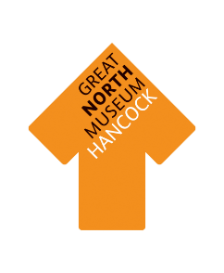
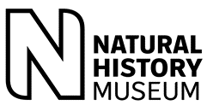
Transforming Learning in Science through Collaboration with Museums
Real World Science Leadership Initiative

We would like to invite your school to participate in the Transforming Learning in Science Through Collaboration with Museums CPD programme. This is a free project run by the Great North Museum: Hancock in collaboration with the Natural History Museum as part of the Real World Science programme. We have funding from the Foyle Foundation which allows us to offer free places to schools who wish to participate this year and are also working in collaboration with STEM learning and the North Tyneside Learning Trust.

The programme runs throughout the academic year 2019/20 and aims to support primary school science subject leaders to transform practice in their school through sustained and quality engagement with local museums.
This CPD programme is free to participating schools; museum staff and local experts will work with primary science leaders to:
- increase the teachers’ knowledge of the human and physical resources of museums which can be used to support science learning, using the Great North Museum: Hancock as an example;
- give subject leaders access to areas of the museum and to experts in order to develop their own knowledge and skills for dissemination among their colleagues;
- support science leaders in developing a programme of museum visits to explore enquiry and object based learning, teaching at greater depth and mastery learning in the science curriculum;
- bring enhanced excitement and confidence about science to your school’s staff and pupils.

This project has been made possible by funding from the Foyle Foundation
Great North Museum: Hancock
Barras Bridge
Newcastle upon Tyne NE2 4PT
Telephone: 0191 208 7578
Email: kate.holden@twmuseums.org.uk

We hope that your school will be able to participate in this exciting project, which will run from September 2019 through to July 2020 and consist of a programme of 6 CPD sessions. These are mainly held at the Great North Museum: Hancock (one is at an outdoor site), and teachers are asked to undertake related visits to the museum and other venues. They also complete a set of supporting in- school activities (see attached programme).
The numbers of places are limited, so, if you would like your school to take part please read and sign the agreement form and return it to Kate Holden before 19 July 2019. For further information or to discuss your school’s participation, please call Kate on 0191 208 7578.

Yours Sincerely,
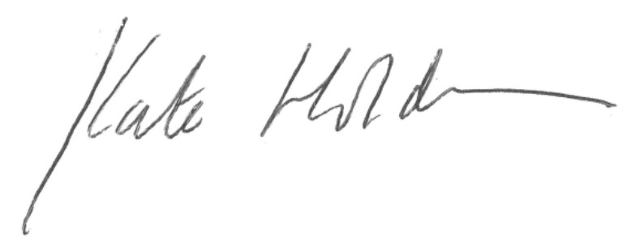
Dr Kate Holden
Learning Officer
Great North Museum: Hancock

Documents Below:
Aims and intended outcomes
Programme

Transforming Learning in Science Through Collaboration With Museums

Aims
This programme of training aims to:
- empower science subject leaders with new skills and confidence so that they can transform science learning in their schools, creating a sustainable change
- develop enquiry-led thinking and object-based learning approaches
- encourage mastery approaches to teaching the science curriculum
- change how participating teachers identify as education professionals
- create schools in which teachers and pupils are enthused with science, inside and outside of the classroom
- develop partnership and collaboration between schools and museums in order to extend and deepen the impact of museum visits

We will do this by….
- encouraging participating teachers to reflect (along with their colleagues) on the current state of science learning and teaching in their schools, what they would like to change and how that can be achieved in a resilient way
- supporting participants in developing and refining a GROW model to audit and plan for change in their school throughout the course of the project
- raising confidence in subject leaders both about their own professional practice and how they can support the professional practice of their colleagues
- introducing a variety of methodologies around enquiry-based and object-based learning which can be used in museum, classroom or other contexts to increase the excitement of science learning
- working to help develop new ways of thinking and to support not just subject knowledge but the working scientifically curriculum
- changing and extending the way in which participants and their schools use museums and museum-style activities as part of their science programme
- bringing together teachers, museum professionals and scientists
- introducing ways of making science feel more ‘real’ to children in primary schools
- encouraging the development of a support network among participants from both the museum and the schools
- giving participants the opportunity to try out new techniques with their class and other classes in the school, discuss how well this has worked and refine their techniques
- supporting participants in producing a portfolio and case study to further their professional development

At the end of the programme, we intend that participants will
- have a personal and school-wide sustainable plan to transform science learning and teaching in their school
- have produced a portfolio of work and a case study to further their professional development
- feel more confident and excited about science in the context of primary school learning
- feel more confident about supporting their colleagues in their role as science subject leader
- want to work further with museums and other organisations
- have enthusiastic, engaged pupils who are interested in doing science as well as learning about it
Real World Science Leadership Initiative
Transforming Learning in Science through Collaboration with Museums

Programme
The CPD consists starts and ends with full day sessions, with four further afternoon sessions spaced through the year. There are tasks to complete between each session to support both the professional practice of the teachers themselves and also their role as Science Leaders in their schools. At the end of the programme, participants will have produced a portfolio of material to support their own professional practice and their role as Science Leaders. They will also have produced, in consultation with their colleagues, a resilient plan for future science learning in their school.
Date | Museum CPD session | In School Activity
September 2017 |  | Complete pre-course questionnaire
Friday 27 September 2019  Full day  9.00am coffee for 9.30am start – 4.00pm  Lunch and drinks provided | Outcomes  - To understand the aims and intended outcomes of the project  - To have an improved knowledge of museums in general and the Great North Museum: Hancock in particular  - To develop an understanding of the role of questioning in using real objects to develop working scientifically  - To create a set of principles for transforming science through partnership with museums  - Using the GROW model to audit and plan for change in transforming science through working with museums  - To investigate how museum visits can develop scientific habits of mind  - To plan for school based activities | School based activity  - Develop whole school principles for using museums with staff.  - Carry out and reflect on effective questioning ‘I wonder task ..’ with at least 2 classes.
Friday 15th November 2019  12.30pm for 1.15pm start – 4.00pm  Bring your lunch along; tea and coffee provided | Outcomes  - To reflect on and share practice from the school based activities and reflection  - To develop understanding of school and museum perspectives on transforming learning through working with museums – local teacher  - To plan for linking a museum visit with classroom activity and science enquiry activities | Visit 1  Science Leader’s class visit to the Great North Museum: Hancock
Friday 31st January 2020  12.30pm for 1.15pm start – 4.00pm  Bring your lunch along; tea and coffee provided | Outcomes  - To reflect on and share practice from the museum visit and school based activity  - To work with experts to develop approaches to using field notebooks, and archive material in working scientifically  - To plan in school activities to develop children’s ability and mastery of using field notebooks and ‘real’ sources in working scientifically  - To plan linked museum visit for children to apply and further develop scientific habits of mind in the light of this session | School based activity  Using field notebooks and ‘real’ sources with your class in school.  Visit 2  Science Leader’s class and another class visit to the Great North Museum: Hancock
Friday 20th March 2020  12.30pm for 1.15pm start – 4.00pm  Bring your lunch along; tea and coffee provided | Outcomes  - To reflect on and share practice from the museum visit and school based activity  - To develop understanding of how to bring together the classroom, museum and ‘real’ world through a mini-project  - To develop understanding of how to use local solutions to ‘Big Questions’ to use Citizen Science to transform learning in working scientifically and plan for using this in school  - To engage with university resources and research, in particular to address ‘Big Questions’ and ‘real’ scientific working  - To develop a curriculum map for using Big Questions and Citizen Science across the primary years | School Based Activity  Setting up a Citizen Science-linked project in school  Visit 3  Science leader to support new class in planning for and evaluating visit to the Great North Museum: Hancock.
Friday 8th May 2019  Session at Gosforth Park Nature Reserve  12.30pm for 1.15pm start – 4.00pm  Bring your lunch along – and a flask if you want a hot drink as we’ll be outside. Bring appropriate clothing and solid footwear | Outcomes  - To reflect on and share practice from the museum visit and school based activity  - To develop science leader skills on embedding and sustaining change  - To map approaches to learning and using museums against the national curriculum for science working scientifically using the Nature Reserve as a stimulus | Visit 4  Science Leader’s class and another class visit to the Great North Museum: Hancock based on linking classroom, ‘Real world’ museum in the context of science.  Collect case study materials for July CPD day.
Friday 3rd July 2020  Full day  9.00am coffee for 9.30am start – 4.00pm  Lunch and drinks provided | Outcomes  - To reflect on and share practice from museum visit and school based activity  - To share visions for the future – local headteacher  - To reflect on and analyse project outcomes, and to consider lessons for the future  - To develop an understanding of mapping your North to transform learning in science  - To develop an action plan for sustainable use of museums and other venues bespoke to your own school to transform learning in science  - To complete project case studies | Completion of case study.

