Teacher notes for cross curricular teaching
For use before, during and after your visit to see the Diplodocus

Before your visit:
Cover what life was like for dinosaurs- what they ate, what their habitats were like etc.
KS1 Literacy | read the ‘Dear Dinosaur’ and ‘Dear Dinosaur: T rex on tour’ | https://www.amazon.co.uk/Dear-Dinosaur-Chae-Strathie/dp/1407159291  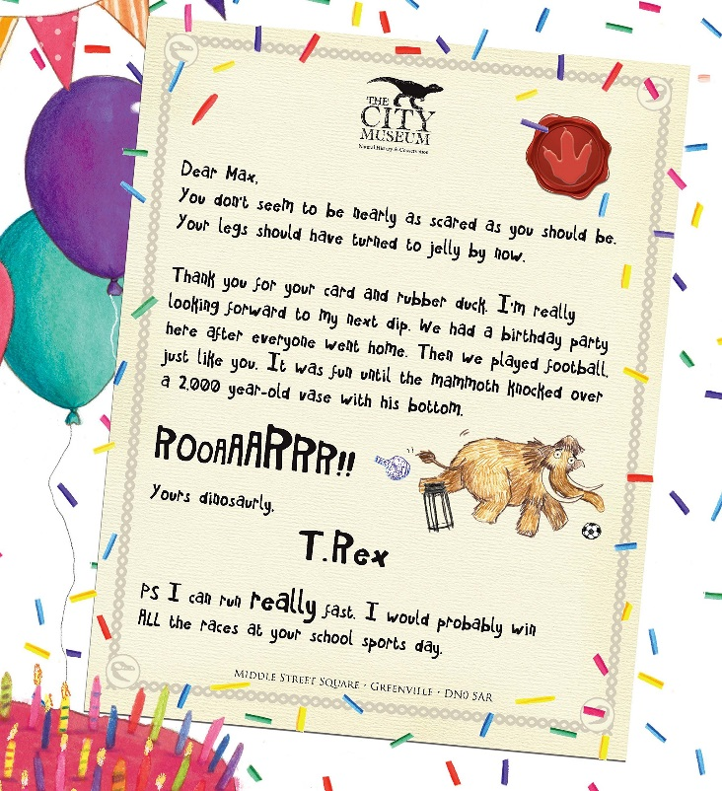  https://www.amazon.co.uk/Dear-Dinosaur-T-Rex-Tour/dp/1407164708/ref=pd_lpo_sbs_14_img_1/258-5593498-3780759?_encoding=UTF8&psc=1&refRID=MN48R0AV5XBK79BFKPM4
KS1 Literacy: Capital letter dinosaur art | When Max sends his tooth to the museum, T-Rex tells him that he’s now part of a dinosaur, and calls him Maxosaurus Rex. Show children the dedications on the title page, where one of them says ‘for my favourite dinosaurs, Strawberatops, Emmadactyl, Paulinasaurus and Chaelodon’.  Invite children to talk together to come up with their own dinosaur names. Provide a range of coloured poster paints and invite children to choose a colour and do a handprint on a piece of paper. Turn it upside down, so the fingers become the dinosaur’s legs and tail. Using a paintbrush, demonstrate how to add a long neck, head and/or spikes along the dinosaur’s back. Once the first colour has dried, children can use the tip of a finger in a contrasting colour paint to dab scales onto the dinosaur, or use a natural sponge for a mottled effect. Finally, fix on a googly eye. Ask children to write their dinosaur name underneath, remembering a capital letter at the start. | 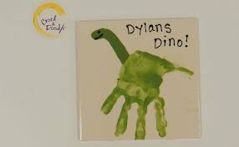  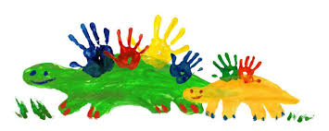  Coloured paints  Paper  Googly eyes  Pens or pencils
KS1 Literacy: Phonemes | When Max is on holiday, he goes for a fossil hunt on the beach. Make some laminated ‘dinosaur bones’ with focus phonemes on, and bury them in a sand pit. Give children the opportunity to dig up the fossils. Can they arrange the sounds to make different words? | Laminated dinosaur phonemes such as  https://www.twinkl.co.uk/resource/t-w-8379-phase-2-phonemes-on-bones  Sand pit  spades
KS1 literacy: Writing Frames | Provide a ‘top trumps’ –style writing frame for children to then draw their chosen dinosaur and record a favourite dinosaur fact. | Cards with a printed top trumps writing frame such as https://www.tes.com/teaching-resource/top-trump-template-11460588  These websites are good sources of information: www.bbc.co.uk/cbeebies/curations/dinosaur-facts  www.kids-dinosaurs.com/dinosaur-facts.html
KS1/2 Literacy: Writing a letter | Write a letter to the museum dinosaur from the class or for older students, individuals (give us plenty of time to reply in advance of your visit!) or set up a temporary email account for Dinosaur Dora, and using the questions that children originally came up with, write her an email from the class. Older children in the school could be asked to find out the answers, so that ‘Dinosaur Dora’ can email back. | Writing frame such as https://www.twinkl.co.uk/resource/t-t-10844-dinosaur-writing-frames
KS2 Literacy: Poetry | Research dinosaur poems, then students choose their favourite. They can write their own poetry, after visiting the museum. | Dinosaur shape poem writing frame  https://www.google.com/search?safe=strict&rlz=1C1GGRV_enGB818GB818&tbm=isch&sa=1&ei=ZkOCXM2dNJLnxgO244uQDA&q=dinosaur+writing+frame&oq=dinosaur+writing+&gs_l=img.1.5.0l10.5239.8387..10873...0.0..0.79.1155.18......0....1..gws-wiz-img.......0i67._694oCIKyNQ#imgrc=ukwgRPuSjiLuuM:  A good place to start researching is https://www.poetryfoundation.org/search?query=dinosaur  https://www.pinterest.com/pin/69383650486805291/
KS1/2 P.E. and Drama: move like a dinosaur | In one of his letters to Max, the T-Rex boasts that he would probably win all the races at sports day. Set up some ‘Dinosaur races’ which might involve running on four legs, jumping, swooping or wading through a swamp. For older children, ask them to design a dinosaur sports day or agility course, linking in to facts about dinosaurs. Alternatively, use dinosaur activities as a P.E. warm up. For younger children, fix a picture of a dinosaur to each of the faces on a large dice. Underneath each picture, write a dinosaur action (jump, swoop, run, stomp, swing your tail etc). Children take turns to roll the dice, and then everyone has to join in with the corresponding action. | Movement dice such as  https://www.pinterest.com/pin/123215739783995281/  P.E agility equipment
KS1/2 Maths: Measurement | In the story of ‘Dear Dinosaur’, T-Rex tells Max that he is longer than a bus, has a head the size of a sofa and teeth as long as a ruler. Work out how long these distances are, and draw out a T-Rex outline in chalk on the playground, so children get a sense of the sheer size of this dinosaur. How many children would fit along the length of a T-Rex? Older children can make a prediction of the sizes of different dinosaurs, and then research these or visit the museum to see if you were correct. (You can compare this to the diplodocus at the museum). | Rulers and measuring tables  Access to internet to research sizes of buses and sofas  Table to record results
KS1/2 Maths: Shapes | Provide children with a range of different 2-D shapes, and ask them to arrange them to create a Shapeosaurus dinosaur, as an opportunity to explore the features of these shapes. How many different shapes have you used for your dinosaur? How many squares are there? How many triangles? Have you used any shapes with curved sides? For older children, provide a range of shapes to convert into different dinosaur outlines.  Alternatively have a dinosaur fruit snack- children make their dinosaur shape out of fruits for snack time (see picture) | https://www.twinkl.co.uk/resource/t-t-16411-build-a-shape-dinosaur-activity  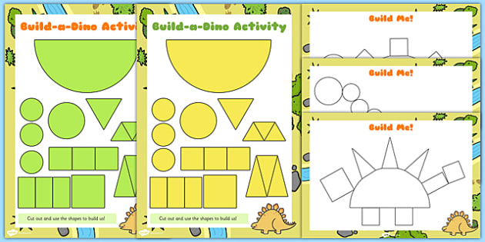  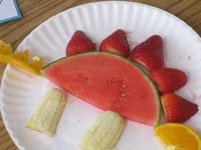
KS1 Maths: food shapes art | In the story, Max invents a ‘Sausagesaurus’ dinosaur. Look closely at his drawing. Provide a range of fruit and vegetable halves that are interesting shapes (e.g. pepper, pear, broccoli, carrot, apple, grape) and support children to do some printing of the shapes onto paper. Once the paint has dried, they can use felt pens to add dinosaur features, bring the Pearodactyl or Potatosaurus to life. | Fruit and vegetables (like potato printing)  Tools to cut out shapes (can premake shapes)  Paper  Paint
KS1/2 Maths: dino footprints and scaling up (ratios) | You could make dinosaur footprints using toy dinosaurs then work out how big they would be in real life and scale up the drawing.  Then use a pantograph (see picture) or software or a tablet to enlarge the prints to the correct size. | 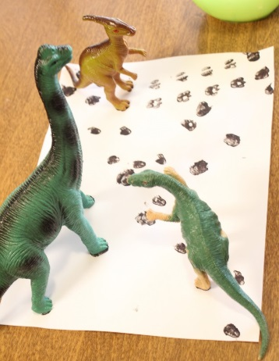  Paint  Dinosaur toys  Paper  Rulers  Internet access  Pantographs:  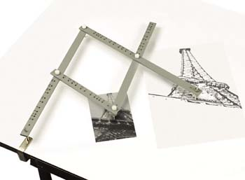
During your visit:
Create an immersive experience with looking at the fossils and living creatures, reading and interacting with the special gallery interventions that start to explain the connections between dippy then and his world and how life today is different and, in lots of cases, under threats. Get an introduction to the threats humans pose for more work back at school.
KS1/2 Literacy:  reading | Read books | Bring your dinosaur stories with you
KS1/2 Literacy: words for dinosaurs | As part of your visit give each child an a5 card folded like a card.  Ask them on the front to write down:  - the name of a dinosaur of your choice e.g. Tyrannosaurus or Diplodocus  Ask them inside to think of:  - a verb and an adverbs to describe how they would move, e.g. stalk menacingly or run elegantly. You can draw a picture of them in the centre of the inside.  - adjectives to describe nouns by describing how parts of your chosen dinosaur looks e.g. rough skin, beautiful feathers, or bright eyes. You can help by naming a part e.g. eyes and then getting children to say describing words such as dark, angry, red, etc. You can ask them to label their drawing with these words. To extent children, ask them to write a simile e.g. the teeth are sharp as knifes.  - Add some Key science facts such as if it is a predator or prey, names of parts of its body, when it lived etc (for older students)  Ask them on the back to write down:  - How did seeing the dinosaur make you feel e.g. terrified, impressed, amazed. You can provide a starter sentence: If I saw the dinosaur in real life I would be…e.g. scared, happy. Draw a picture of themselves (could add meeting their dinosaur) on the back.  To differentiate you can provide suggested word lists. You could get the children working in teams. This can then be used back at school to create a story book, by turning the words into a story and colour the picture (or poem by linking all the words chosen on the visit) or an infographic (see picture) | A5 card folded like a card  pencils, one for each student/group  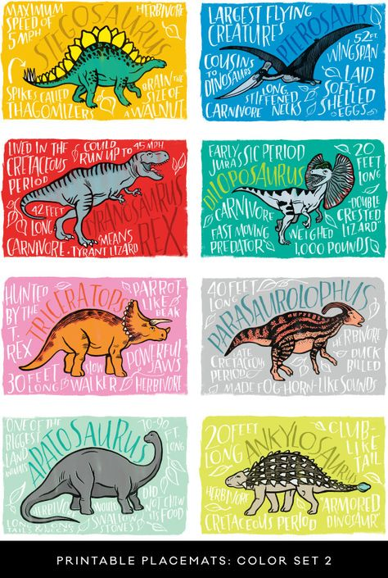
KS1/2 Maths: Measurement | Before your visit you may have measured the details from the story ‘Dear Dinosaur’ that the T-Rex tells Max that he…  - Is longer than a bus  - has a head the size of a sofa  - has teeth as long as a ruler.  - How many children would fit along the length of a T-Rex?  Can the children remember these measurements? Ask the children to complete the statement that a t-rex is as long as a….? his head is the size of a …? His teeth are as long as a …..?  Measure the length with the children in a) children standing shoulder to shoulder and b) if each child is roughly 1m and there are 26 children (or however many there are), how many metres is this? Check them for real by measuring the t-rex skeleton in fossil stories gallery. Repeat these measurements for the diplodocus skeleton. | Measuring tape, a short ruler (15cm).  You can ask us to borrow child friendly Vernier callipers to measure the size of their heads arms etc, very fun!  See the resource: teacher notes on diplodocus versus tyrannosaurus  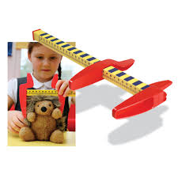
KS2 Maths: Scale | In your time to visit the diplodocus or the t rex skeleton or similar, measure the lengths of the skeleton and key body parts, record this is a table (can predraw this table, with headings such as length of body, head, eye, tooth, arm, leg, foot, toe etc and the columns for different dinosaurs such as T. rex versus diplodocus etc) and then work out the scale to draw it on a piece of A4 paper. Draw to scale an observation drawing. | A4 Paper (possibly graph paper would work best), pencils, rulers, measuring tapes, premade tables.  To extent the learning, use scale elevation and triangulation  https://www.tes.com/teaching-resource/angle-of-elevation-scale-drawing-worksheet-11222017  some more information on how to draw to scale  http://deffufa.info/grid-drawing-worksheets/
KS/2 Science: living or non living, alive or dead (explaining taxidermy or extinction) | To understand that dinosaurs are no longer living on the planet, the children first will need to know the difference between living and non-living things. Here is a suggested trail for you to lead your children on to explore the concepts of dead, extinct and endangered.  - To do this ask the children to think of something that is alive, such as a plant or bird in the garden area of the museum (if you have time, start outside on the lawn/gardens of the museum).  - Next ask the children to find something in the museum that is non-living, such as a pot in the Sheferton (Ancient Greek) Gallery. Then discuss the difference between living and non-living things.  N.B. use MRSGREN to remember the 7 features of living things, which are:  - Movement (move themselves without motors the wind so walk fly swim etc)  - Respiration (breathe)  - Senses (have senses to tell them information such as touch)  - Growth (grow)  - Reproduction (make more of themselves  - Excrement (get rid of waste from their bodies ie wee and poo!)  - Nutrition (need to make/eat food)  - Of those things that are living, they need to know the difference between alive or dead. To do this go to Natural Northumbria (local wildlife) Gallery and find a taxidermy animal such as the Chillingham cow. Ask the children if this is living or non-living. Then explain that these were once living but have died (peacefully and naturally) and to preserve them so we could see their beauty in life, we have kept their skins and filled it with fluff to show their natural shape and be able to see them much closer and in more detail than if they were alive. Reinforce to the children that these animals were once alive but are now dead and so are all living things.  - Next go to the Ancient Egypt Gallery next door and look for something else that was once alive but has died and been preserved (mummies!) and reinforce the idea that humans are living things too.  - Next go to the Ice Age to Iron Age Gallery and find something that was once alive but is now dead (great Elk or Wooly Mammoth). Ask the children: Are there any wooly mammoth alive today? But once lived? Do you know the name for livings things that have all died out completely? (Extinct). You could also do this in Fossil Stories Gallery as it may be easier to understand extinction in the dinosaur area and then reinforce this idea of extinction with the wooly mammoth.  N.B. living things alive today are called extant.  - Now you can look at the Living Planet (world wildlife) and also the Natural Northumbria Galleries to look at species that are living today (extant) or extinct. Explain to children that if there are not many left alive today we say they are endangered. Normally this is due to humans, via hunting, habitat loss or completion for food. Point out some examples… both in the world and particularly in our locality:  Hedgehogs- habitat loss  Red squirrels- competition from introduced species grey squirrels that carried a squirrel pox.  Red kites- were endangered and reintroduced in areas successfully  Starlings- still large numbers but massive species decline due to habitat loss  Puffin- overfishing in North Sea of sand eels, which they feed chicks on  Bees- habitat loss | 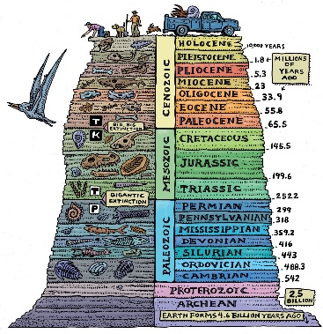  useful diagram for looking at time periods  See the resource: teacher notes on diplodocus versus tyrannosaurus
KS1/2 Science: feeding – what dinosaurs ate | There is a wealth of activities that can be done around what dinosaurs ate- we can look at teeth and fossilised stomach contents and coprolites (fossilised poo!) to tell us about what extinct animals ate.  N.B. Recently a fossilised food chain has been found (a fossilised snake contained a fossilised lizard which had just eaten a beetle)!  Explore the dinosaur fossils in the Fossil stories Gallery and look at teeth:  - Herbivores: flat with ridges (like our molars) for grinding and chewing, or nipping teeth (like our incisors) to peel parts of plants off (see dippy’s incisor-like teeth)  - Carnivores: sharp and pointy teeth (like our canines),  - Omnivores: show both kinds of teeth (like ours!)  Look at the plants in the Fossil story gallery and then visit the gardens to look at plants herbivores would have eaten, horsetails, conifers etc that are in the display and compare it to plants nowadays (no grass or flowering plants were around in dinosaur times)  For older children you could try to find examples of food chains and webs, looking at producers, primary consumers, secondary consumers, and apex predators at different geological time periods within the gallery. E.G. find the Ichthyosaurs and then work out what they might have eaten ( the clue is hanging next to them- Belemnites)  N.B. T rex did not predate Diplodocus as they lived in different times. | See: https://www.calacademy.org/explore-science/food-webs-before-the-impact to extend your students.  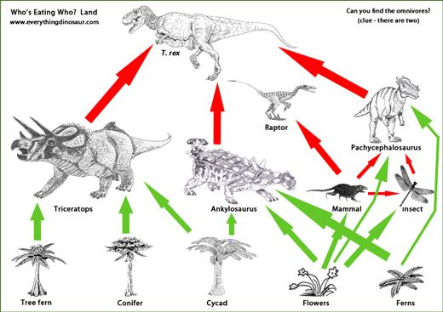  See the resource: teacher notes on diplodocus versus tyrannosaurus
Following your visit-
You will have seen how the past climate was different to today. But our planet is changing due to climate change, habitat loss and damage to the environment caused by human activities. Now what does this mean for life today? What can we do to change our future- young people are the voice of the future!
What is climate? | It’s important to understand the difference between weather and climate if you are to understand climate change. Essentially, weather is what happens day to day, while climate is a long term average (often 30 years is used). That means that you can have a cold snap during a phase which is generally getting warmer and it does not mean global warming is a myth! Or as it is put in a quote which the Meteorological Office use:  In the words of Robert Heinlein, "Climate is what you expect, weather is what you get". Perhaps even more simply, "Weather is how you choose your outfit, climate is how you choose your wardrobe".  Discuss what the children understand by weather (get them to describe different weathers) seasons (weather in certain time periods) and geographical climates (get them to describe regions of earth such as the rainforests vs tundra). | The Meteorological Office have a good guide to weather and climate at:  https://www.metoffice.gov.uk/climate-guide  including a video clip which should be accessible to UKS2 and older. You can click through to lots more resources from them around climate, climate change, the water cycle and some great infographics of the evidence for changing climate.
Looking back in time to past climates | We can show the children what the climates of Britain would have looked like back in time. We can ask them to match images of what the climate meant and what life was around.  In the past there were crocodiles in the artic what do you think the artic looked like then? | The British Geological Survey website has lots of great information.  Britain’s ice ages:  https://www.geolsoc.org.uk/ks3/gsl/education/resources/rockcycle/page3585.html  https://www.dailymail.co.uk/sciencetech/article-5803855/Interactive-map-reveals-Britain-looked-like-ice-age.html  Britain in a warmer climate with lagoon, lake and fluvial environments:  https://www.bgs.ac.uk/discoveringGeology/time/timechart/phanerozoic/cretaceous.html  Britain in hot, dry desert conditions:  https://www.bgs.ac.uk/discoveringGeology/time/timechart/phanerozoic/permian_triassic.html
What is climate change? How are humans changing the climate? | So here is where we talk about how human actions have impacted on our climates:  Global warming caused by emissions  Cutting down trees which absorb carbon dioxide  Removing habitats that lock away carbon dioxide (carbon sinks such as bogs)  Then as a class, discuss and create an image to reflect the climate of the future.  This activity can be turned into a series of stained glass windows for your classroom using bits of tissue paper collaged inside black pen outlines on acetate sheets (like florists wrap) from the different climates of Britain. An alternative to this would be to make tapestries for the classroom. | The Guardian produced a digest (in 2014) of how to teach climate change which can be found at: https://www.theguardian.com/teacher-network/teacher-blog/2014/mar/03/how-to-teach-climate-change  Rainforest Alliance discuss how to talk climate change to children without inducing tears and panic: https://www.rainforest-alliance.org/articles/how-to-talk-to-kids-about-climate-change  If you want the most up-to-date and internationally agreed information about climate change, the place to find it is from the Intergovernmental Panel on Climate Change (IPCC): https://www.ipcc.ch/
What can we do about it? | It can be depressing to think about what is happening to our climate and the environment more broadly. You may have heard of calculating your carbon/environmental footprint to see what impact you are having.  A more positive approach could be to calculate your carbon handprint.  Have a discussion on what are the positive things you are doing to help the environment?  One positive thing you can do for the climate and the environment more generally is to grow plants. Trees take up lots of carbon as they grow and wildflowers help bees and other insects and form the base of food webs.  The United Nations Sustainable Development Goals link global challenges we all face and structure ways in which we can find solutions. Lots of organisations use them to talk about the work they are doing around poverty, health, gender equality and education, but also climate action, life on land and in the seas, energy and production. | http://www.parkcitygreen.org/Calculators/Kids-Calculator.aspx  http://www.carbonhandprint.org  http://climatechangeconnection.org/wp-content/uploads/2018/04/Ecological-Handprint-2018.pdf  You can find ideas about climate change prevention at: https://www.wildaboutgardens.org.uk  They can form a great way to start talking about international efforts to work to a better future. The UN’s own website is a great starting place for this: https://www.un.org/sustainabledevelopment/sustainable-development-goals/ with facts and figures, targets, ‘why it matters’ sheets and links to follow.  You can download a Sustainable Goals in Action app from https://sdgsinaction.com/ which gives you news and ideas and allows you to create and join events.
Young people making a difference | If your pupils need to be convinced that young people can make a difference (and with the slight danger of bringing on a climate strike) you could introduce them to the campaigning work of Greta Thunberg, the Swedish activist teenager.  You could write to your local MP as a class or individually or see the final idea suggestion below about a video or assembly to teach others what they have learnt and how they can make a difference | https://www.ted.com/talks/greta_thunberg_the_disarming_case_to_act_right_now_on_climate
Artists highlighting climate change | Artistic responses to climate change can be really powerful and a great way to study and covey the significance of climate change.  Or if you are really clever, you can use graphical data on climate change as a basis for your art! Such as Jill Pelto:  Her illustrations depict the same kind of graphs you might find in a textbook (decline in glacier mass balance; ocean acidification; deforestation) overlaid with watercolour paintings of the affected natural wonders, bringing the research to life.  For younger children, provide a black and white outline to colour in. For older students, create a results table of animals of a particular species use this to plot a graph.  Draw lines of best fit.  Sketch onto tracing paper, then create art in the lines you have drawn, linked to what the data in the graph shows you.  This is an ideal subject for an Artsmark discover award. | Start conversations on climate change:  https://www.theartnewspaper.com/news/artists-deliver-climate-change-message  http://theconversation.com/can-art-put-us-in-touch-with-our-feelings-about-climate-change-77084  https://www.pbs.org/newshour/arts/artist-captures-climate-change-in-7-stunning-watercolors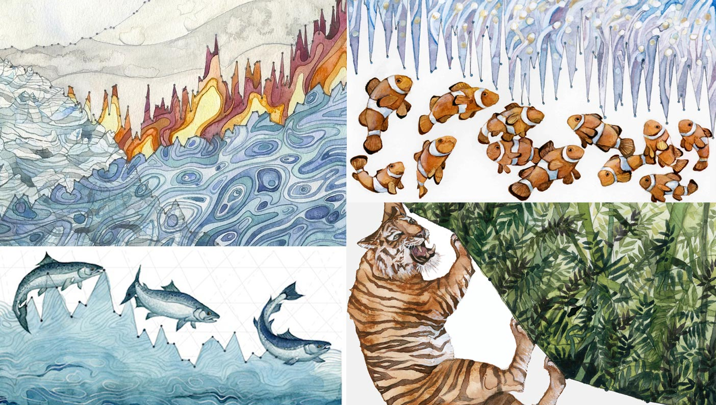  https://www.smithsonianmag.com/arts-culture/these-watercolor-paintings-actually-include-climate-change-data-180958374/  https://www.climate-lab-book.ac.uk/
Final project | Following your visit you can review the learning and create a video of ‘what we learned’.  The class can help plan the script, choose images to go with the text and then you use an app that adds their voice over to a video with images such as: Sonic Pics.  You could make an assembly for the parents and other children in the school, based on what you have made and help teach them the importance of what they have just learned. | Sonic Pics app http://www.sonicpics.com/  Tablets

