Camera Trapping Tips and Tricks
Deploying your camera
Before heading out, make sure you have everything you need to set up your camera trap
- Clean memory card
- Charged batteries
- Strap or cable lock to fix your camera in place
- Ruler/tape measure to measure height of camera trap
- Notepad or data sheet and pen/pencil
Set up and position
Start by checking the settings on your camera. It is important to check that the time and date are set correctly, please set this to GMT time, also be aware that most camera trap models use the American date system (MM/DD/YYYY). Make sure the mode is set to camera (not video), photo number is set to 3, and interval is set to 1 minute. (If you are unsure about this please refer to the Hancock MammalWeb instruction guide.)
When fixing the camera in place, get a helper to stand/crouch at the spot you are aiming the camera at and ask them to check you are aiming the camera lens in the correct direction. Try to aim your camera at a clear area, with no obstructions.
Crouch next to the camera to get a look at where it is aiming, if you have a smart phone you can even try placing your phone camera in front of the camera trap’s lens and taking a picture of the view from its location, to give you a better idea of where your camera trap is pointing.
When you are happy with your camera placement, remember to turn it on! This is surprisingly easy to forget…
Keeping records
It is easy to forget when cameras were put in which location, especially if you are trying out a few different spots – so it’s important to keep track. It might help to make a data collection sheet that you can take with you, or take a notebook, to keep records of camera deployment and collection.
Site | OS grid reference | Deployment date | Deployment time | Collection date | Collection time | Can the camera see water | Camera height
School field 1 |  | 17/12/2018 | 14:30 | 11/01/2019 | 10:00 | No | 60cm
Woodland |  | 11/01/2019 | 10:30 | 25/01/2019 | 09:45 | No | 45cm
School field 1 |  | 25/01/2019 | 10:30 | 08/02/2019 | 14:15 | No | 60cm
School field 2 |  | 11/02/2019 | 14:45 |  |  | Yes | 50cm
E.g.

You can use a smartphone apps to get an OS grid reference for your current location (e.g., https://itunes.apple.com/gb/app/gps-os-grid-reference/id993436655?mt=8). There are also websites where you can convert postcodes into OS grid references (e.g. https://gridreferencefinder.com/). Alternatively, you can wait until you upload your photos then find the camera location grid reference on google maps.

Storing your photos
It is helpful to keep your photos organised on your computer. This way you will know exactly which photos came from each camera and when. This will make uploading your photos to MammalWeb easier.
For example, if you have moved your camera between a few different locations you could make a folder for each location.

Within each site folder you can make a folder for each deployment period. Naming the folders with the dates is a good way to stop photos from different deployments getting mixed up!

When you have created your folders, you can simply drag and drop the photos from the camera trap SD card into your folder. Then, when you come to upload your photos to MammalWeb, you will know exactly where to find them.

Once you are happy that all your photos are safely saved onto your computer and uploaded to MammalWeb it is good practice to format your memory card before placing your camera trap back out. This will delete all data from the card and will help prevent confusion between photos collected from different sites. It also prevents the memory card from becoming full, as it will then stop storing photos even if your camera trap is still taking them.

Uploading your photos to MammalWeb

Navigate to the ‘Trapper’ page on the MammalWeb site.
If you have kept your camera in the same location you can simply upload more photos to that site by clicking “upload” and entering your new deployment times.
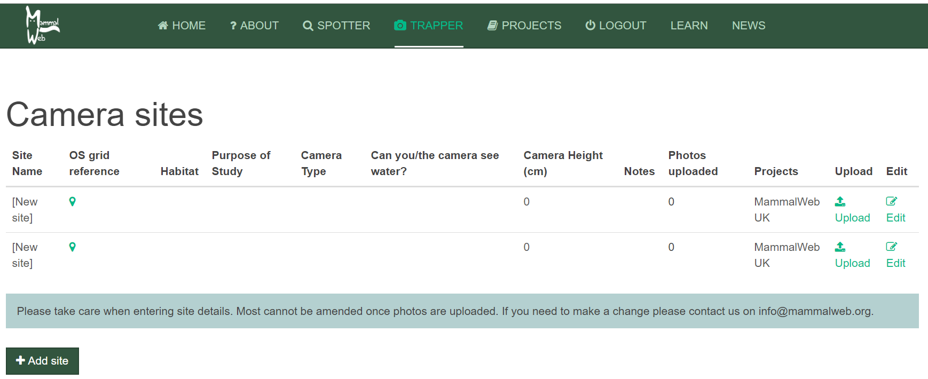
If you have placed your camera in a new location you can add a site here.
You can edit the details of a new site after clicking this ‘edit’ button.

Projects: A drop down with a list of all MammalWeb’s projects. Your project will be your school’s name.
Can the camera see water: A drop-down with yes/ no options.
Camera height: enter the height your camera is placed at.
(It is useful to make a note of these when setting up your camera).

Purpose of Study: A drop-down box will show different options. For this project we would like you to select ‘Part of scientific study – random’.
OS grid reference: If you click on the marker, it will take you to Google Maps. You can then enter the grid reference in the box at the bottom if you already know it, or you can mark the location with the marker by zooming in and moving it to the correct spot. Grid references are in the form ‘NZ 27623 41214’. If you are entering a grid reference directly (rather than from the map), please ensure that you enter at least 8 digits after the 2 letters at the start (i.e., 4 of the first group of 5 numbers, and 4 from the second group).
Upload: Clicking here will display another box where you can start the process of uploading your photos.
Site Name: It is helpful to choose a name you can easily recognise.
Notes: Here you can make any other notes that you feel may be important for your camera.
Camera Type: All the cameras given out as part of the Hancock ‘Dippy’ schools project are ‘Ltl-Acorn 5310’.
Habitat: A drop-down box of habitat options. Choose the one which best describes the immediate surroundings (say, within 10m or so) your cameras location. (But don’t worry about it being an exact description).

You can click here to check which photos you have already uploaded for this site.

Enter the dates and times of the deployment period for the photos you would like to upload.

Then click ‘upload’, which will bring up this display…

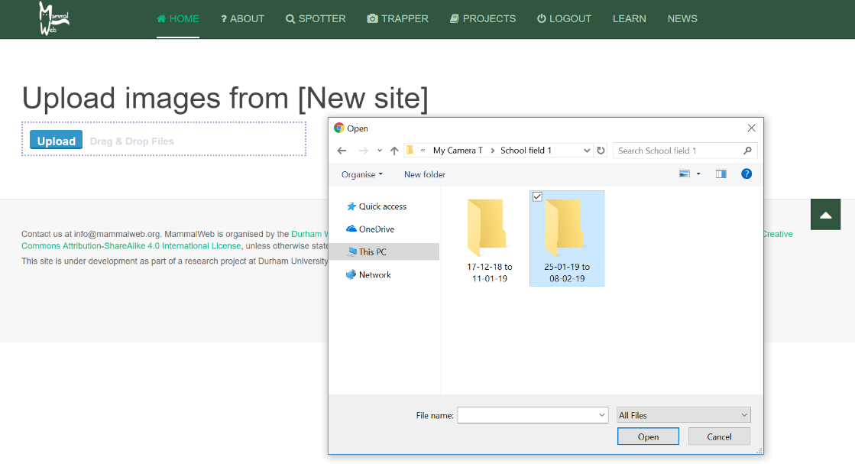

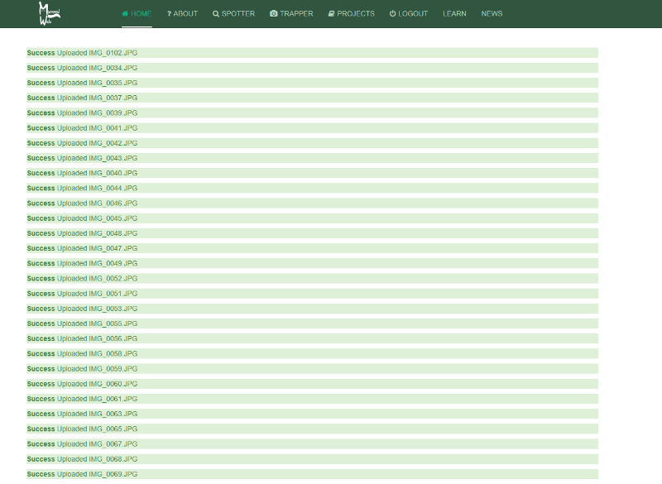
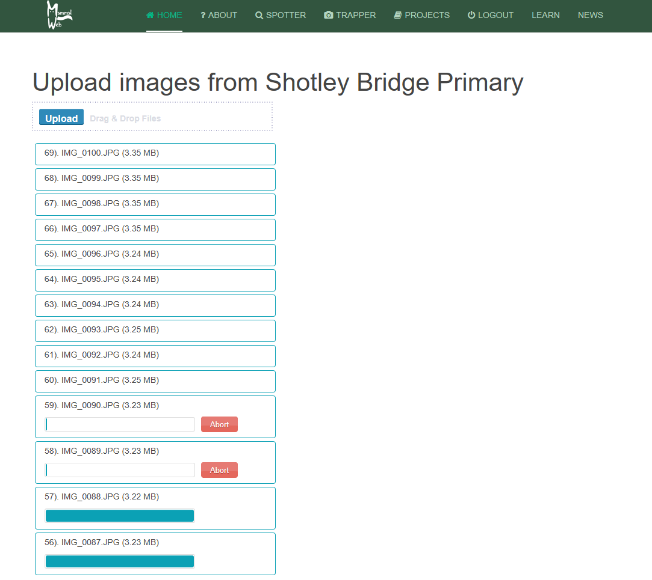
You can either drag and drop photos straight in to the box or press the ‘upload’ button then navigate through your folders to find and select the images you want to upload.
You will need to keep this page open whilst the photos are uploading. As they are uploading each photo will have its own progress bar, which will turn green when the photos are successfully uploaded.
(If you have lots of photos and a poor internet connection you may have to upload images in smaller batches).

