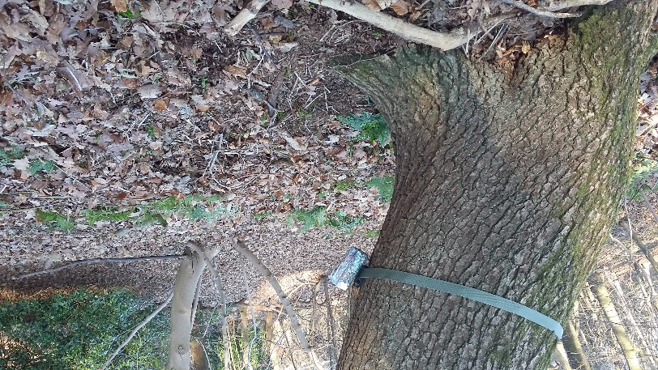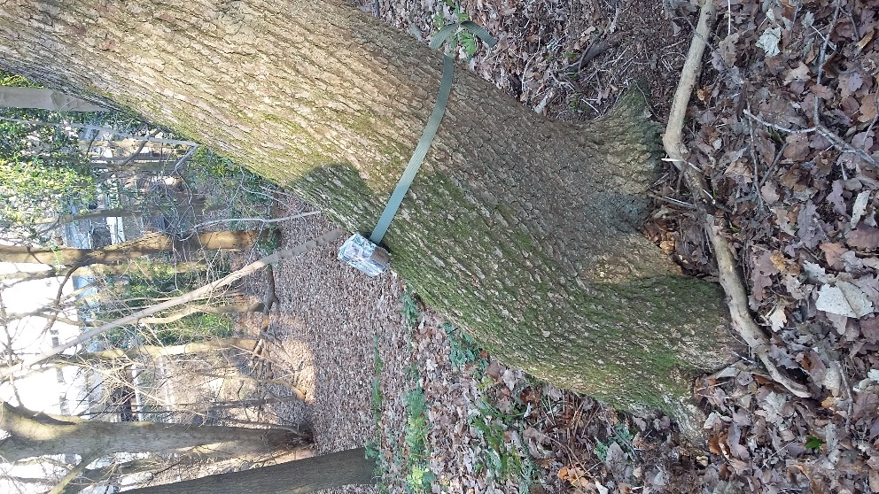

This camera is angled too steeply towards the ground. This reduces the amount of area that can be captured in a photo, meaning you may record fewer animals.



**MammalWeb’s Tips for Good Camera Trap Placement**

This camera is angled too steeply upwards. This means most animals will walk beneath the detection zone of the camera making it less likely to be triggered. Even if it is triggered, you are likely to just end up with a picture of the sky!

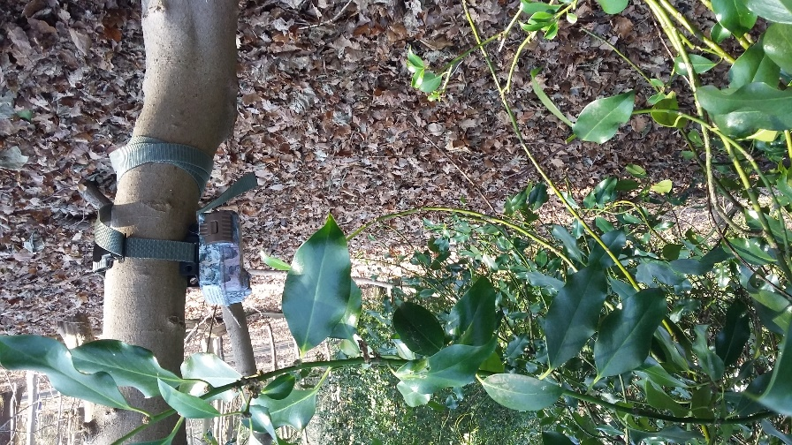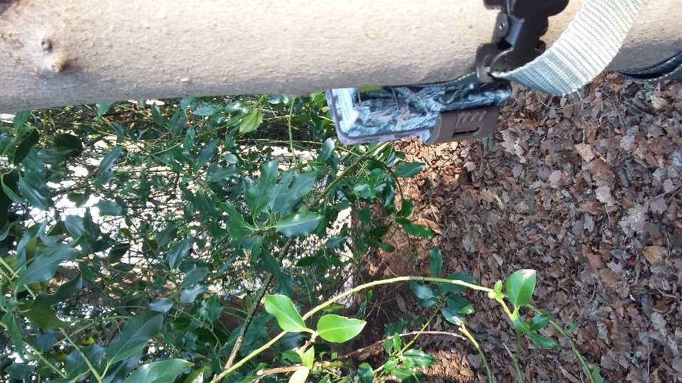

This camera has been placed too close to vegetation. This will obstruct the view of the camera and waving branches in the wind will cause false triggers (i.e. it will end up with lots of pictures of the bush and not much else!)

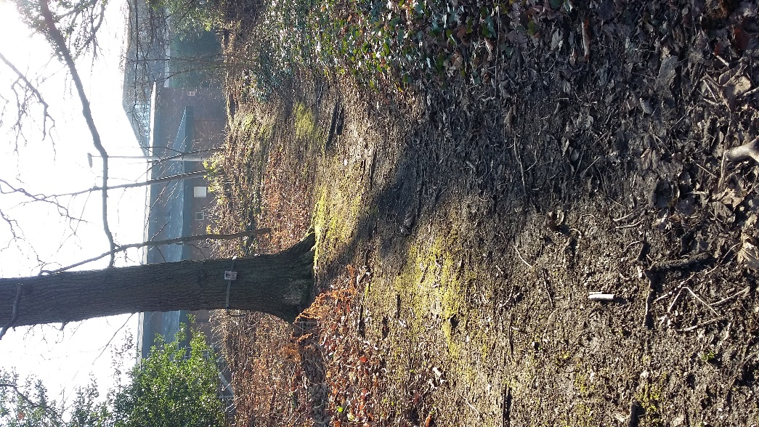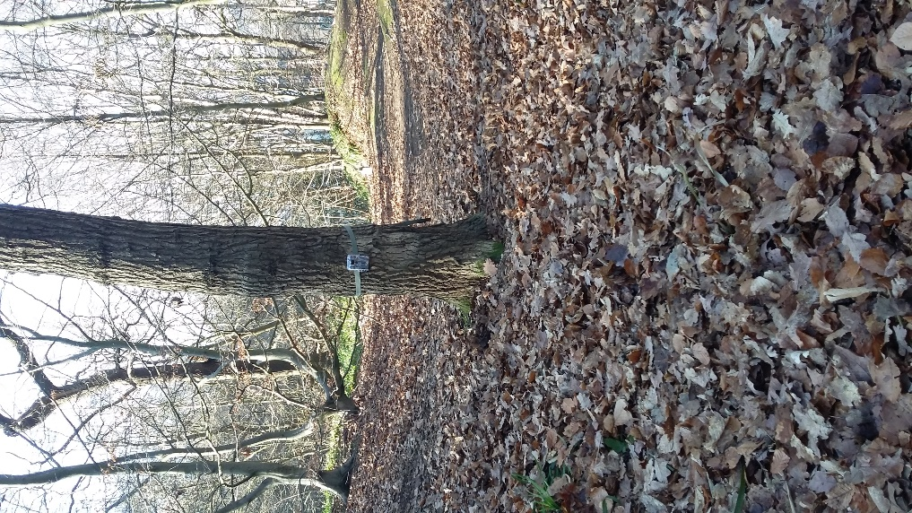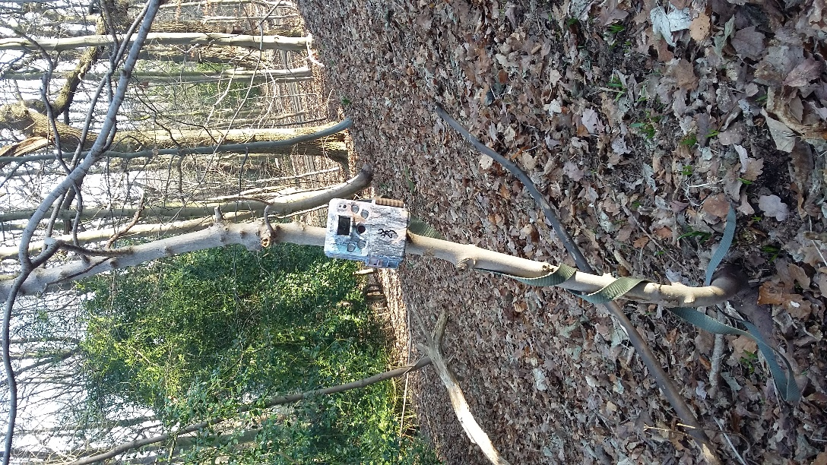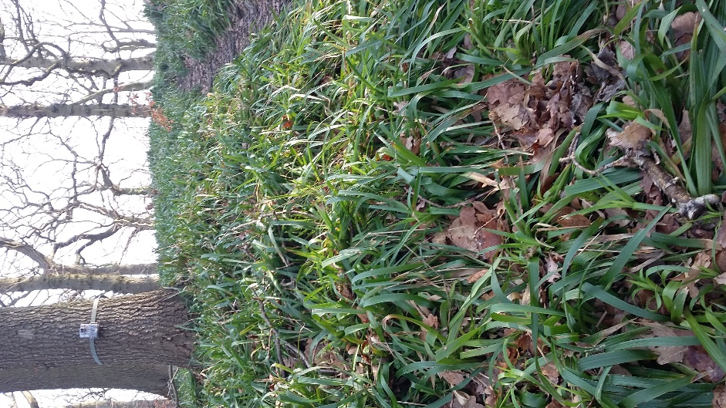

They have a good clear area of space in front of them.

They are approximately 2 feet off the ground.

They are facing straight ahead, not tilted towards the floor or the sky.

They are aimed at a spot roughly 3 to 5 metres away from the camera.

They are fastened securely to strong, straight growing trees.

This camera is at the top of a steep hill. This makes it difficult to angle correctly. Animals walking up or down the hill are likely to pass beneath the camera detection zone and be missed.

This tree is too small. It is likely to sway in the wind and this movement can cause your camera to trigger even when there is no animal. Small trees are less secure and can get broken.

These camera placements are good!

