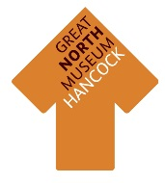
Dippy Schools Butterfly Donation

Name of School:
Additional short line of text (eg class, year group, date)
Address:

School e-mail address:
Donation amount (min £30):

Please make cheques payable to
‘Tyne and Wear Archives and Museums Development Trust’
and include them when you send this back. If you would like a butterfly but a cheque is hard to do, please get in touch with Kate Holden for other payment options on kate.holden@twmuseums.org.uk

Return this form to:
Dr Kate Holden
Great North Museum: Hancock
Barras Bridge
Newcastle upon Tyne
NE2 4PT

Or bring it with you if you are visiting the museum

Dippy Butterflies will all be in the signature teal colour of Dippy’s tour and will be spread through the other butterflies on the wall as a way of commemorating this project

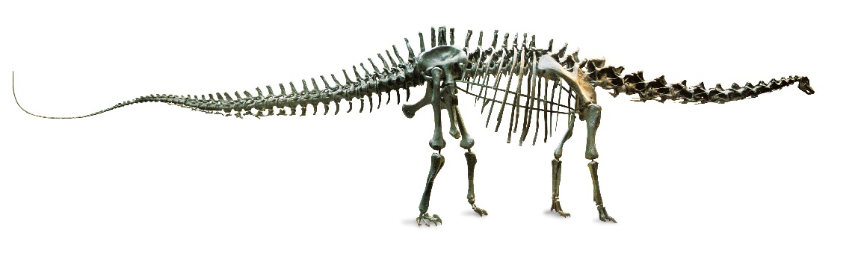
The offer goes extinct after 15 Feburary 2019 so please return forms by then.

