Prehistory explorer kit
To be used in the Ice Age to Iron Age at Great North Museum: Hancock

There are four activities in the suitcase designed to be used by small groups. We would recommend splitting the group into four to rotate them round the activities. It might be advantageous for the same adult to remain with each activity so that each adult does not need to learn four different activities.

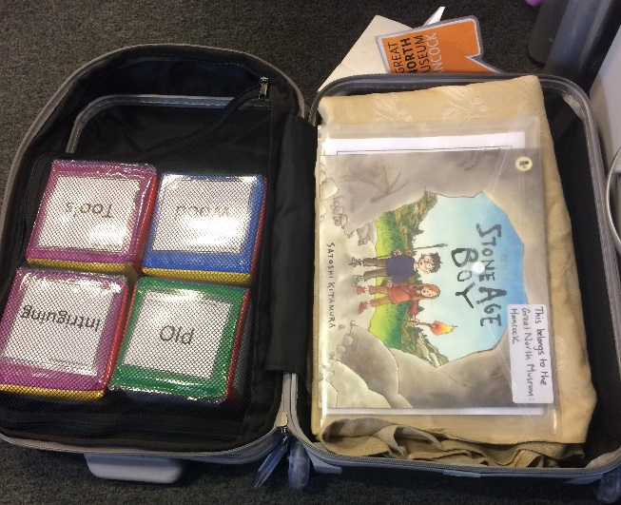

Activity 1 Stone Age Boy by Satoshi Kitamura
Read Stone Age Boy with the group and complete a class book review with the sheets provided.

Activity 2 Map reading ancient Briton
Investigate prehistoric sites using an Ordnance Survey map of Ancient Briton. Keys are provided to see what sites are in the local area and viewing squares and extension tasks are included for more able children.

Activity 3Literacy cubes
Roll a cube and find something in the gallery that links to the word it lands on; themes include materials, ownership and object types.

Activity 4 Archaeological banner of Low Hauxley
Explore what stratigraphy is and learn more about a local prehistoric site at Low Hauxley using a textile banner, photographs and archaeological drawings. There are labels to match to the different features on the banner and a glossary to explain archaeological phrases.
