Roman explorers

These resources have been created to help your group explore the Hadrian’s Wall gallery at the Great North Museum: Hancock.

The activities include:
- Object Eye Spy
- Investigating Roman Numerals
- Measuring the past
- Map the Hadrian’s Wall gallery
- A BIG Question

If you have any suggestions on other resources we can create that would support your groups learning or if you would like to share any of your work with the museum then please email learning@greatnorthmuseum.org.uk
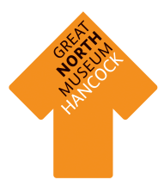

Object Eye Spy

Find all these objects in the Greek gallery and write what they are called beneath them.
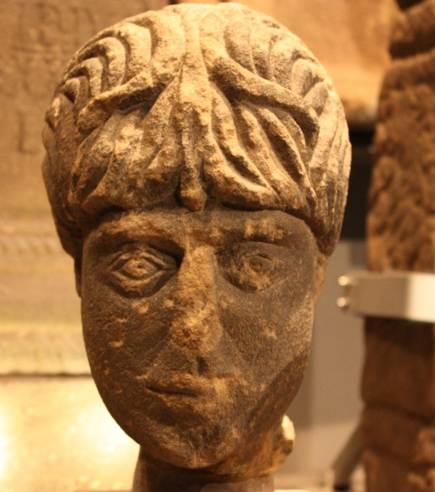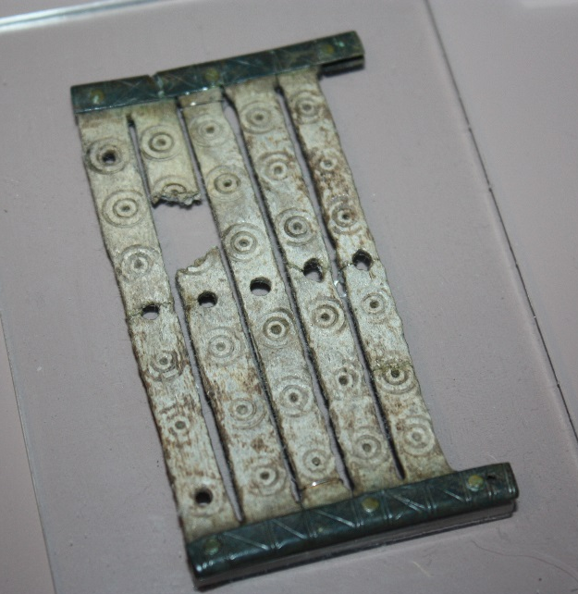

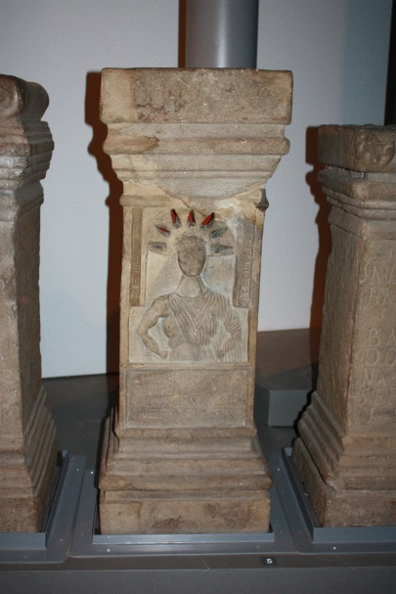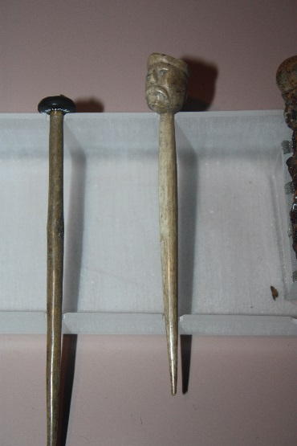

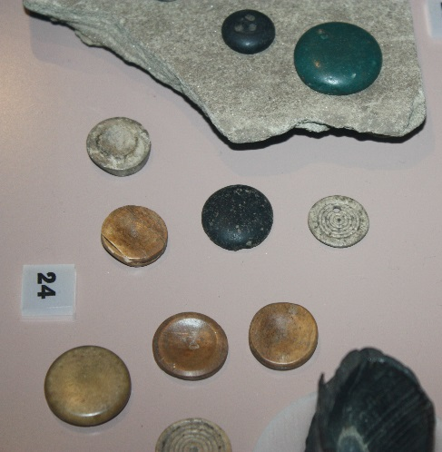

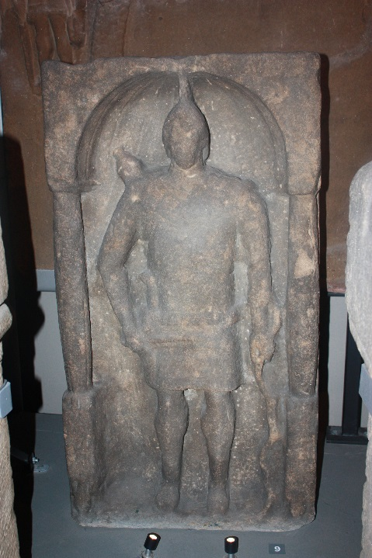

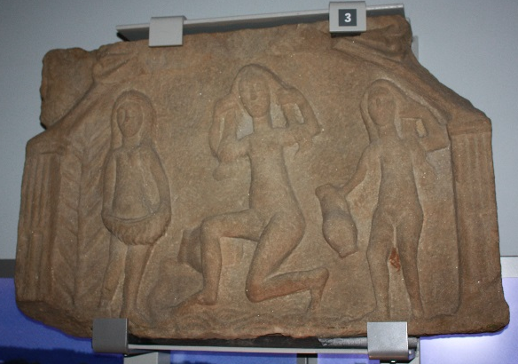

Investigating Roman Numerals

The Roman’s used different shapes to represent numbers and they were called Roman Numerals. Here are some Roman numerals.
1 | 2 | 3 | 4 | 5 | 6 | 7 | 8 | 9 | 10 | 11 | 12
I | II | III | IV | V | VI | VII | VIII | IX | X | XI | XII
13 | 14 | 15 | 16 | 17 | 18 | 19 | 20 | 50 | 100 | 500 | 1000
XIII | XIV | XV | XVI | XVII | XVII | XIX | XX | L | C | D | M

Let’s have a go at using Roman numerals;
 | Number | Roman numeral
Example – when did the museum first open? | 1884 | MDCCCLXXXIV
How old are you?

How many children are in your group?
How many children are in your school?
How many Roman soldiers can you find in this gallery?
How many forts can you see on the Hadrian’s Wall model?
How many faces can you see in this gallery?

Measuring the Past

Objects are very important in helping us to understand Roman life. Which objects survive over time depends on what material they are made from.
Count the number of objects made from each type of material in five cases.
Type of material | Tally of objects made from this material | Total
Earth Materials: stone, pottery, terracotta, clay, bronze, iron, gold, silver.
Animal materials: wool, cloth, ivory, leather, skin, bone.
Plant materials: linen cloth, wood, flowers, reeds.

Circle the type of material that has survived the best.
Earth Animal Plant
Why do you think this is?

Circle the type of material that has survived the worst.
Earth Animal Plant

Why do you think this is?

Choose a starting point and an end point in the Hadrian’s Wall gallery. Draw your favourite objects on the route, remember to label what they are.

Make it your own!
Map the Hadrian’s Wall gallery

A BIG Question

Was it right that the Roman’s invaded different countries to expand their Empire?

Note – there is no right or wrong answer to this question. If you and friends disagree then try and persuade each other with good reasoning why your answer is the strongest with evidence.

