Ancient Greek explorers

These resources have been created to help your group explore the Shefton Collection (ancient Greek gallery) at the Great North Museum: Hancock.

The activities include:
- Object Eye Spy
- Creating a Greek myth
- Measuring the past
- Map the Greek gallery
- A BIG Question

If you have any suggestions on other resources we can create that would support your groups learning or if you would like to share any of your work with the museum then please email learning@greatnorthmuseum.org.uk
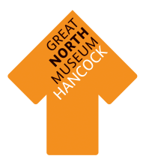

Object Eye Spy

Find all these objects in the Greek gallery and write what they are called beneath them.
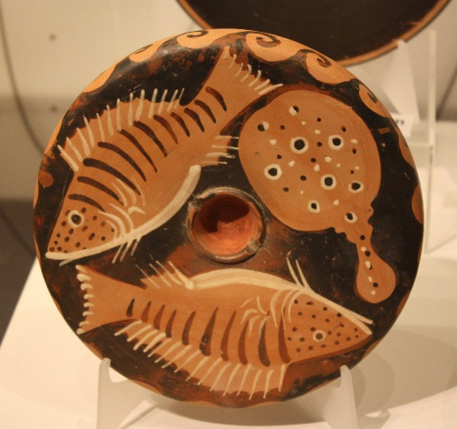

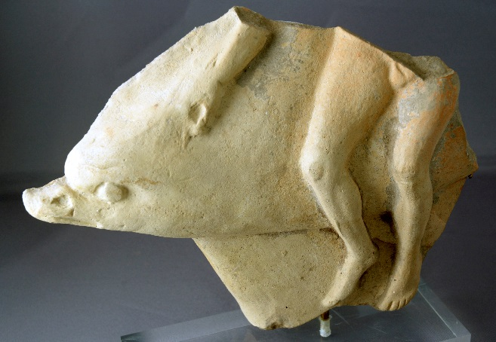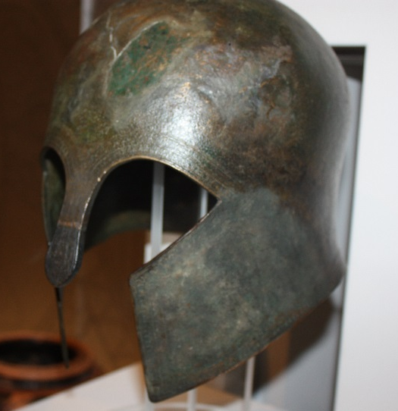

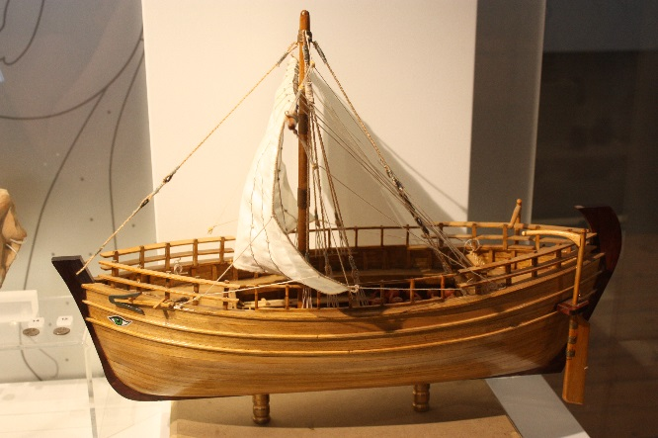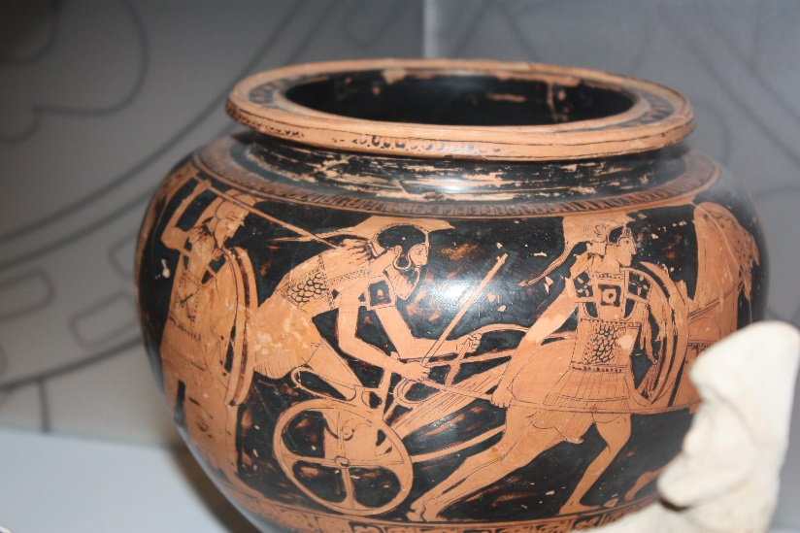

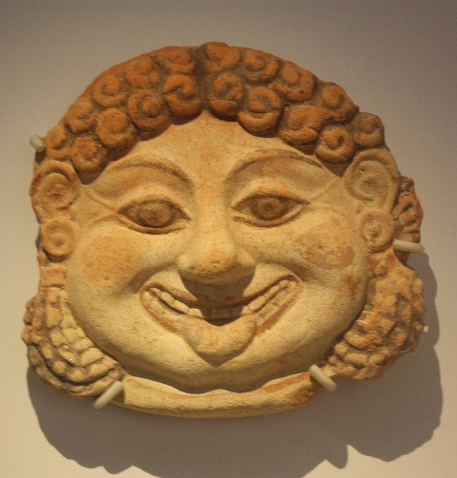

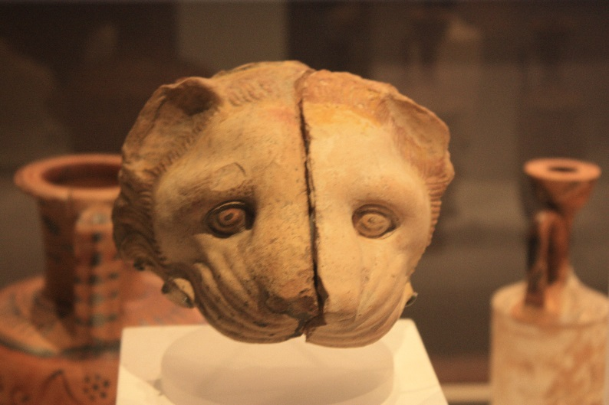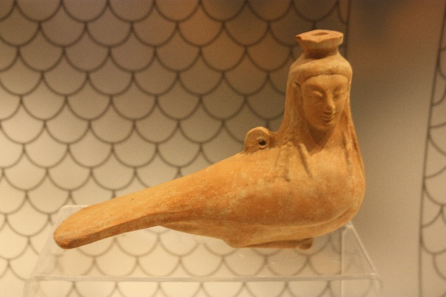

Creating a Greek Myth

To create a memorable Greek myth you need certain ingredients. Use the museum gallery to collect ideas to write your own Greek myth back in school or at home.

Every myth needs a star. What is your hero called? What do they look like? (Remember a hero can be male or female!)
Your hero needs to complete a mission, what is it?
No story would be complete without a mythical creature. What does yours look like?
Which Greek God or Goddess will help you on your journey?

What is the journey like?
Something disastrous happens, what is it? How do you overcome it?
How does your story end?
Sketch below one scene from your myth.

Measuring the Past

Objects are very important in helping us to understand Ancient Greece. Which objects survive over time depends on what material they are made from.
Count the number of objects made from each type of material in five cases.
Type of material | Tally of objects made from this material | Total
Earth Materials: stone, pottery, terracotta, clay, bronze, iron, gold, silver.
Animal materials: wool, cloth, ivory, leather, skin, bone.
Plant materials: linen cloth, wood, flowers, reeds.

Circle the type of material that has survived the best.
Earth Animal Plant
Why do you think this is?

Circle the type of material that has survived the worst.
Earth Animal Plant

Why do you think this is?

Choose a starting point and an end point in the Greek gallery. Draw your favourite objects on the route, remember to label what they are.

Make it your own!
Map the Greek gallery

A BIG Question

Which Greek God or Goddess do you think was the most powerful and why?

Note – there is no right or wrong answer to this question. If you and friends disagree then try and persuade each other with good reasoning why your answer is the strongest with evidence.

