Dinosaur Explorer Bags
The Dinosaur Explorer Bags are designed to be used during your visit to the Fossil Stories gallery. Each bag has a different set of activities exploring an aspect of fossils, dinosaurs, palaeontology and our collection. They work best if you divide the class into small groups, each with an adult, then carousel the groups through the five different bags

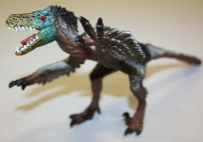
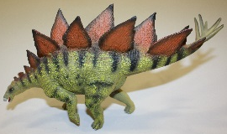
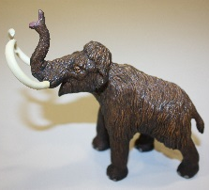
Dinosaur Bag
Use our toy dinosaurs to help decide which ancient creatures are actually dinosaurs, then think about the size of different dinosaurs with a measuring activity.

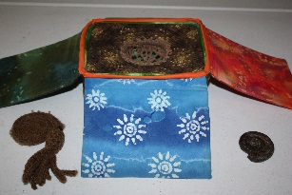
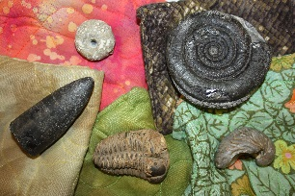
Fossilisation Bag
Explore some real fossils, then discover how the ammonite turned to stone with our story and interactive fossilisation demonstration.

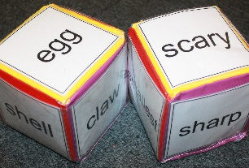
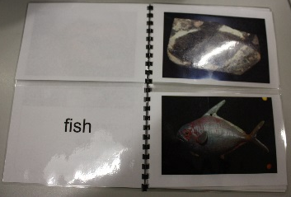
Explore Bag
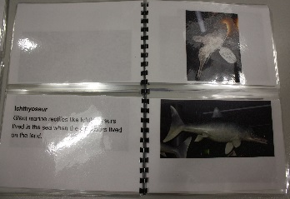
Use the dice to help you explore the Fossil Stories gallery. When you have looked at the fossils on display, use the match the fossils book to match fossils and what they would have looked like when they were alive. The book comes in two versions, for early readers and for confident readers or those with adult help.

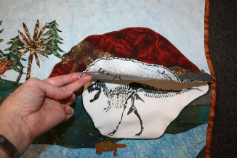
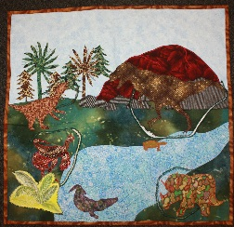
Habitats Bag
Explore the way that dinosaurs and other prehistoric creatures lived together in different habitats. Examine the difference between sea creatures and swamp dwellers and use our lift the flap activity to explore the dinosaurs of Hell Creek and the ancient Northumbrian animals of Newsham Swamp.
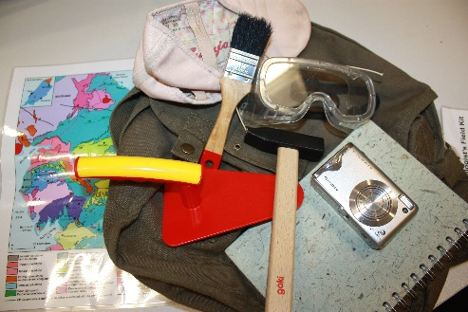
Palaeontologist’s Kit
Have a look through the palaeontologist’s fieldwork bag. Decide what all the different tools are for and whether you would add anything – or take it out.

