Habitat Bags

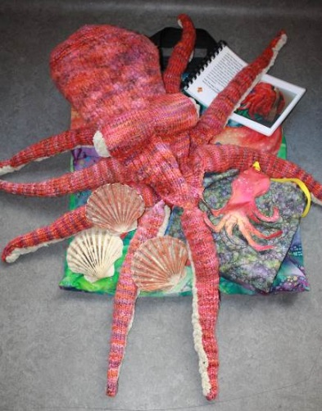
There are seven habitat bags, which are designed to be used in the Living Planet and Natural Northumbria galleries. Each bag focuses on a particular animal and its habitat and contains dressing up material, resources related to the climate in which the animal lives, to what it eats and how it uses its habitat. In each bag is a booklet with questions (and answers!) for an accompanying adult to guide a group of up to around 6 children through the bag and its resources. No prior knowledge is required either for the adult or the children.
Octopus

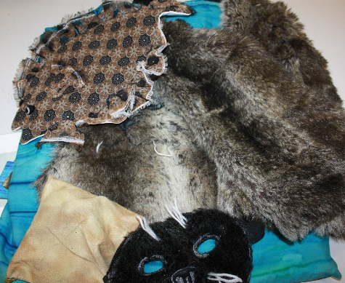
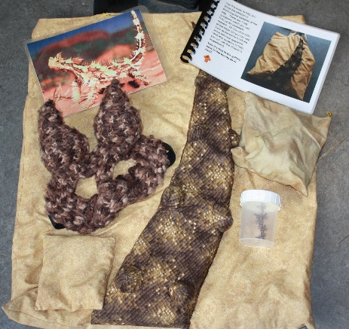
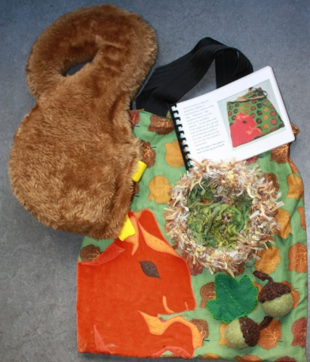
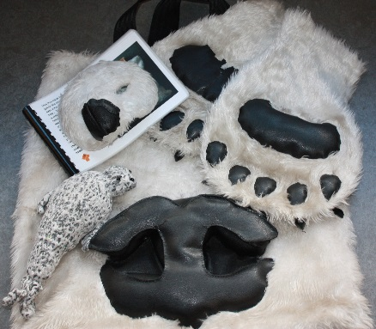
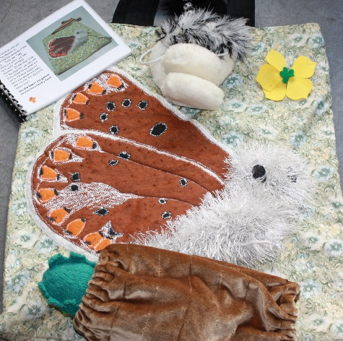
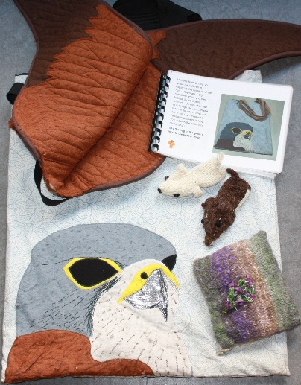
The bags are mainly suitable for use by KS1 and lower KS2 children (although some Reception groups or upper KS2 groups may also enjoy using them).
Seal
Thorny Devil
Red Squirrel
Polar Bear
Butterfly
Kestrel

