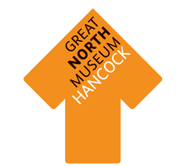
Roman Britain resource box
To be used in the Hadrian’s Wall gallery at Great North Museum: Hancock
There are five activities in the box designed to be used in small groups. We would recommend splitting the class into 5 groups and rotating them around the activities. It might be advantageous for the same adult to remain with each activity so that they do not need to learn five different activities.
Tapestry of a Roman fort Using an Archaeologists drawing match the various labels to the correct place on the Benwell Roman fort tapestry plan.

Character bubbles children should work together to match the speech and thought bubbles to the various characters. There are also blank bubbles for children to fill in their own ideas. They should think about how they would feel if they were A) a roman soldier B) a tribe’s person.

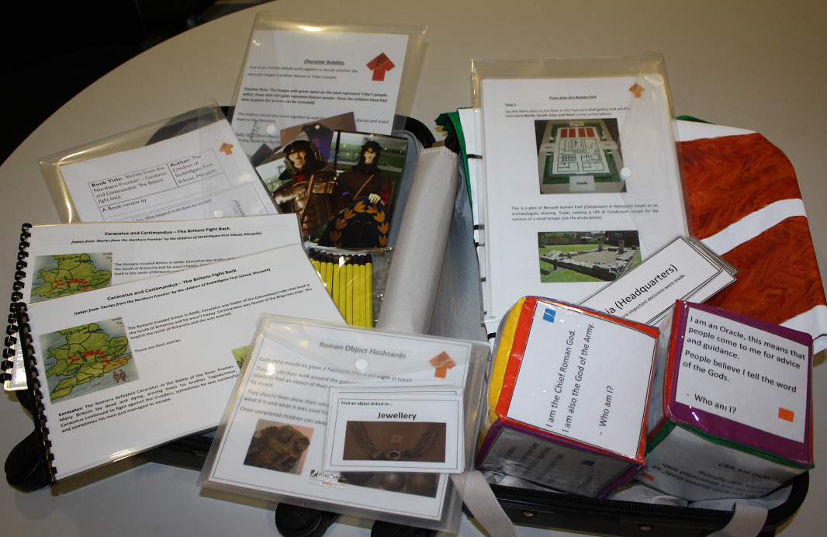

‘Who am I?’ cubes children are given 2 large cubes with descriptions of different characters, they then take it in turns to roll the cube. They should then work together to find out who is being described on the cube by exploring the gallery and reading the various object labels.

Story review children should work together to read the story and then each fill in their own story review worksheet, thinking about the impact of the Romans invasion on the tribes who lived in Britain first.

Object flash cards each child is given a card with a phrase, they should then find an object in the gallery that matches the phrase and tell their teacher about it.

