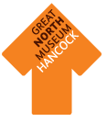
Gallery Activities
Some of these activities for the museum galleries work well for small groups, others can involve a full class. We also have downloadable worksheets focused on particular collections: http://www.twmuseums.org.uk/schools/great-north-museum/downloads.html

I Spy
A game of I Spy can give children a focus for exploring and looking harder around a gallery. You can go with the traditional ‘I spy with my little eye, something beginning with….’ approach, or try
- Colours
- Textures
- Shapes
- Objects from a particular place or habitat (‘something that lives in a desert’)

Treasure Hunt
Set a task – who can find the oldest, youngest, largest, smallest object etc. Pupils could simply report back or use a digital camera or drawings to record their findings.

Make a Museum
Find information while you are at the museum about how to display, catalogue and label objects, then make your own museum when you are back at school.
Colours, shapes and counting
Consolidate work from school on colours or shapes by getting pupils to find a rainbow of objects or to spot objects in particular 2D or 3D shapes. Offer a prize to whoever can record the largest number of objects of different shapes and name the shapes they have found. Get children to find numbers of things or to count how many x in a case.

Local objects
Many objects on display at the Great North Museum: Hancock are from North East England but our collection stretches world wide. See if you can find something from close to where you live or where your school is located. Can you find objects from different countries where pupils in your class may have family or friends?

Selfies
How about a class picture with the T. rex?

A few of our favourite things
Set everyone the task of finding their favourite object through the day (or indeed something they didn’t like at all!). This works particularly well if you have digital cameras or ipads with you but drawings or just descriptions can work well too. Back at school you can compare and contrast and use the material as an opening for art, literacy, ICT or PSHE work as well as the topic for which you may have been visiting the museum.
Can you guess?
Divide groups into teams. Someone from a team has a minute to describe an object in a display in front of them without naming it. The rest of the team have to guess what it is before the time runs out.

Scavenger hunt
Issue everyone with a list of objects (or a set of pictures for younger children) to look for through the course of the visit. This obviously works best if you have time for a planning visit, but can also be very generic (eg something old, something new, something borrowed, something blue….).

Design your own Top Trumps
Get everyone to research objects or animals for a Top Trumps game. Make sure you agree the categories in advance and then you can make the game when you get back to school.

Outdoors
If the weather is fine, you are very welcome to use the lawn in front of the museum. It’s a good time to run off some energy and you could even bring a skipping rope or similar along with you. Due to the nature of the space, we wouldn’t recommend ball games.
Visit Cubes

Print out the templates below onto card and make them up into cubes to use on your visit. The questions are designed to provoke discussion and investigation.

We also have cubes which you can borrow with colours and phonics sounds to use with younger groups. It is helpful if you book these in advance of your visit so that they are ready for you when you arrive.
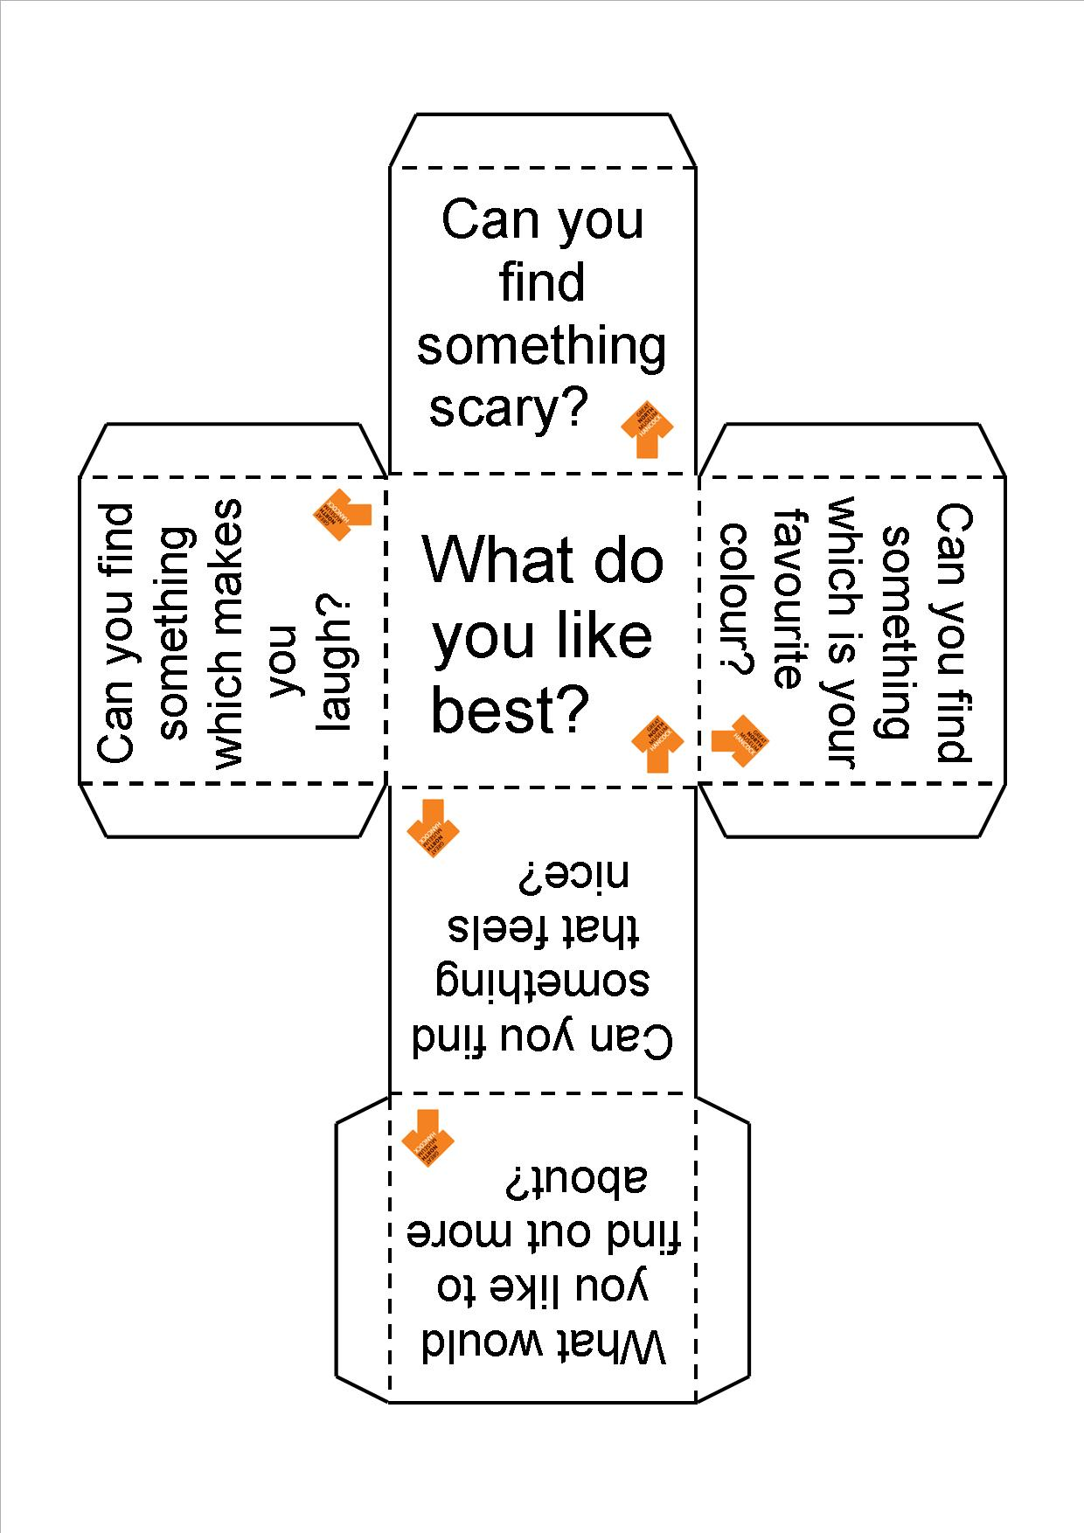
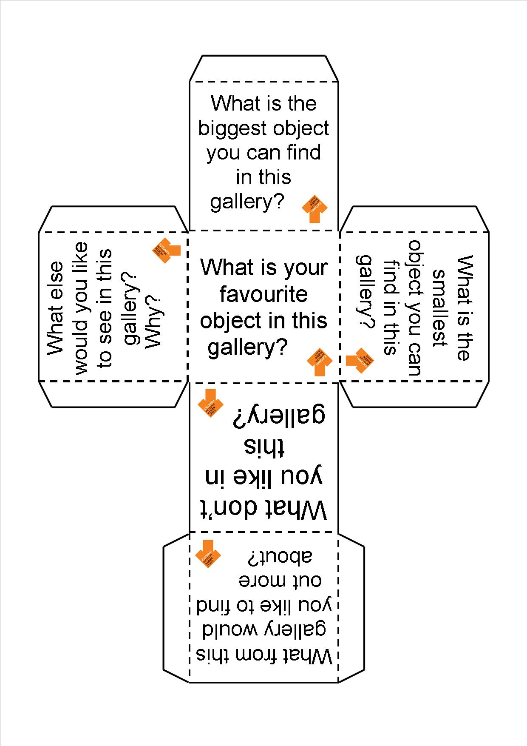
Dinosaur Explorer Bags

Our custom-made dinosaur explorer bags are designed to be used in the Fossil Stories gallery and can be booked out by groups for use during their visit. They provide a good accompaniment to Fossil Finders or Dinosaur Detectives workshop and also work well for self-led groups. The bags are aimed at children from KS1 or lower KS2 (although some groups of Reception pupils or those from upper KS2 may also enjoy using them).

Each bag contains a set of resources and also a laminated sheet for use by an accompanying adult to guide a group of up to around 6 children through the bag and its contents. No previous knowledge is necessary for either children or adult in order to use the bags.

There are five bags, each of which explores a different theme:

Habitats
Find out about our local Carboniferous rocks by using this bag in the Carboniferous Swamps and Seas area of the Fossil Stories gallery. Think about what different adaptations animals need to live in these different habitats.
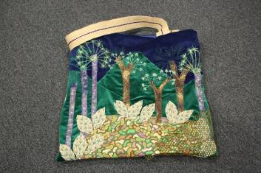
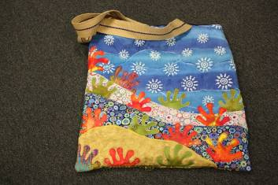
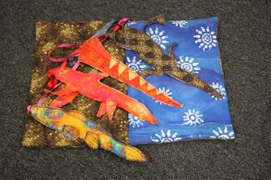

Dinosaur Stories
Use the hand and finger puppets of dinosaurs and other animals from their time to encourage children to act out a story. We have provided a story for you – or you can make up your own!
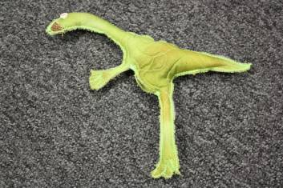
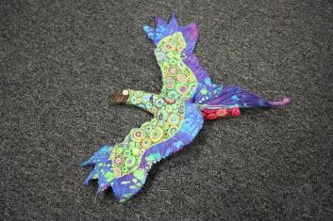
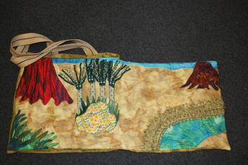

Explorer Bag
Become a palaeontologist and e xplore the Fossil Stories gallery. This bag contains resources which help you to learn about how different fossils are found and dug out and also how to interpret what they mean.
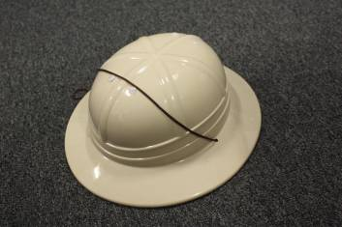
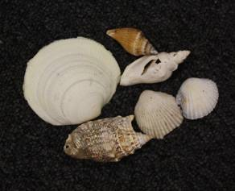
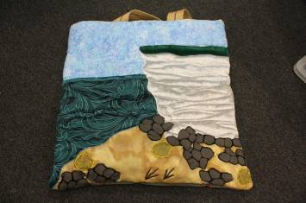

Dinosaur Dressing up
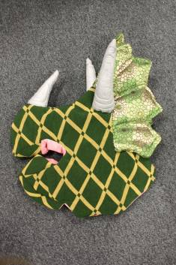
Be transported back to the Mesozoic Era and find out about the features of four of the most famous dinosaurs. When you have investigated their adaptations, maybe you could mix and match to make your own new creature, or explore the gallery as a herd.
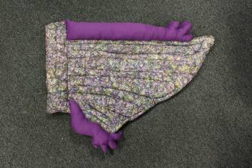
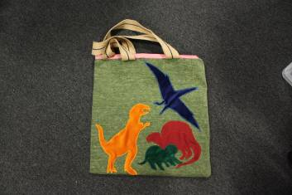

Fossilisation
How did these animals go from being live creatures in the sea to pieces of rock? This bag contains real fossils and invites children to find out about how they were made and the way in which different creatures from the past have been preserved.
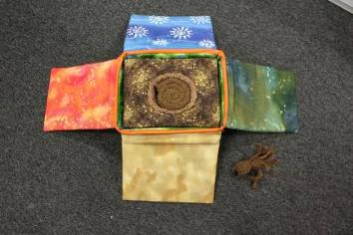
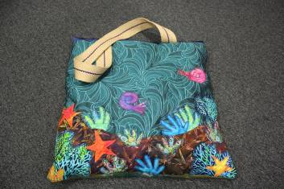
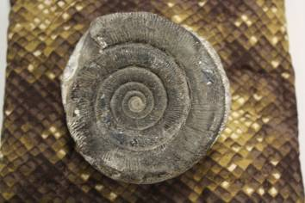

If you would like to use the Dinosaur Explorer Bags, please book them in advance of your visit to ensure that they are available for you.
Habitat Bags
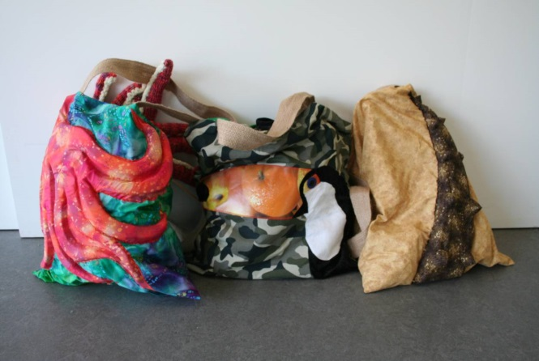
If you have booked a Habitat Explorers workshop, you will be given the opportunity to use our Habitat Bags in the galleries at the end of the taught session, but they are also available to book separately.

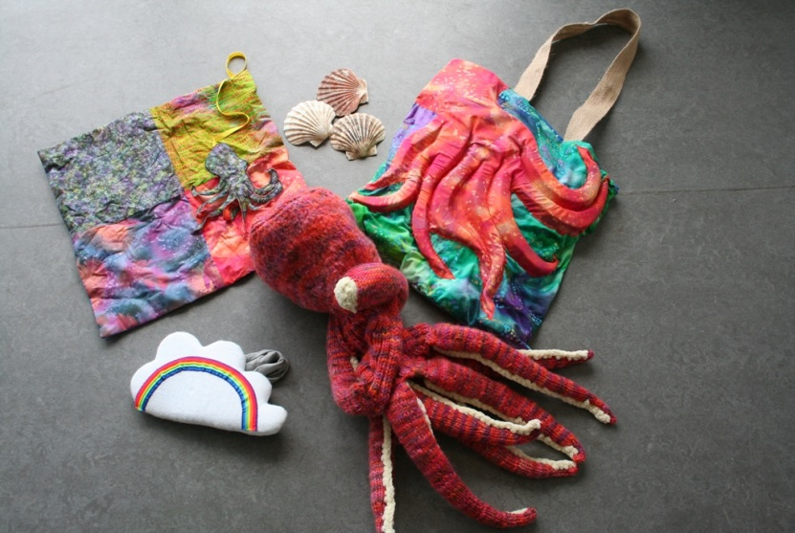
There are eight habitat bags, which are designed to be used in the Living Planet and Natural Northumbria galleries. Each bag focuses on a particular animal and its habitat and contains dressing up material, resources related to the climate in which the animal lives, to what it eats and how it uses its habitat. In each bag is a laminated sheet with questions (and answers!) for an accompanying adult to guide a group of up to around 6 children through the bag and its resources. No prior knowledge is required either for the adult or the children.

The bags are mainly suitable for use by KS1 and lower KS2 children (although some Reception groups or upper KS2 groups may also enjoy using them). Some bags have alternative inserts to help explore animals’ use of colour, camouflage and display.

If you would like to use the Habitat Bags, please book them in advance of your visit to ensure that they are available for you.
Dare to Enquire
If you are interested in developing your classroom skills for use in a museum context, why not try our Dare to Enquire programme: http://www.twmuseums.org.uk/latest/news/dare-to-enquire.html. Enquiry based learning works really well in museums and Dare to Enquire can empower teachers to respond to themes chosen by children. To find out about training for Dare to Enquire, contact the Learning Innovations Team on learning@twmuseums.org.uk.

