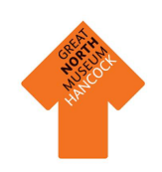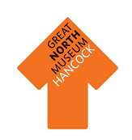

**Roman Soldiers**



Name three differences between the clothing of each soldier.

1……………………………………..……………………………………….

2……………………………………..……………………………………….

3……………………………………..……………………………………….

Find the two Roman Soldiers in the Hadrian’s Wall gallery and draw your own Auxiliary Cavalaryman and Legionary (make sure you give them the correct shaped shield and protective armour).

|  |  |  |  |  |  |  |  |  |  |
| --- | --- | --- | --- | --- | --- | --- | --- | --- | --- |
| 1 | 2 | 3 | 4 | 5 | 6 | 7 | 8 | 9 | 10 |
| I | II | III | IV | V | VI | VII | VIII | IX | X |
| 11 | 12 | 13 | 14 | 15 | 16 | 17 | 18 | 19 | 20 |
| XI | XII | XIII | XIV | XV | XVI | XVII | XVII | XIX | XX |



Can you answer the following questions using the Hadrian’s Wall gallery and give your answers in Roman numerals

Roman Numerals

The Roman’s used different shapes to represent numbers, they were called Roman Numerals.

How many models of Hadrian’s wall are in the gallery? ………………………………..

How many keys are in the **Frontier Homes** case? ……………..

How many sites are named on the Hadrian’s Wall model?...................

Add together the number of rings in the **Fashion Case**, the lead sealings in the **Written Word Case**, and the number of bronze studs and mounts in the **Defending The Frontier Case**……………………………………………………………………………………………………

Times the number of **tombstones** you can find by the amount of **coffins** you can see in the gallery

……………………………………………………………………………………………………………………

……………………………………………………………………………………………………………………

|  |  |  |  |
| --- | --- | --- | --- |
| 50 | 100 | 500 | 1000 |
| L | C | D | M |



Roman Numerals

Now answer some questions about yourself using Roman numerals.

How old are you? …………..

How many children are in your class? ………………

How many children are in your school?………………

Using the table on the other side and the table below can you find out what numerals we would use for this year? …………………..

…………………………………………………………………………………………………………………...

Using the table on the other side and the table above can you create some questions to ask your friends?

……………………………………………………………………………………………………………………

……………………………………………………………………………………………………………………

……………………………………………………………………………………………………………………

……………………………………………………………………………………………………………………

……………………………………………………………………………………………………………………

……………………………………………………………………………………………………………………





**Archaeological evidence**

Objects are very important in helping us to learn about the Romans. Which objects survive over time depends on what material they are made from.

Walk around the Hadrian’s Wall gallery and fill in the sheet below with the number of objects made from each material.

Circle the type of material that has survived the **best.**

**Earth Animal Plant**

Circle the type of material that has survived the **worst.**

**Earth Animal Plant**

What reasons do you think there are for this? Discuss your answers with your group.

|  |  |  |
| --- | --- | --- |
| Type of material | Tally of objects made from this material | Total |
| **Earth Materials:** stone, pottery, terracotta, clay, bronze, iron, gold, silver. |  |  |
| **Animal materials:** wool, cloth, ivory, leather, skin, bone. |  |  |
| **Plant materials:** linen cloth, wood, flowers, reeds. |  |  |



Roman gods

Find the two images of Mercury, god of trade, thieves and travel.

**Find one thing which is similar and one thing which is difference between the two images**

**Differences Similarities**

**……………………………………………………….. ………………………………………………..**

**……………………………………………………….. ………………………………………………..**

Can you spot the shrines dedicated to the gods Neptune and Oceanus near the entrance to the Explore! gallery? **Draw their symbols in the boxes below.**

**Neptune is the god of Oceanus is the god of**

**……………………………………………….. ………………………………………………..**

The Roman gods were part of a large family and many myths and stories were told about them and they were worshiped in temples and shrines.

The Great North Museum: Hancock has many shrines on display in the

Hadrian’s Wall gallery. **How many can you spot?**



Roman gods: shields

**Jupiter—**King of the gods and the protective god of the army

**Fortuna—**Goddess of good luck

**Neptune—**God of water and the sea

**Mercury—**Messenger to the gods and god of trade, thieves and travel

Roman gods were just like people but they had magical powers. Each god and goddess looked after different things from the goddess of love to the god of the sun.

It can be difficult trying to remember which god looks after what. **Design a shield for some of the gods using what they look after as a starting point.**





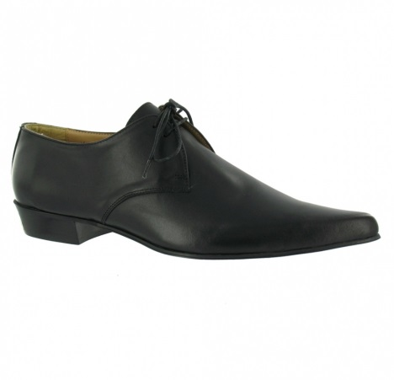

What is it?..............................................................

Which case is the Roman version found in?

……………………………………………………………………………

Does it look similar to those that we wear today?

…………………………………………………………………………….

Roman objects

We still use many objects which are similar to those used by the Romans. On this sheet are some objects we use today. Identify the object and then locate the Roman version in the **Hadrian’s Wall** Gallery.

Locate the sewing needle. Is it made from the same material as a needle we use today is?.............................................

……………………………………………………………..

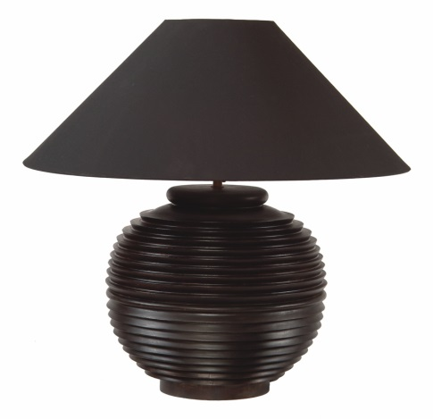

Where is the Roman version of a lamp located?

……………………………………………………………………………

How would it work compared to the lamps we use today? ………………………………………………………... …………………………………………………………………………..

……………………………………………………………………………..

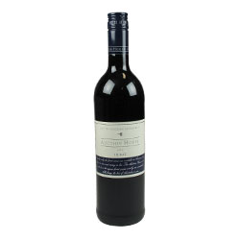

Can you find the Roman version? (Hint! It is not made from glass) …………………………………………………………………….... ……………………………………………………………………………………….

List some differences to those that we use today?...........……………..……………………………………………………………………..… ………………………………………………………………………………………………………...

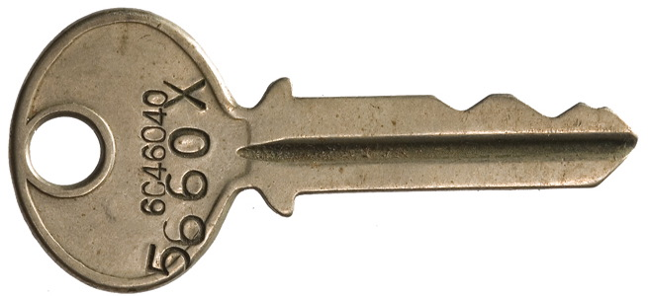

Roman objects

Find the case which contains parts of a broken mirror. What case is the Roman version found in? ……………………………………………………………….

Do you think you would be able to see your reflection easily in it? ………………………………………

…………………………………………………………………………

Can you find the number of the case the Roman keys are in?

…………………………………………………………….

Does it look like a key you might use today?…………………………………………………..

Look carefully in the gallery to find the Greyware dish, it is in the ’Living on the Wall’ part of the gallery.

What is on the dish that should not be there?

………………………………………………………………………………………………………………….



The Romans used knives and spoons like we use. Explore the Hadrian’s Wall gallery and try and find Roman knives and spoons.

How many knives you can find in the gallery? …………

How many spoons you can find in the gallery. ………...

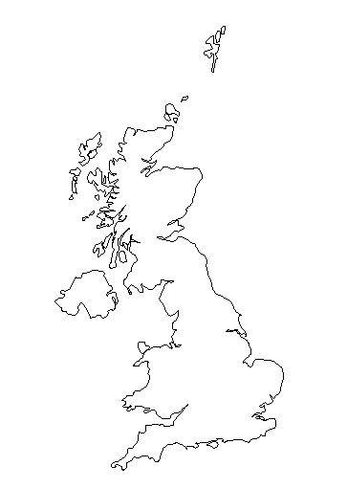

Hadrian’s Wall

Find the model of Hadrian’s Wall.

Look along the Hadrian’s Wall model. Name three different Roman sites labelled.

1………………………………………………………………………………………………………………...

2………………………………………………………………………………………………………………...

3………………………………………………………………………………………………………………...

How many men made up a century of soldiers?

50 75 80 100

Can you find the Centurial Stones? They were used as markers when a section was completed by a century of men.

Draw on the map of the United Kingdom a line where Hadrian’s Wall stretched between.

Look around Hadrian’s Wall. What was the Western part of the Wall made from?....................................

Can you see the bust of Hadrian’s head? What words could you use to describe how he looks?

………………………………………………………………………………………………………………………………………………………………………………………………………………………………………………………………………...



**Why was the Roman army so successful?**

**Teacher’s notes & student worksheet**

This document has been put together to help support teaching of the topic ‘Why was the Roman army so successful.’ The resource is to be used in the Hadrian’s Wall gallery in the Great North Museum: Hancock. It is recommended that pupils will have had at least one introductory lesson on the topic to get the most from the resource.

The basis of the success of the Roman army is widely attributed to the following

factors:

Fighting technique

Training

Equipment

Discipline

Numbers

Good health

Transport

Rewards

In the Hadrian’s Wall exhibit there are examples of many of these reasons. See if the students can find the evidence below (or any additional examples) in the gallery. You could get them to explain why each advancement or quality gave them the

advantage over their adversaries. We have created a worksheet that the students could use to record their work at the end of this document.

**Evidence**

**Training and Discipline**

In the ‘Building of the Wall’ display there is evidence that they were a much

regimented, disciplined group of men, for example Florus, the Centurion of the First Cohort talks of ordering his men. In the ‘Arming the Wall’ there is evidence from Marcus Hispanius Modestinus keeping his men doing drills whenever they are not fighting.

**Health**

The ‘Kill or Cure’ display shows the lengths the army went to in order to keep their soldiers healthy, using a mixture of scientific medicine and relying on the Gods. Which civilisation have they got their remedies from?

**Transport**

In the ‘Supplying the Wall’ display there is evidence that they built new roads in countries they invaded in order to move through the countryside quickly and

efficiently, and they also developed new shoes for their army which gave better grip and lasted longer.



**Equipment**

The display of the two soldiers show the extent of the Romans’ weapons and armour, and the army was wealthy from all their conquests so could afford the cost of commissioning new and unstoppable equipment.

If you need any further guidance or advice for your visit then please contact the learning team at learning@greatnorthmuseum.org.uk



Why was the Roman army so successful?

There are a number of factors as to why the Roman army was so successful. Some of the factors are:

- Training

- Equipment

- Discipline

- Good Health

- Transport

- Rewards

Can you explore the Hadrian’s Wall gallery and find evidence to support this claim? Evidence could include objects, inscriptions or gallery text and can be written or illustrated below.

1. The romans were a **well trained** army

Evidence:

1. The romans had **advanced** equipment

Evidence:

|  |
| --- |
| 3. **Discipline** was a big part of the army |
| Evidence: |
| 4. The army enjoyed very good **health** |
| Evidence: |

Can you find any other evidence for the Roman army’s success?

What do you think was the **most** important factor for the Roman army’s success?