**Stone Age to Iron Age**

**Gallery resources and activities**

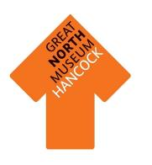

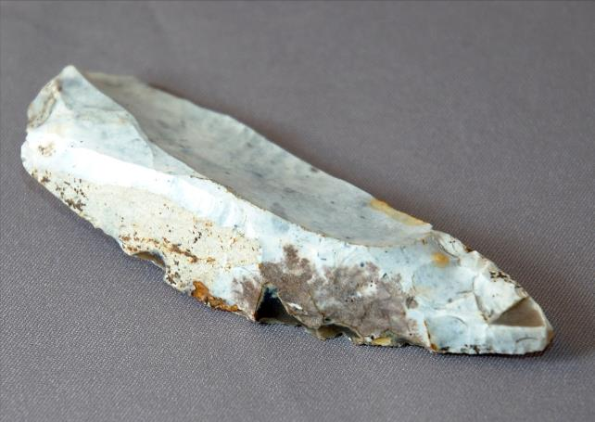

Can you find this tool?

This is the only artefact found in the North East from the Palaeolithic (Old Stone Age).

What do you think it was used for?

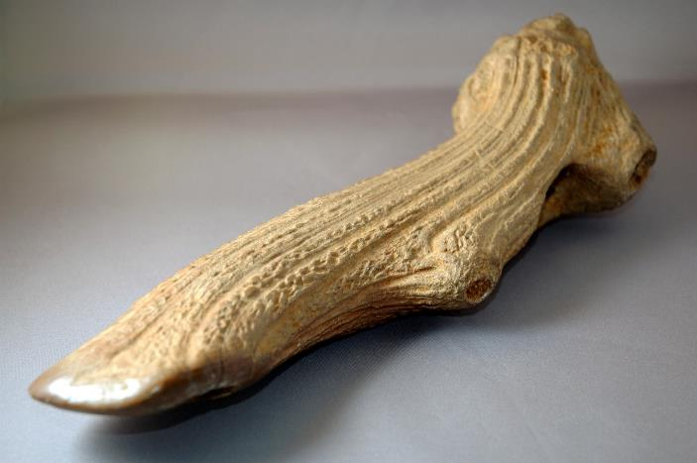



Can you find this object?

What animal has it come from?

What other parts of this animal do you think

prehistoric people would have used to survive?

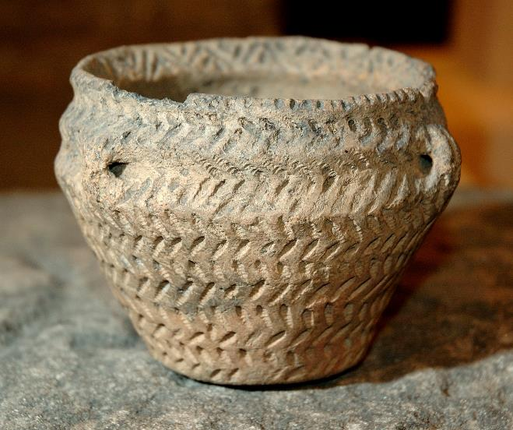

Can you find this object?

How do you think it was made?

What do you think was kept in it?

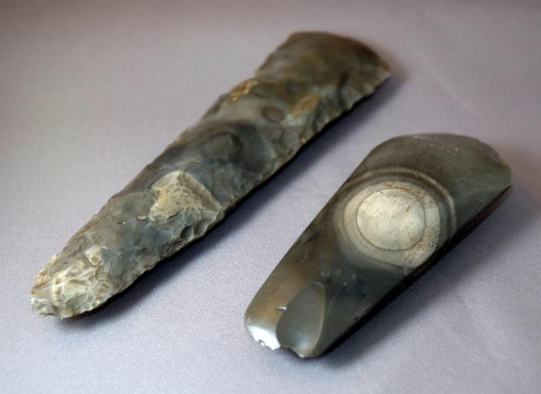

Can you find these stone axes?

Who do you think made them?

Why do you think they were made?

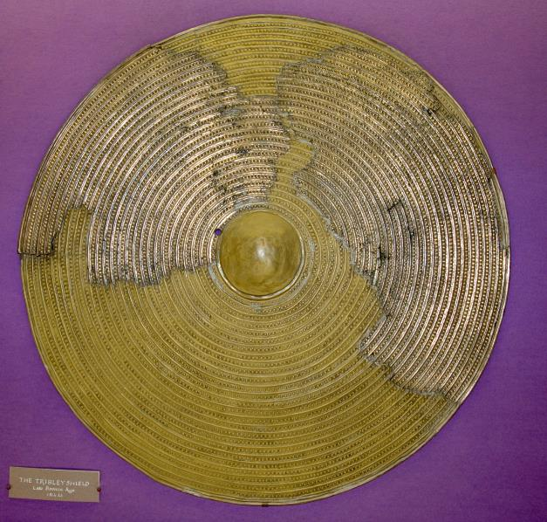

Can you find this shield in the gallery?

What do you think it would have been used for?

Do you think it looks very strong?



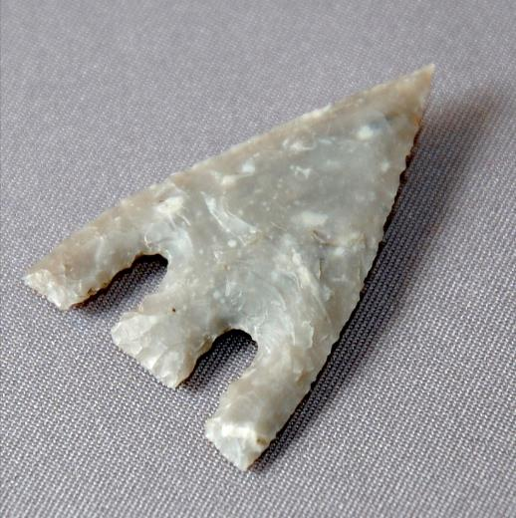

Can you find this barbed and tanged arrow head?

What material is it made from?

What other objects can you find in the gallery

made from the same material?

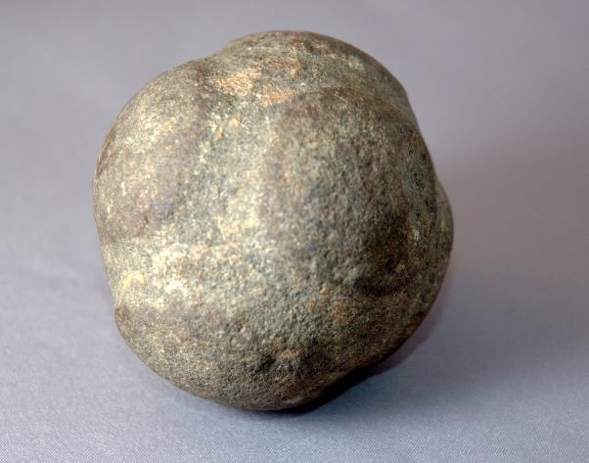

Can you find this stone ball in the gallery?

What do you think prehistoric people used it for?

What other objects are in the same case?

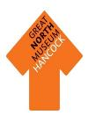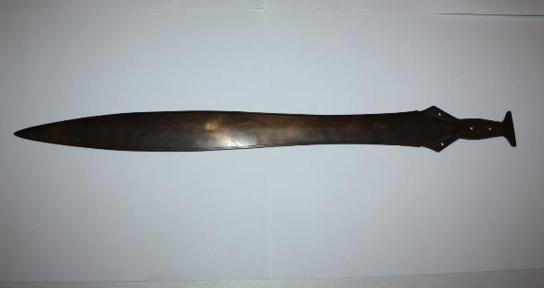

Can you find this object?

Do you think this was used to fight with?

What do you think life was like in the Late Bronze Age 3500 years ago?

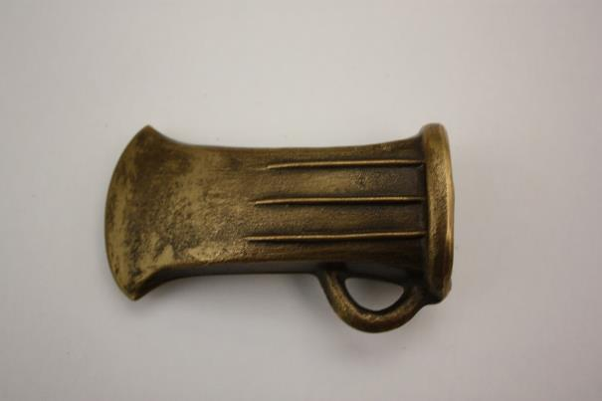

Can you find a socketed axe?

People in the Bronze Age would have attached this to a wooded handle.

How do you think they would have done this? What material do you think they would have used?

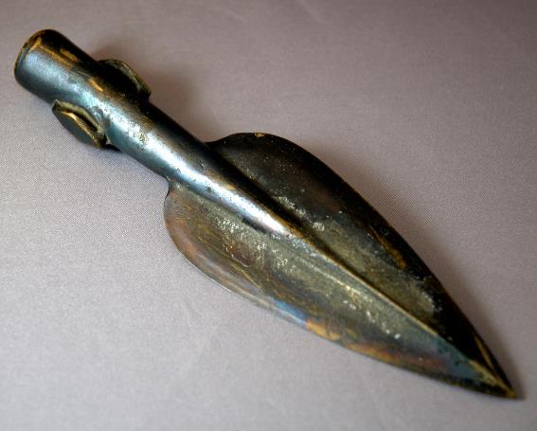



Can you find this spearhead?

What do you think it would have been used for?

**Archaeological Evidence**

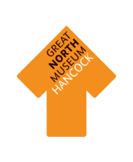

Objects are very important in helping us to understand British prehistory. Which objects survive over time depends on what material they are made from.

Walk around the Ice Age to Iron Age gallery and fill in the sheet below with the number of objects made from each material.

|  |  |  |
| --- | --- | --- |
| Type of material | Tally of objects made from this material | Total |
| **Earth Materials:** stone, pottery, terracotta, clay, bronze, iron, gold, silver. |  |  |
| **Animal materials:** wool, cloth, ivory, leather, skin, bone. |  |  |
| **Plant materials:** linen cloth, wood, flowers, reeds. |  |  |

Circle the type of material that has survived the **best.**

**Earth Animal Plant**

Circle the type of material that has survived the **worst.**

**Earth Animal Plant**

What reasons do you think there are for this? Discuss your answers with your group.

What materials can you find in the Ice Age to Iron Age gallery?

Can you find at least **three** objects for each time period made from different materials in the gallery? (There is only one object from the Palaeolithic, a flint backed blade).

Are there any **differences** or **similarities** between the materials found and used in the different periods?

Are there any materials that you think they would have used but are not in the gallery because they have not survived?

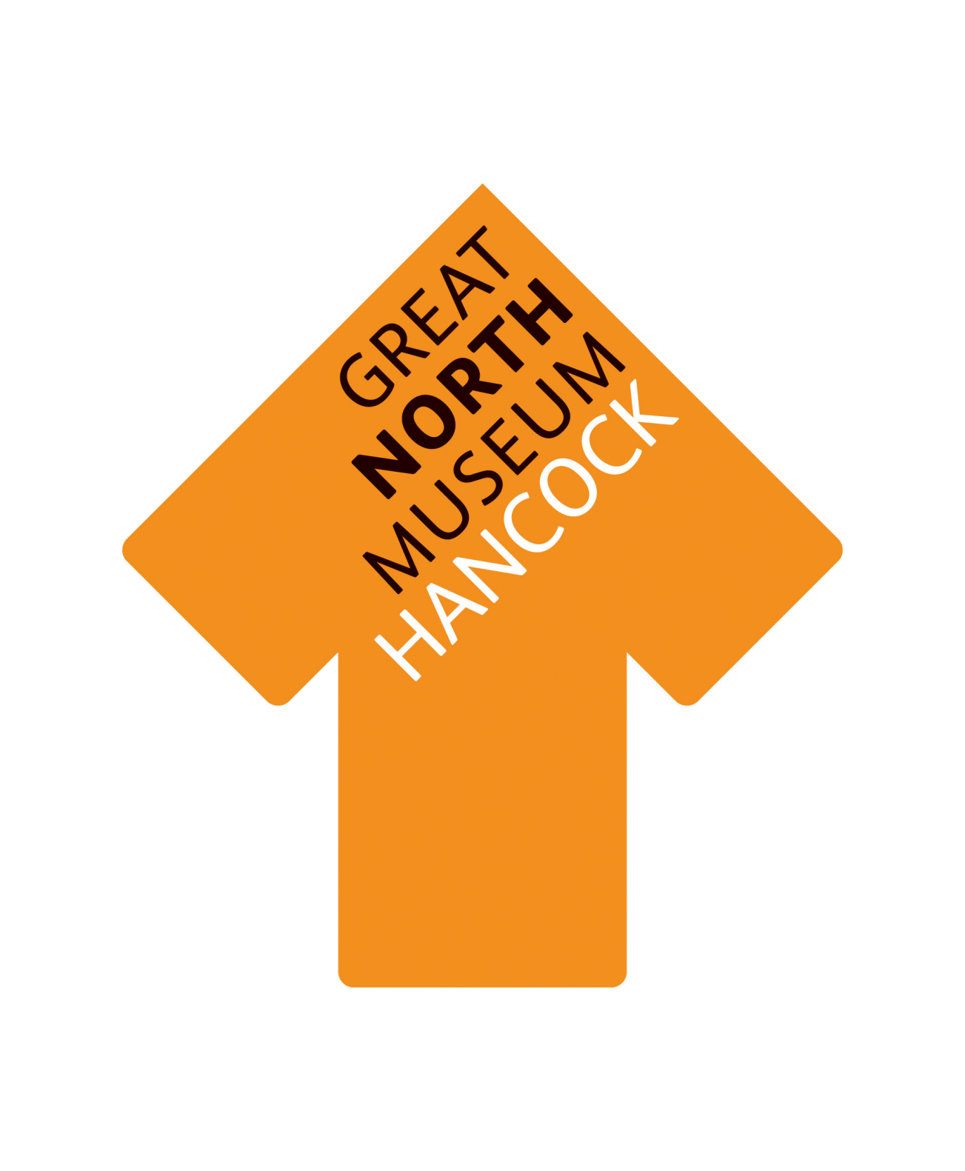

|  |  |  |
| --- | --- | --- |
| Palaeolithic  (Old Stone Age)  12,000 – 8,000 BC | Mesolithic  (Middle Stone Age)  8,000 – 4,000 BC | Neolithic  (New Stone Age)  4,000 – 2,500 BC |
| Early Bronze Age  2,500 – 1,500 BC | Late Bronze Age  1,500 – 800 BC | Iron Age  800 BC – 43 AD |

**Which tool belongs where?**

|  |  |  |
| --- | --- | --- |
| Palaeolithic  (Old Stone Age)  12,000 – 8,000 BC | Mesolithic  (Middle Stone Age)  8,000 – 4,000 BC | Neolithic  (New Stone Age)  4,000 – 2,500 BC |
| Early Bronze Age  2,500 – 1,500 BC | Late Bronze Age  1,500 – 800 BC | Iron Age  800 BC – 43 AD |

You can find all the tools on the opposite page in the Ice Age to Iron Age gallery at the Great North Museum: Hancock. Can you find out what they are and put them in the right place on the tool chart? If you can’t visit the museum then research the tools online. Are there any additional tools you can add to the chart?

Are there any differences or similarities between the tools from the different periods?

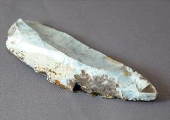**Which tool belongs where?**

Can you find all these different tools in the Ice Age to Iron Age gallery and put them in the right place on the chart on the opposite page?



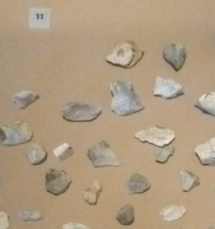

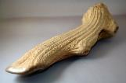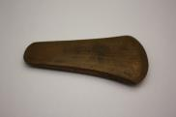

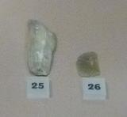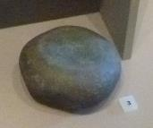

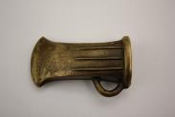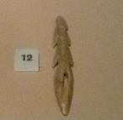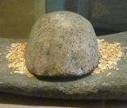

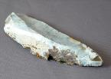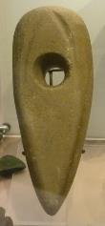

Investigating animals from the Ice Age to the Iron Age

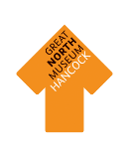

How resourceful is a deer? – Adult leaders prompt sheet



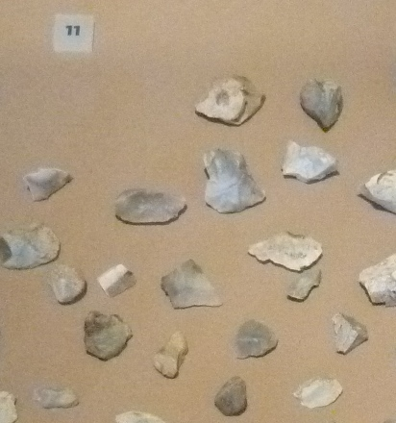

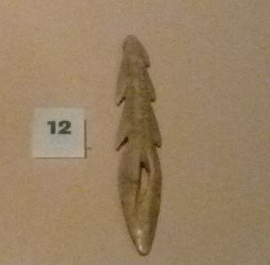

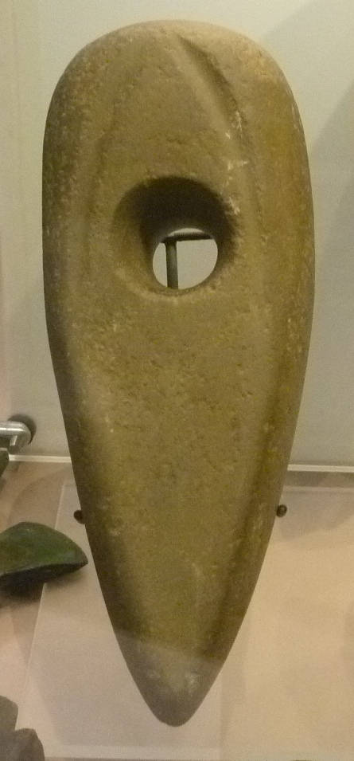

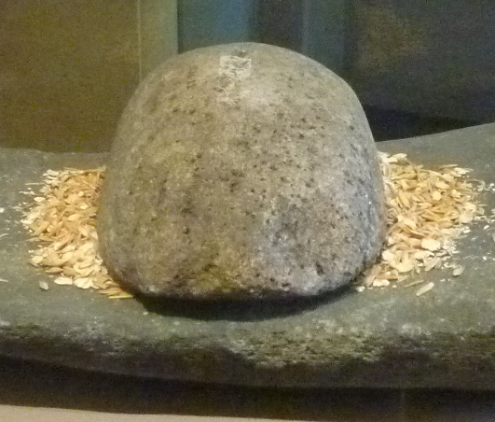

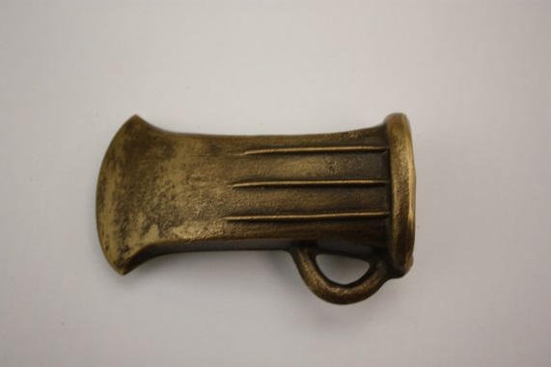

Throughout the Stone Age people gathered berries, nuts and seeds for their diet and hunted animals including aurochs, boar and deer (even when farming was introduced in the Neolithic or New Stone Age).

**Find the deer’s in the Living Planet gallery.**

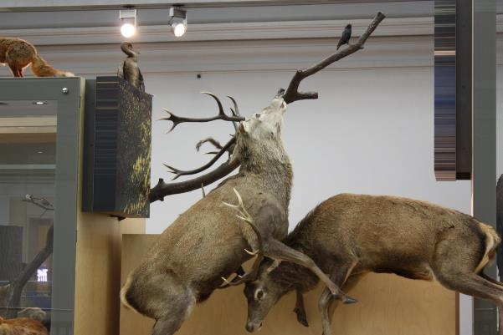

**How do you think it would feel to hunt a deer?**

**What tools can you find that would help them hunt the deer in the Stone Age?**

**Why do you think hunting deer was so important to Stone Age people? What would they use the deer for?**

**Meat - Food**

Human would have to work together to hunt a deer. In the Mesolithic (Middle Stone Age) hunters followed the herds over great distances; they would eat all the meat off the animal and would not waste any. A family of four could live off 3 deer per year as part of a varied diet which would also include foraging for berries and seeds. They would have had to be able to preserve the meat, and drying would have been the easiest option. *If this is their only answer then ask them to consider why they still hunted deer after farming was introduced.*

**Sinew – string**

Sinew is a cord that connects muscles together so it must be very strong. It can be dried out and joined together to make long string which would be a very good as sewing thread or lashings for a shelter.

**Hide – clothing/blankets**

When the Ice Age ended in the Palaeolithic (Old Stone Age) people would have needed clothing to survive and they would have used animal skin including deer hide. Do you think it would have kept people warm? What other animal’s do you think they could have used? *Beaver, seal, wolf, goat, aurochs or bear.*

**Bone – tools**

Bone was ideal for piercing hide and being used as a needle. On the attached sheet is how people in indigenous America people used different parts of a deer skeleton. In some soils bone does not survive so people in the Stone Age may have used deer bone in a similar way.

**Antler – tools**

Can you find the antler harpoon and antler mattock in the gallery? How do you think people in the Stone Age would have used these? *The harpoon was probably used for catching fish and the mattock would have been used for digging which could include building house or farming.*



How resourceful is a deer?

Throughout the Stone Age people gathered berries, nuts and seeds for their diet and hunted animals including aurochs, boar and deer (even when farming was introduced in the Neolithic or New Stone Age).

Can you label parts of the deer that would have been used by people living in the Stone Age and write how you think they would have been used?

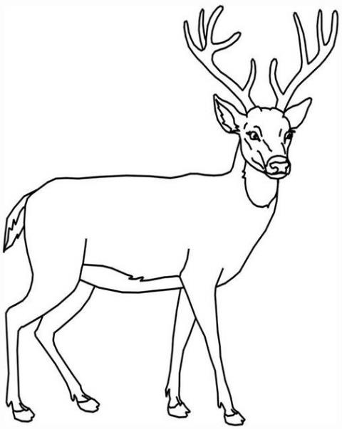

Antler

Hide

Sinew

Meat

Bone

Can you find a reindeer in the Living Planet gallery?

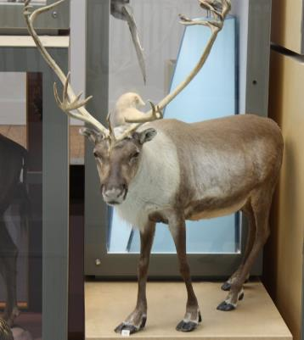

Reindeer were hunted in the south of Britain in the Old Stone Age. Why do you think they were hunted? Which part of the reindeer would be used?



Can you find these birds in the Natural Northumbria gallery?

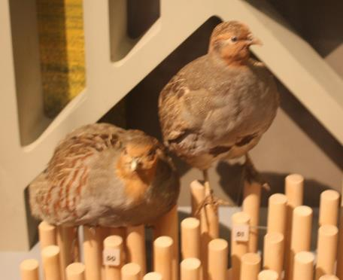

There would have been many different types of wild fowl in the landscape throughout the Stone Age, Bronze Age and Iron Age. Do you think that these birds would have been hard to hunt?



Can you find the sheep in the Natural Northumbria gallery?

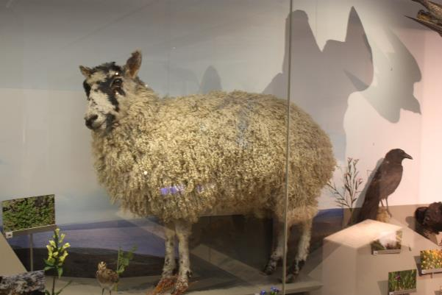

Sheep were introduced to Britain in the Neolithic (New Stone Age). They were brought over with the knowledge of how to farm the land and keep domestic animals. Do you think this would have changed people’s lives?



Can you find this grey seal in the Natural Northumbria gallery?

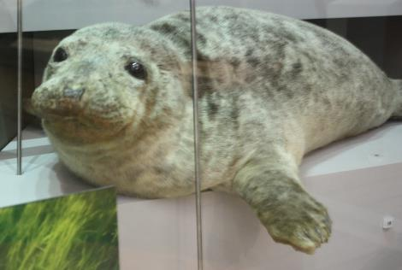

Grey seals can be found along the shores of the North Sea coats and were hunted by people in the Stone Age over 10,000 years ago. They would have been very useful to people living then. Which parts of the seal do you think would have been used?

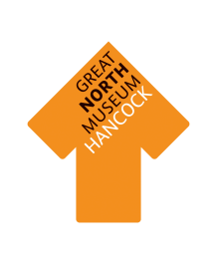

Can you find the goat in the Natural Northumbria gallery?

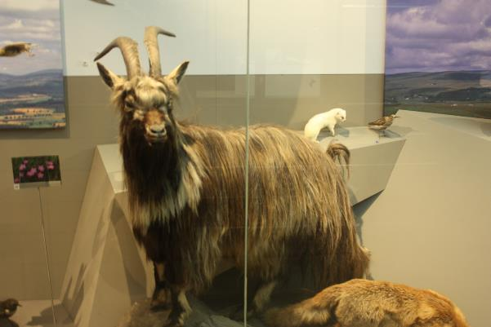

Goats are native to Britain but were domesticated when farming was introduced in the Neolithic (New Stone Age). What kind of habitat do you think this goat would be best suited to?



Can you find this cow in the Natural Northumbria gallery?

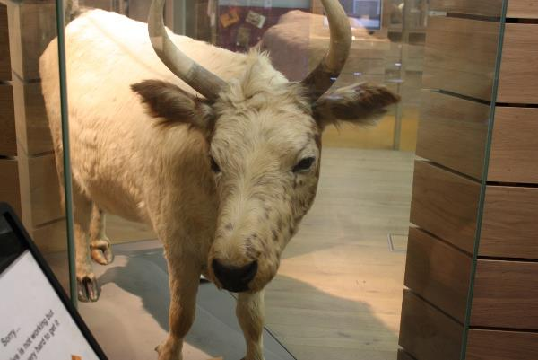

During the Stone Age a type of cow called Aurochs lived in the landscape. They were twice the size of this cow but you can no longer find them in Britain. Can you imagine trying to hunt such an animal?

