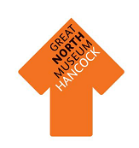
What is your fossil?

………………………………………

Why is it your favourite?

………………………………………

………………………………………
Now find your favourite fossil in the gallery and draw it below:
What type of fossil did you uncover?

………………………………………..

………………………………………..
Draw your fossil in the box below:

What tools did you use?

……………………………………………………………………………………………………………………….

……………………………………………………………………………………………………………………….
Find one of the ‘Reconstructing the Past’ touch screens and use the tools to extract a fossil from the rock.
Find a Fossil
Triassic Period
Date:
Find the dates for each time period and then draw your favourite object from each section in the boxes.
Prehistoric Timeline
Cretaceous Period
Date:
Jurassic Period
Date:
Carboniferous Period
Date:
Fossilisation
Write a storyboard on the process of fossilisation—start with a creature dying and end with the fossil being excavated.
1.
2.
3.
4.
5.
6.

Dinosaur Explorer Bags

Our custom-made dinosaur explorer bags are designed to be used in the Fossil Stories gallery and can be booked out by groups for use during their visit. They provide a good accompaniment to Fossil Finders or Dinosaur Detectives workshop and also work well for self-led groups. The bags are aimed at children from KS1 or lower KS2 (although some groups of Reception pupils or those from upper KS2 may also enjoy using them).

Each bag contains a set of resources and also a laminated sheet for use by an accompanying adult to guide a group of up to around 6 children through the bag and its contents. No previous knowledge is necessary for either children or adult in order to use the bags.

There are five bags, each of which explores a different theme:

Habitats
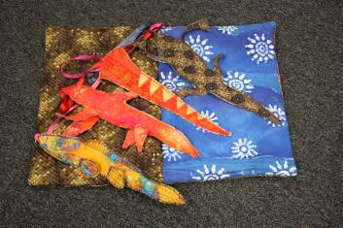
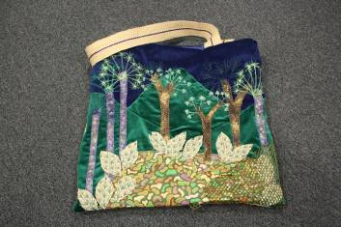
Find out about our local Carboniferous rocks by using this bag in the Carboniferous Swamps and Seas area of the Fossil Stories gallery. Think about what different adaptations animals need to live in these different habitats.
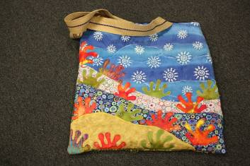

Dinosaur Stories
Use the hand and finger puppets of dinosaurs and other animals from their time to encourage children to act out a story. We have provided a story for you – or you can make up your own!
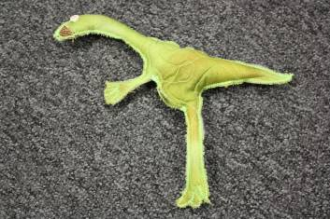
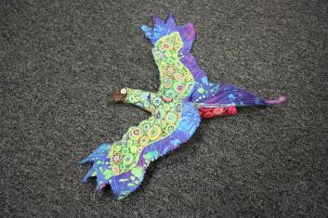
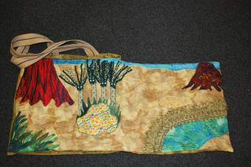

Explorer Bag
Become a palaeontologist and explore the Fossil Stories gallery. This bag contains resources which help you to learn about how different fossils are found and dug out and also how to interpret what they mean.
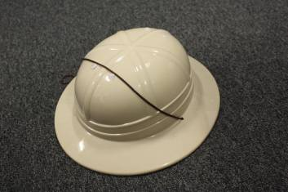
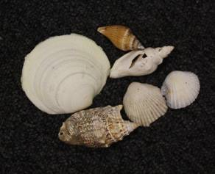
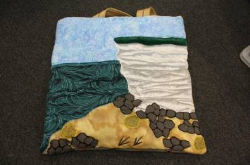

Dinosaur Dressing up
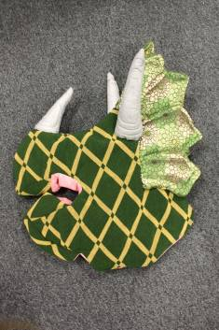
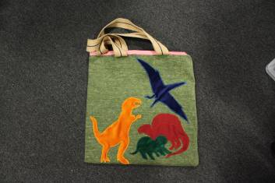
Be transported back to the Mesozoic Era and find out about the features of four of the most famous dinosaurs. When you have investigated their adaptations, maybe you could mix and match to make your own new creature, or explore the gallery as a herd.
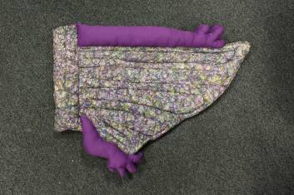

Fossilisation
How did these animals go from being live creatures in the sea to pieces of rock? This bag contains real fossils and invites children to find out about how they were made and the way in which different creatures from the past have been preserved.
