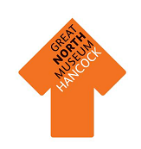
Draw a T. rex skull in the box—don’t forget to include its sharp, pointy teeth.
Think of three words to
describe the T. rex skeleton:
1…………………………………………
2…………………………………………
3………………………………………...
T. rex skeleton Facts:
T. rex is ……………………m long and ………………………...m tall
T. rex weighed as much as: 1. A rhinoceros?
2. A male elephant?
3. A car?
T. rex had ……………………………………...teeth.
Tyrannosaurus rex is arguably the most famous dinosaur to roam the earth and is definitely one of the most fearsome carnivores. Our T. rex skeleton cast dominates the Fossil Stories gallery—Create a dinosaur profile page for our T. rex.
T. rex Profile
How many teeth has the Igauanadon?
…………………………………………………………….
Was Igaunadon a carnivore or a herbivore?
…………………………………………………………….
How would the shape of Igauadon’s teeth help it to eat its chosen food?
…………………………………………………………….
…………………………………………………………….
Find the Iguanodon skull near the T. rex model and draw one of its teeth in the box.

How many teeth does the T. rex have?
………………………………………………………….....
Was T. rex a carnivore or a herbivore?
………………………………………………………….....
Think about what T. rex ate. How would the shape of its teeth help?
……………………………………………………………..
……………………………………………………………..
Look at the T. rex model’s teeth and draw one in the box below.
A carnivore eats…………………………………………………………………………………………
A herbivore eats………………………………………………………………………………………..

Dino Dinner
Dinosaur Explorer Bags

Our custom-made dinosaur explorer bags are designed to be used in the Fossil Stories gallery and can be booked out by groups for use during their visit. They provide a good accompaniment to Fossil Finders or Dinosaur Detectives workshop and also work well for self-led groups. The bags are aimed at children from KS1 or lower KS2 (although some groups of Reception pupils or those from upper KS2 may also enjoy using them).

Each bag contains a set of resources and also a laminated sheet for use by an accompanying adult to guide a group of up to around 6 children through the bag and its contents. No previous knowledge is necessary for either children or adult in order to use the bags.

There are five bags, each of which explores a different theme:

Habitats
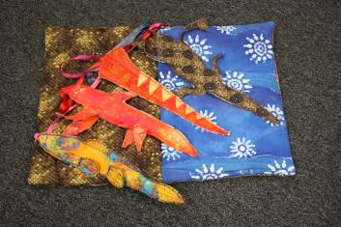
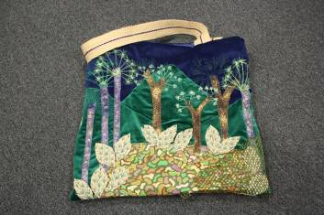
Find out about our local Carboniferous rocks by using this bag in the Carboniferous Swamps and Seas area of the Fossil Stories gallery. Think about what different adaptations animals need to live in these different habitats.
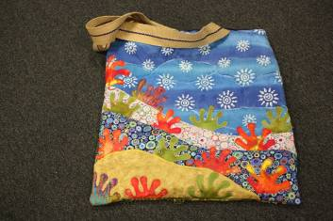

Dinosaur Stories
Use the hand and finger puppets of dinosaurs and other animals from their time to encourage children to act out a story. We have provided a story for you – or you can make up your own!
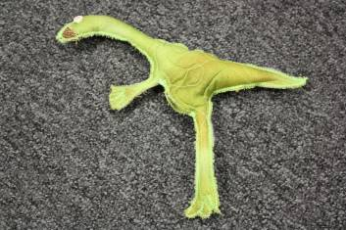
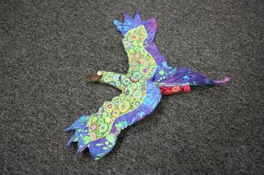
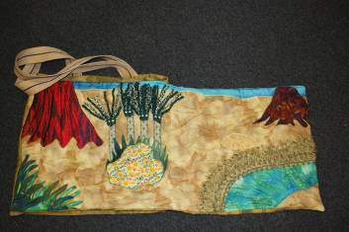

Explorer Bag
Become a palaeontologist and explore the Fossil Stories gallery. This bag contains resources which help you to learn about how different fossils are found and dug out and also how to interpret what they mean.
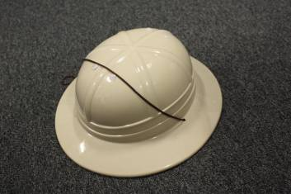
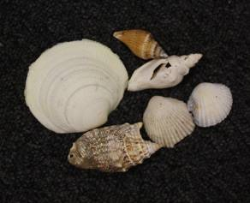
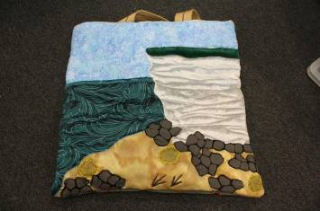

Dinosaur Dressing up
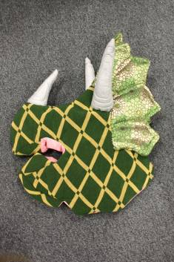
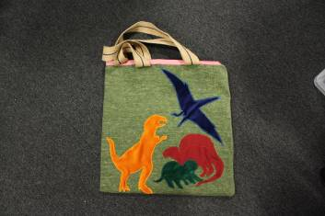
Be transported back to the Mesozoic Era and find out about the features of four of the most famous dinosaurs. When you have investigated their adaptations, maybe you could mix and match to make your own new creature, or explore the gallery as a herd.
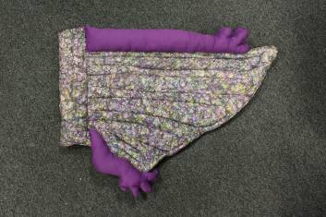

Fossilisation
How did these animals go from being live creatures in the sea to pieces of rock? This bag contains real fossils and invites children to find out about how they were made and the way in which different creatures from the past have been preserved.
