Egyptian pack contents

Pick and choose which resources you would like to use with your group. The resources have been created in a Word format so that you can adapt them to meet the needs of your group.

Pages 2 – 11 Object flashcards
Pages 12 – 13 Egyptology detectives
Page 14 Archaeological evidence
Page 15 Egyptian writing
Page 16 Egyptian gods and goddesses
Page 17 Egyptian farmers
Page 18 Bakt en Hor
Page 19 Irtyru
Page 20 Mummification

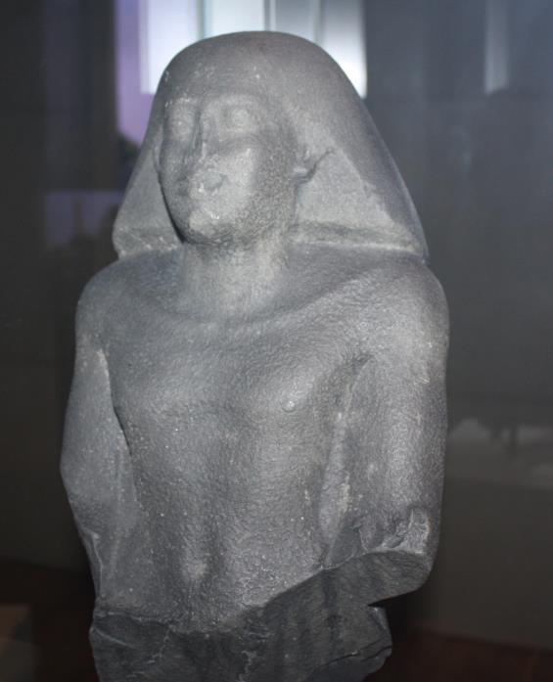

Can you find this statue?
Looking at the other objects in the case what job do you think this person does?

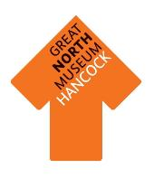
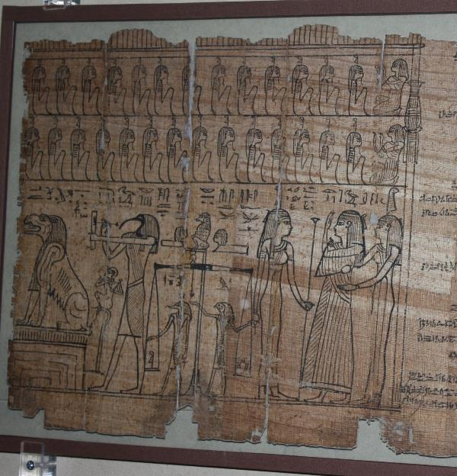
Can you find this papyrus?

Look carefully at the images, what do you think is happening?

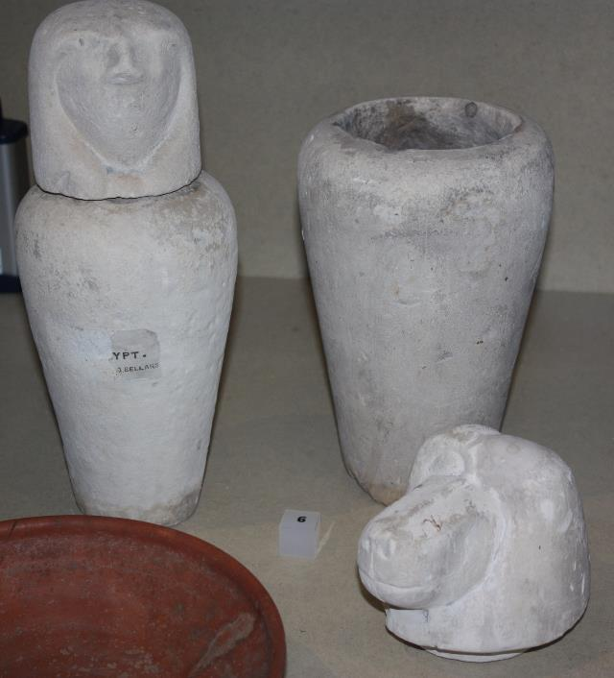
Can you find these canopic jars?

Do you know what would have been kept inside them?

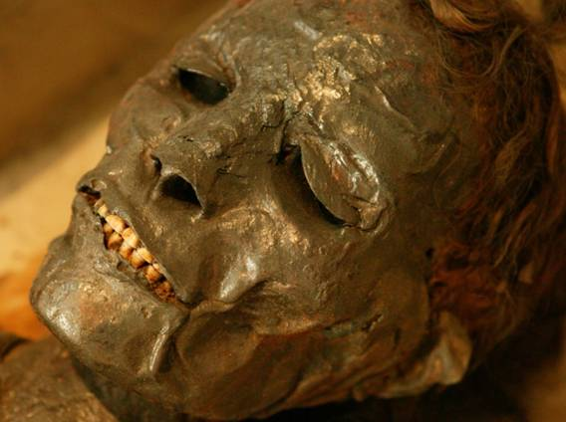
This is Irtyru, one of the museum’s mummies. Can you find her in the gallery?

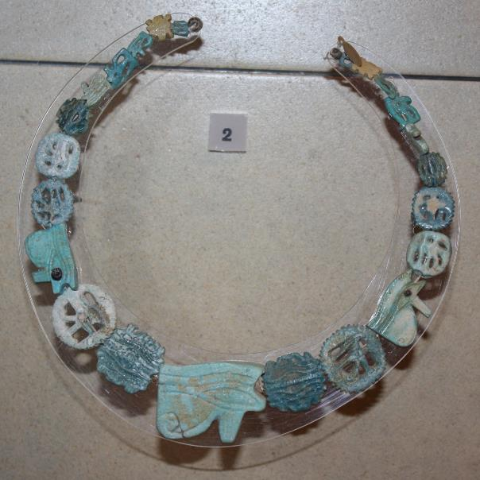
Can you find this Egyptian necklace in the gallery?

Who do you think would have worn a necklace like this?

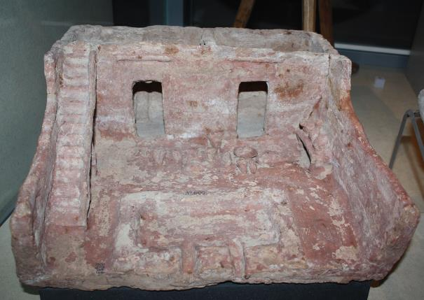
Can you find this miniature house?

What other objects can you see in the case?

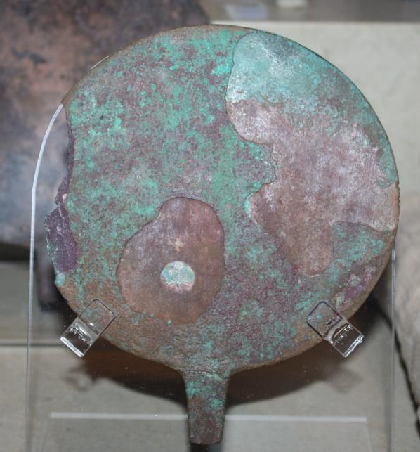
Can you find this object?

What is it?

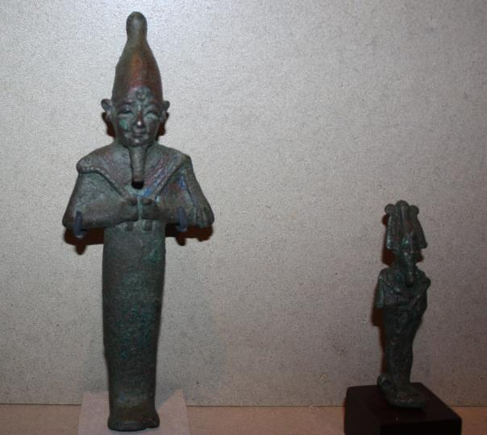
Can you find these Egyptian gods?

Why were they so important in Ancient Egypt?

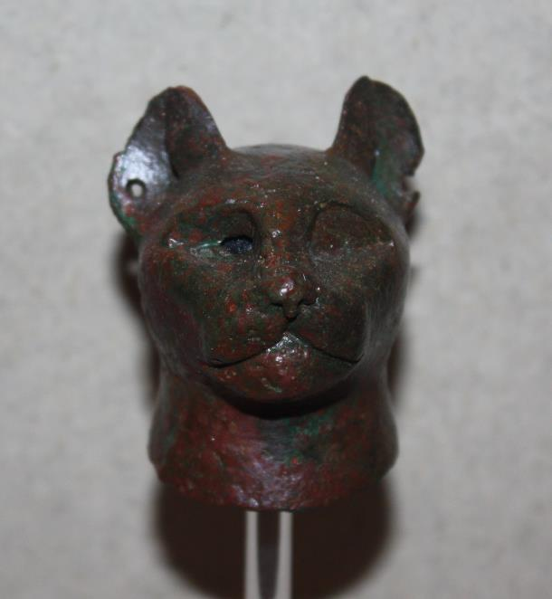
Can you find this object?

Are there any more cat objects in the gallery?

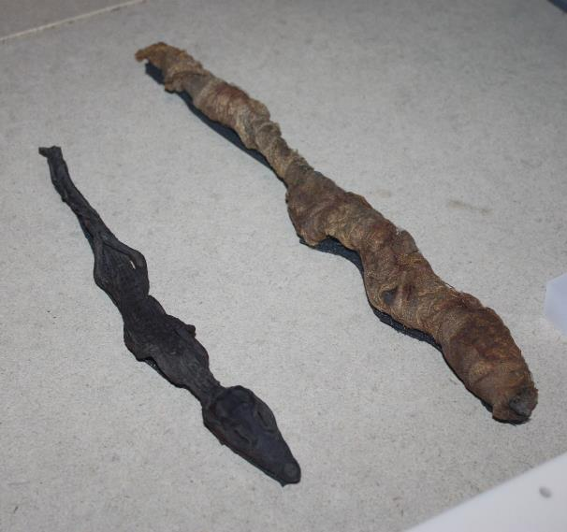
Can you find these?

Which animal has been
mummified?

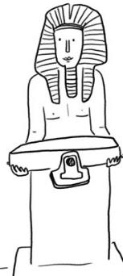
Egyptology detectives

Name of Egyptologist:

What are you investigating?
When did it happen?
Where did it happen?

Exploration time.
Explore the Egyptian gallery, choose your favourite object and answer the following questions:
What is your object called?

What is it made from?

What do you think it was used for?

What does it tell us about life in Ancient Egypt?

What does it not tell us about life in Ancient Egypt?

Exploration time.
Explore the Egyptian gallery again and record five different facts you have learnt about Ancient Egypt.
1.

2.

3.

4.

5.

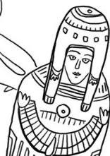
What other facts would you like to know about the Ancient Egyptians?
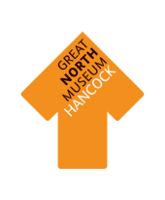

Archaeological Evidence

Objects are very important in helping us to understand Ancient Egypt. Which objects survive over time depends on what material they are made from.
Walk around the Egyptian gallery and fill in the sheet below with the number of objects made from each material.

Circle the type of material that has survived the best.
Earth Animal Plant

Circle the type of material that has survived the worst.
Earth Animal Plant

What reasons do you think there are for this? Discuss your answers with your group.

Type of material | Tally of objects made from this material | Total
Earth Materials: stone, pottery, terracotta, clay, bronze, iron, gold, silver.
Animal materials: wool, cloth, ivory, leather, skin, bone.
Plant materials: linen cloth, wood, flowers, reeds.

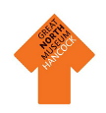
Egyptian writing
Draw some hieroglyphics you can see in this space.
How many different languages are on the Rosetta Stone? ……………………..
Can you name each of the languages? ………………………………………………….. ……………………………………………………………………………………………………………...
Find the Rosetta Stone.
How many languages do you know? ……………..
If you could invent your own language, what would you call it?
………………………………………………………………………………………………………………….

What jobs could you do if you could write? …………………………………………………………………………………………………………………………………………………………………………………………………………………………………..

Did boys or girls learn to write? ………………………………………………………………

What does hieroglyphic mean in Greek? ………………………………………………..
Look in the Reading and Writing case for the answers.
What are hieroglyphics?..............................................................................
Look in the Divine Words section for the answers.
Ancient Egyptian Gods and Goddesses
Now you can design your own god or goddess. It might look like an
animal, a human, or a mix of both!
Name: ……………………………….
Description:
………………………………………………………………………………………………………………………………………………………………………………………………………………………………………………………………………………
Drawing
1. Look in the Favoured by the Pharaohs section

Gods could be represented as
humans or animals, or a mixture of both.
What animal is Sekhmet? ……………..

What is Isis the goddess of? ……………………………………………………..

2. Now look in the Gods of the People section.
Which goddess was a cobra?
…………………………………………………….

What animal was the god Sobek?
…………………………………………………….

Who was the goddess of love?
……………………………………………………..

Can you find Sekhmet? Draw her in this space.
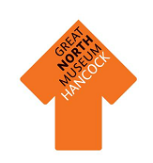
Imagine you are an ancient Egyptian. Write two sentences about the food you eat (Is it tasty? Do you enjoy it?) …………………………………………………………………………………………………….....…………...…………………………………………………………………………………………………………….………..…………………………………………………………………………………………………………………………………………………………………………………………………………………………………………………………………………………………………………………………………………………………………………………………………...
Beer
Chicken
Bread
Circle the three foods or drinks which poor people would eat.
2. Now go to the Gift of the Nile gallery
Which two foods would wealthy people eat?
…………………………………………….
and ……………………………………..

What did the ancient Egyptians
believe would happen if they gave offerings to the Nile?
……………………………………………………………………………………………………………..
………………………

1. Look in the Power of the Pharaohs gallery
Egyptian Farmers
Fish
Wine
Goose

Can you find the statue of Ramses II making an offering? Draw him here.
Collect evidence from the Ancient Egyptians gallery to complete this worksheet.
Bakt en Hor
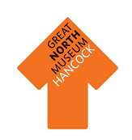
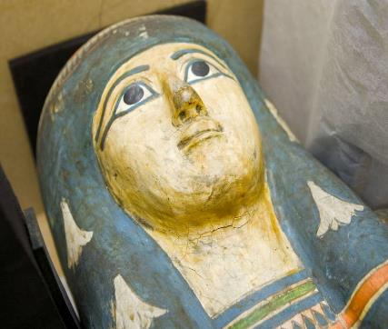
Can you find out any facts about Bakt en Hor?
………………………………………………………………………………….………………………………………………………………………………………………………………………………………………………………………………….

Imagine what this person might have been like before she died (for example: was she young or old? Rich or poor?).
I think that …………………………………………………………………...…………………………………………………………………………………...……………………………………………………………………………………………………….
……………………...……………………………………………………………………………………………………….
What descriptive words can you use to describe the mummy?
.………………………………………………………………….…………………………………………………………………

………………………………………………………………………………………………………………………………………
How is this mummy different to Irtyru?
……………………..………………………………………………………………………………….................................
Name: Bakt en Hor
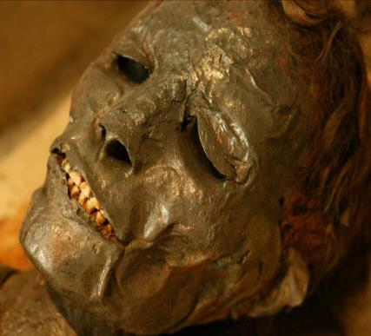
Imagine you are unwrapping this mummy for the first time. How do you feel when you see Irtyru?
I feel
………………………………………………………………………….……………………………………………………………
………………………………………………………………………………………………………………………………………
……………………………………………………………………………………………………………………………………..
Age at death: ……………
Date unwrapped: …………………
Name: Irtyru
Collect evidence from the Ancient Egyptians gallery to complete this worksheet.
Irtyru

What descriptive words can you use to describe the mummy?:
.………………………………………………………………...……………………………………………………………………
………………………………………………………………………………………………………………………………………
Mummification
Look in the Art of Mummification section
Organs were removed from the body and stored in canopic jars. Each jar lid had the head of a
different god; these gods
protected the organs inside.

Look for the mummified animals. Can you list the different types of animals that are mummified?
1………………………………………………...
2………………………………………………...
3………………………………………………...
Design your own Egyptian mask
Ancient Egyptians had beautiful masks made because they wanted to look their best in the afterlife.
Match the names of the Egyptian gods who protected these jars with the animals they looked like.
Jackal Hapi
Human Imseti
Baboon Duamutef
Hawk Qebehsenuef
Look for the metal hooks. What were they used for?........................ ........................................................
……………………………………………………..
Can you name the four organs which were stored in the canopic jars?
1……………………………………..
2……………………………………..
3……………………………………..
4……………………………………..

