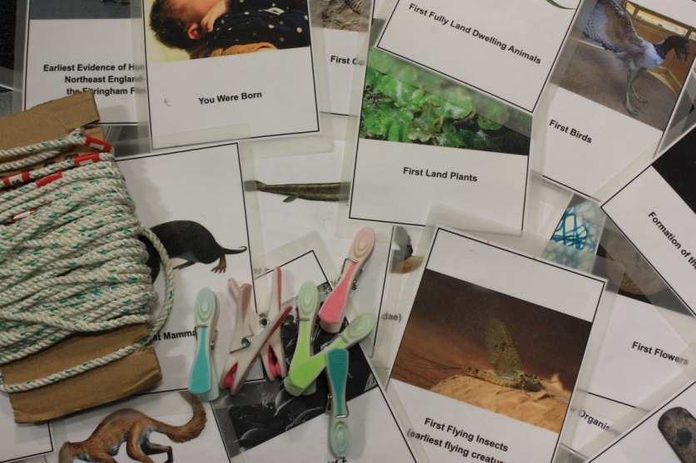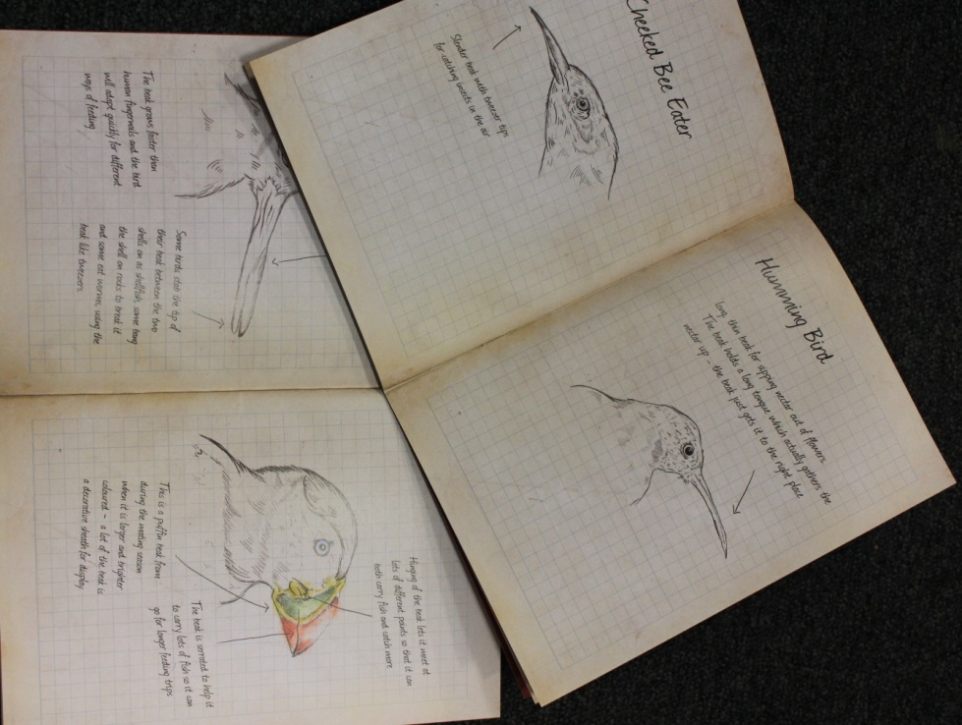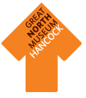

**Beak Adaptations**

This is a can be **a small group or a whole class activity.** These books are based on our collection and designed to look like a naturalist’s field notebooks, such as those Darwin kept on his journeys. Use the information about bird's beaks to guide you in the Living Planet and Natural Northumbria galleries to find birds which are adapted to eat different kinds of food.

**The Washing Line of Evolution**

This is a **whole class activity** to encourage thinking about the timescales of evolution and the order in which different species emerged. Peg the cards showing different events in the evolution of life on Earth along our 13.5m washing line. Can you get them in the right order?

**Evolution Gallery Explorer Kit**

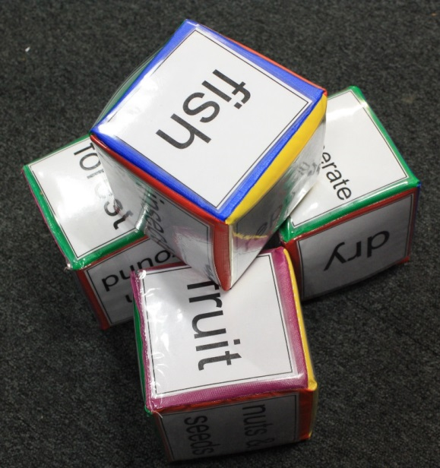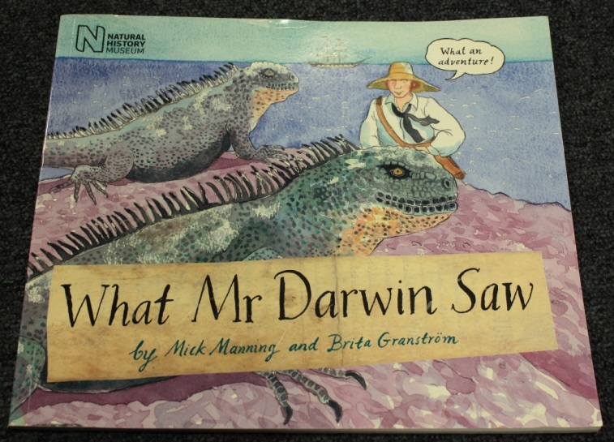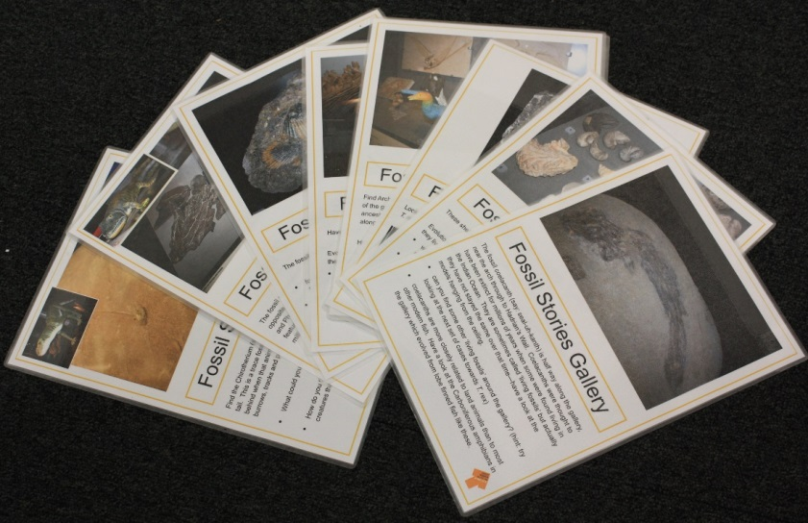

**Adaptation Dice**

This can be a **small group or a whole class activity.** Roll the dice to find a type of food, animal or environment then see if you can find an animal in the Living Planet gallery which has the right adaptations. For a more challenging search, roll more than one of the dice at a time.

**What Mr Darwin Saw**

This is a **small group activity.**  Use the book to follow Darwin’s journeys in space and science to discover how he came to his theory of evolution.

**Flash Cards**

This is a **small group activity** aimed at highlighting key fossils which teach us about evolution. Use the cards in the Fossil Storiesgallery to discover ancient adaptations, living fossils and key moments in the story of evolution.