Fossil Counting
Use a tally chart to help you work out how many of these different things you can find in the Fossil Stories gallery

 | Tallies | Number
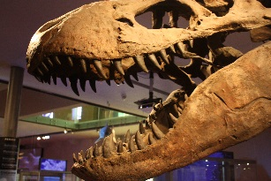
T. rex’s teeth
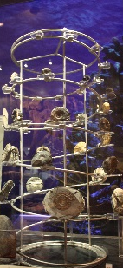
Ammonites in the big spiral
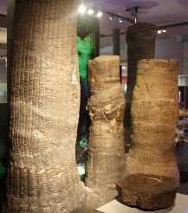
Big tree fern trunks
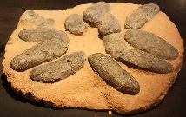
Dinosaur eggs
Live snakes

Which were there the most of?

