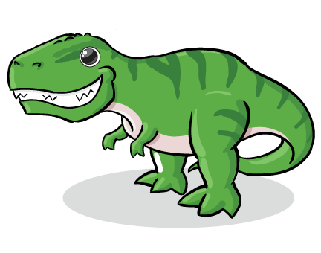
Dinosaur Maths

Compare

What is the biggest dinosaur you can find in the gallery?

__________________________________________________________

Which is longer: | 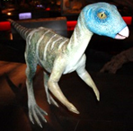 | 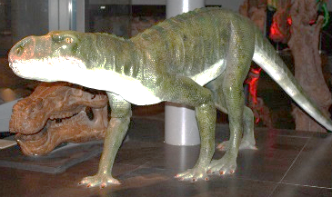
 | Hypsilophodon | or Chirotherium?

Whose head is smaller? | 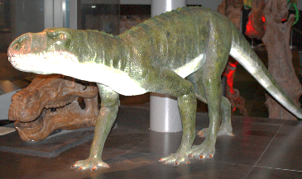 | 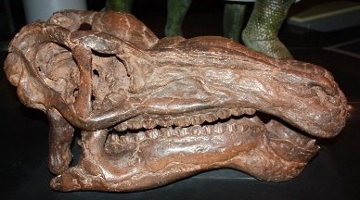
 | Chirotherium | or Iguanodon?

Measure

Use the ruler on the other side of the page to measure:

My friend’s tooth is _______________cm long
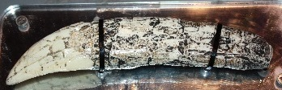
The T. rex tooth is ________________cm long
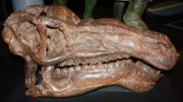
The Iguanodon’s tooth is ___________________cm long

Which is the biggest? _______________________________________

Which is the smallest? _______________________________________

0
1
2
3
4
5
6
7
8
9
10
11
12
13
14
15
16
17
18
19
20
21
22
23
24
25
26
cm

