Skeleton Game Gallery Resource Pack

Book the Skeleton Game Gallery Resource Pack to complement your visit with a skeletons theme. You can use it in the museum galleries to embed the way the human skeleton fits together.

In the pack, you will get four skeletons and mats, plus dice and instructions (see overleaf). The game works like the old fashioned game of Beetle – you throw the die to get each part of the skeleton in turn. Players take turns to throw and the first one with a complete skeleton wins. To make it all run faster, you can also give each team one skeleton and a die, then get them all throwing and building simultaneously.

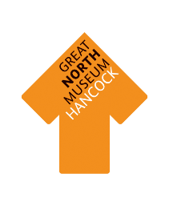
The Leg Bone’s Connected……

- Take turns throwing the die to put together your skeleton – the first one to complete the skeleton wins.

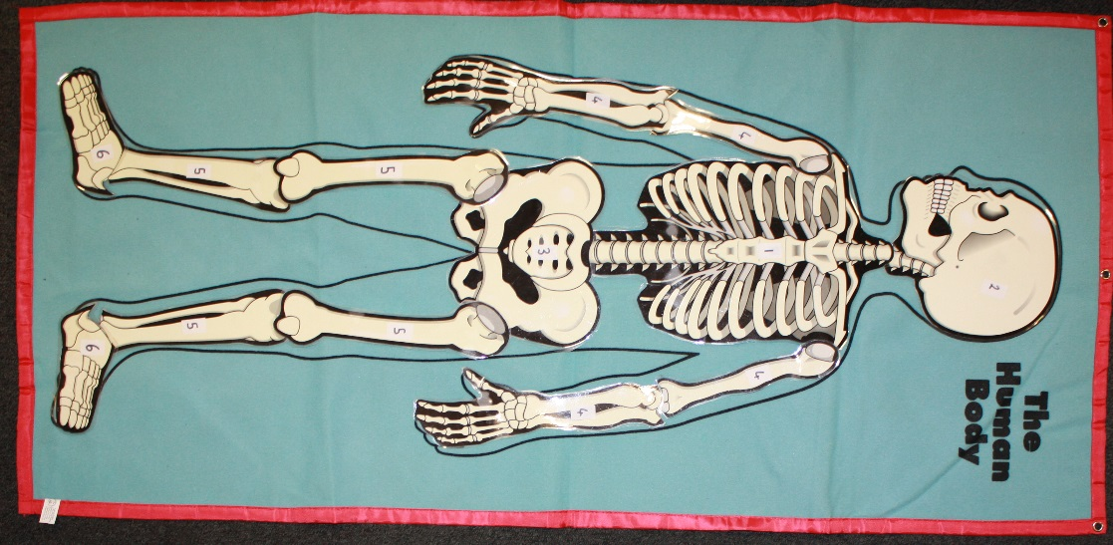
- To start, you need to throw a 1 to get the spine and ribs. After that, you need to throw the correct numbers to add the other bones onto it.

- Remember that all the bones must be connected to each other – so you can’t add the leg until you have the pelvis, or add a foot until the leg is there waiting for it.

- If you throw a number which relates to more than one bone, you only get one of them for that throw and will need to get the others on future turns.

1: spine and ribs
2: skull
3: pelvis
4: arm and hand bones (2 x right and 2 x left)
5: leg bones (2 x right and 2 x left)
6: foot bones

