Counting While You Wait

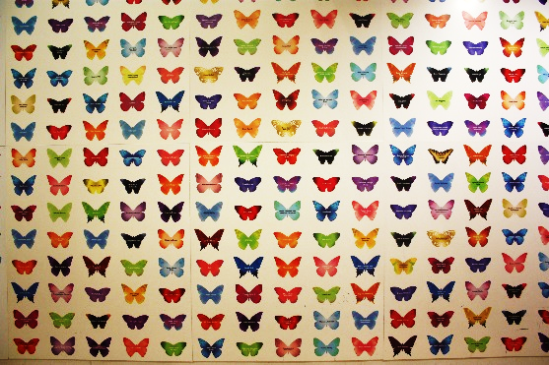
Our butterfly wall is a collection point for lots of activities – signing in, going for your workshop, waiting for the toilet….. here are some things that you can do while you wait.

Counting and Times Tables
The panels are mainly grouped into 5 by 8 butterflies. For small children, you can just count them out. As children progress, you can count in fives or practise the 5 or 8 times table.

Tallying, Charts and Graphs
Whose favourite colour is shown on the most butterflies? Are there more boys or girls’ names on butterflies? Everyone can count everything (and compare their answers!), or split into teams to count the different things.

If you are doing tallying, there is a sheet below which you can use to investigate questions like this. You could then turn your findings into a bar chart or pictogram either now or back in school.

Fractions
What fraction of butterflies are a particular colour? You could start out with the tally chart if that. Try turning that into a decimal number or percentage to challenge those working faster.
Colour | Tallies | Total
Red
Orange
Yellow
Green
Blue
Purple
Gold

 | Tallies | Total
Girl
Boy
Both
Don’t know

