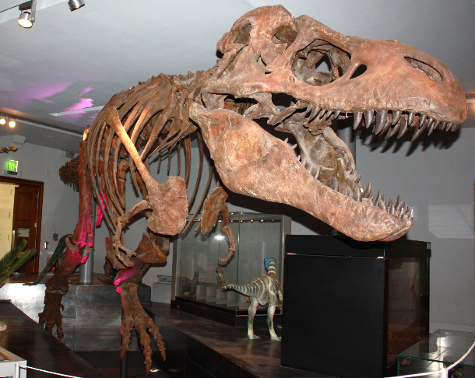
Dinosaur Maths

What units would you use to:

Measure the height of T. rex? ___________

Weigh T. rex? _______________________

Estimate:
How many teeth does T. rex have? ______________________________

Tally:
Use tallying to count the number of teeth you can see:

 |  | Tally | Total
T. rex | 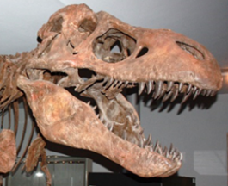
Iguanodon | 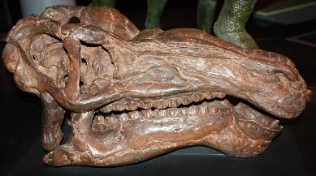
Cheirotherium | 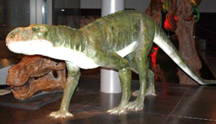
Dimorphodon | 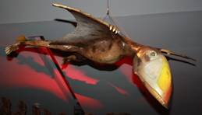

Who has the fewest teeth? _____________________________________

How close did you get when you estimated how many teeth T. rex has?

How many teeth does T. rex have if you round to the nearest 10? ______

Pictogram:
Now count how many toes each creature has on one foot
 |  | Number of toes on one foot
T. rex | 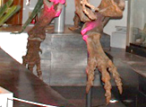
Hypsilophodon | 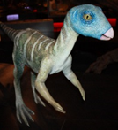
Cheirotherium
Dimorphodon

Use your totals to make a bar chart or pictogram of dinosaur toes:

6
5
4
3
2
1
 |  | T rex | Hypsilophodon | Cheirotherium | Dimorphodon

Do any creatures have the same number of toes?

__________________________________________________________

