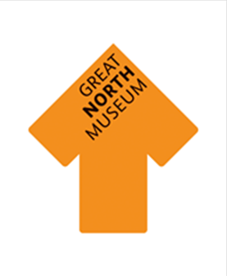

The following images display some spaces in the museum which you might encounter on your visit. They can be used to support transitioning within an individual child’s ‘Visual Timetable’ or ‘Now and Next’ system. These can also be used to help prepare the children for their visit in a pre-visit activity.

Please feel free to resize images to fit with your own formats and individual needs. If there are any other specific photographs that you feel would be helpful during your visit, please contact a member of the Learning Team on 0191 2086865. Alternatively we do allow photography in our galleries and you are more than welcome to photograph the venue on your own pre-visit to the museum.

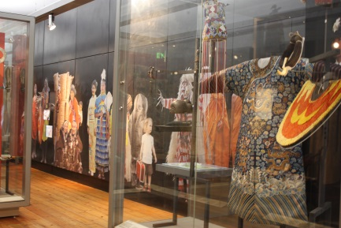

World Cultures

Gallery

(includes some weaponry)

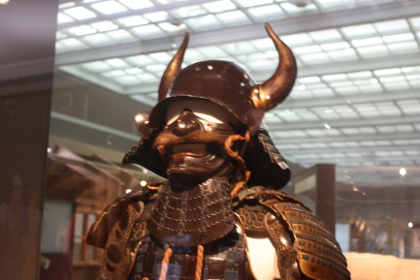

World Cultures

Gallery

(includes some weaponry)

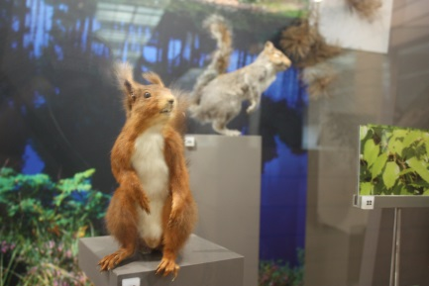

Natural Northumbria

Gallery

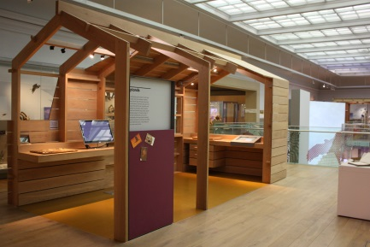

Natural Northumbria

Gallery

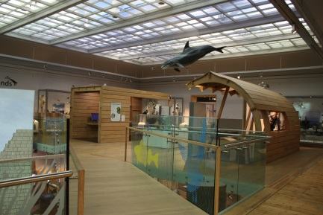

Natural Northumbria

Gallery

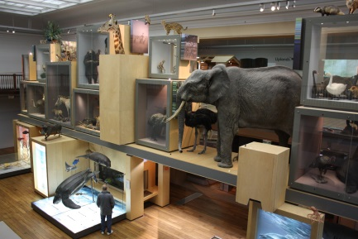

Living Planet

Gallery

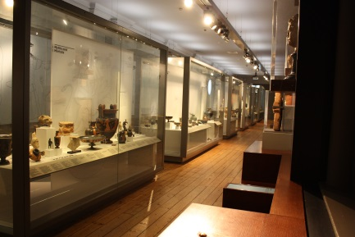

The Shefton Gallery

(Which houses our Ancient Greek Collection)

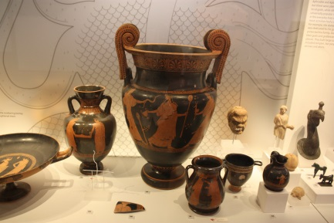

The Shefton Gallery

(Which houses our Ancient Greek Collection)

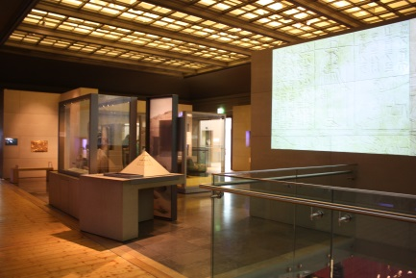

Ancient Egyptians Gallery

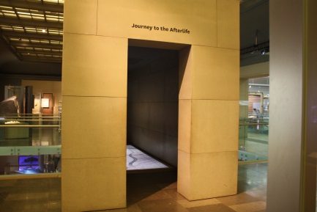

Ancient Egyptians Gallery

(Walk though aspect which includes sound and animated floor including snakes and fire)

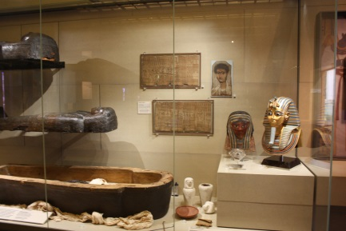

Ancient Egyptians Gallery

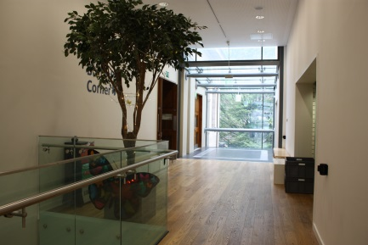

Butterfly Corner

(allocated for lunch spaces)

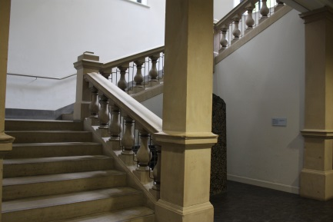

Stairwell.

This space is often quiet and could provide a calming space to support some children.

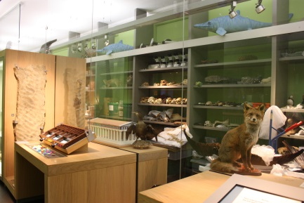

Explore Gallery

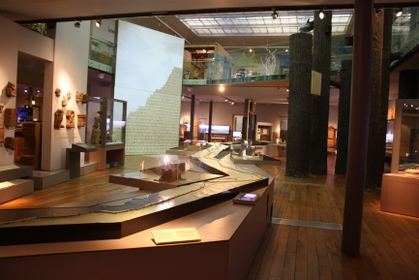

Hadrian’s Wall Gallery

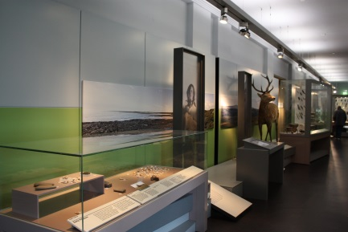

Ice Age to Iron Age

Gallery

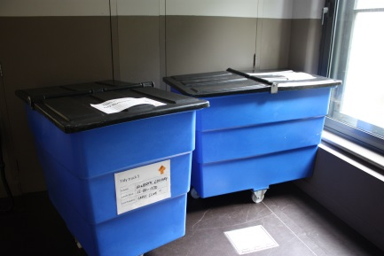

Tidy Trucks

(used to keep pupils bags and coats in during a visit.

Occasionally groups will be asked to leave bags and coats in a room)

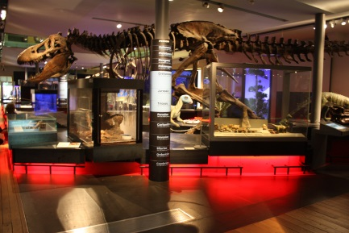

Fossil Stories

Gallery

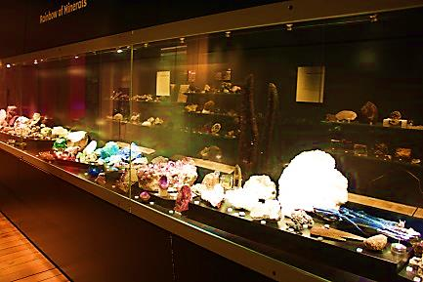

Crystals and Gems

Gallery

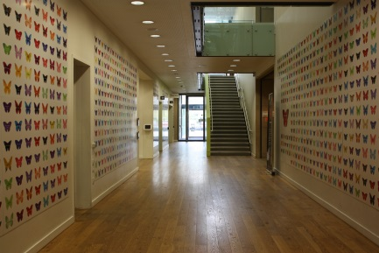

Butterfly Wall

(meeting point for school workshops)

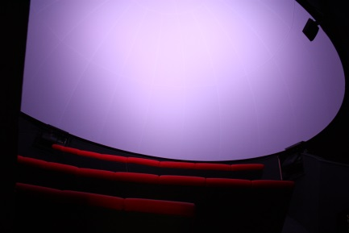

The Planetarium

(Very Dark inside)

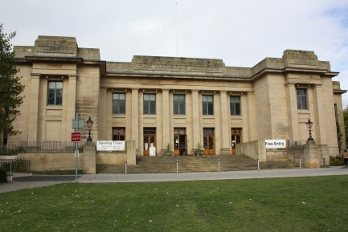

The Great North Museum: Hancock

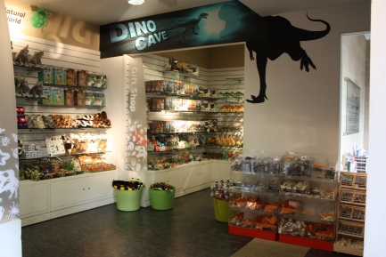

Shop

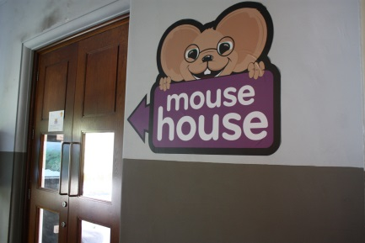

The Mouse House

(Used for Early Years Workshops)

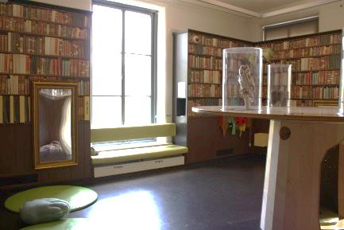

The Mouse House

(Used for Early Years Workshops)

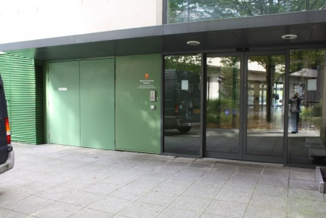

Schools Entrance

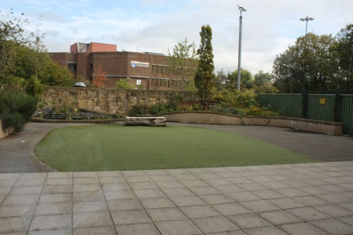

Study Garden

(sometimes open for lunch space. Includes a shallow pond.)

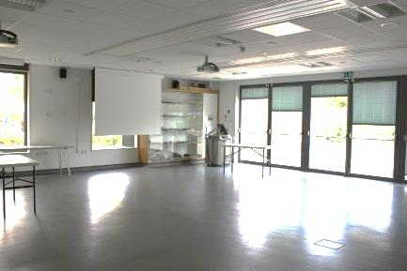

Large

Clore Learning Centre

(used for workshops and lunch spaces)

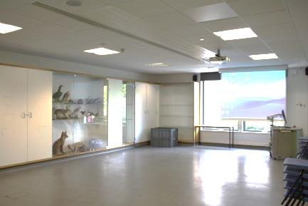

Small

Clore Learning Centre

(used for workshops and lunch spaces)

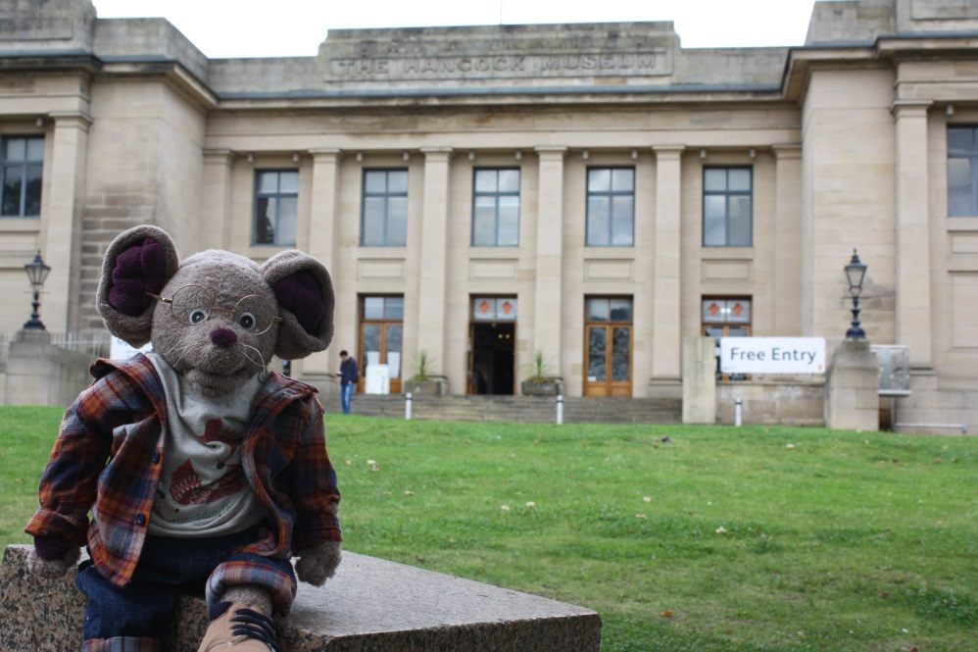

The Great North Mouse

(will meet during early years workshops)