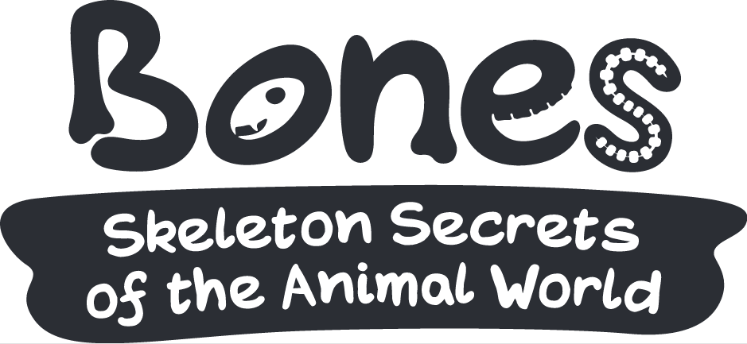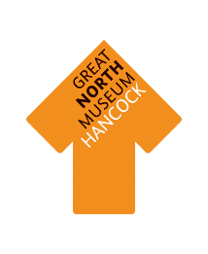

**PREDATORS**

**AND PREY**

Whether an animal is a predator or prey depends on where it is in its food chain. You can find the skeletons or skulls of some animals on different parts of their food chain around the exhibition. Can you list some:

|  |  |  |
| --- | --- | --- |
| **Primary Consumers** | **Secondary Consumers** | **Top Predators** |

**Have a look at the skulls of some animals on different parts of the food chain**

What do you notice about their teeth?

Are their eye sockets on the front or on the side of their head (see if they are looking straight back at you or if they are looking out to the side)?

Which animals are predators and which are prey?

Why do you think they have their eyes in this position?

**Can you find some ways in which prey animals are defending themselves from predators? Look all round the exhibition to see what different things you can find.**

**How are predator’s skeletons helping them to hunt? Think about how they move and what they do to catch their prey:**