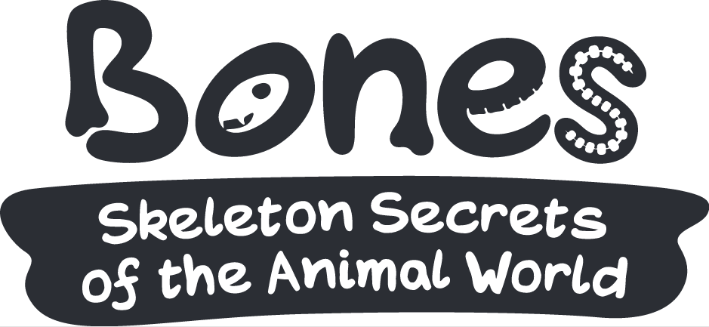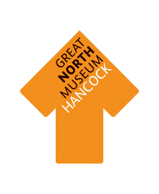

**Fly**

**Slide**

**Swim**

**Walk**

In each box below, draw a picture or write a description of how an animal’s skeleton helps it to move in these different ways:

**MOVEMENT**

How about your own skeleton? How does that help you to move? Look at the animal skeletons to help you to work it out!

What do you notice about the skeletons of the animals that jump?

Draw a picture of the rabbit’s feet

What do you notice about the feet of animals that climb?

Draw a picture of the sloth’s front feet